November 2014 update

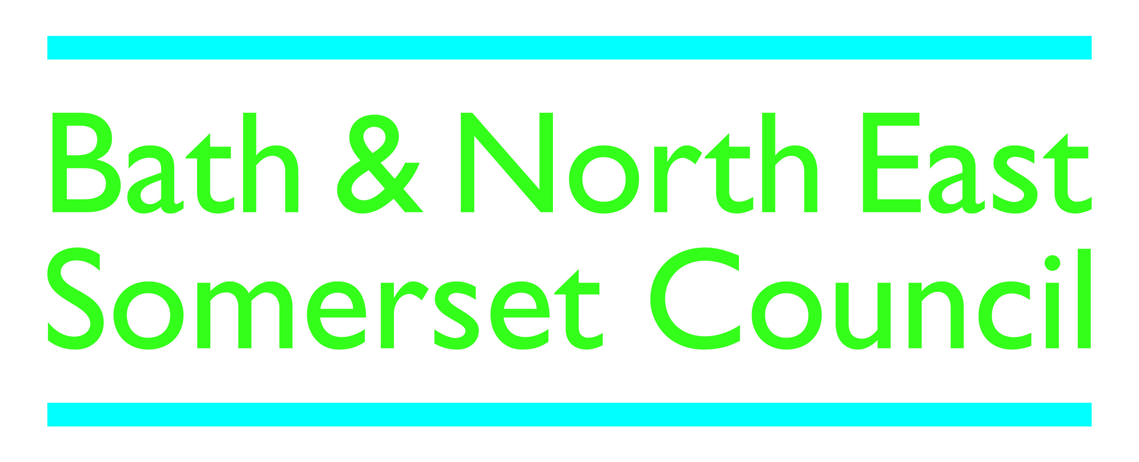

Public toilet improvement plan continues
The Council’s contract with Healthmatic Ltd will provide comprehensive cleaning and management services for fifteen years. It means that 15 public toilets in parks, play areas, green spaces and key transport hubs will remain open. The contract has now guaranteed the provision of high quality toilets for our residents and visitors for many years – something which we have never previously been able to do. That is in the context of very serious pressures on local government finance and this protected level of provision in Bath and North East Somerset is not something that many Councils could offer at the moment.
The new cubicles being installed by Healthmatic combine a number of improvement features:

- A high standard of cleanliness and safety and able to handle large numbers of people using them
- Large enough for a parent with a couple of small children and a pushchair to use together so parents and carers can keep a better eye on their children
- Built into the existing toilet buildings, disability compliant with safe sharps boxes
- Many more baby-changing facilities than there are now, accessible to male and female parents and carers.
- High-tech controls means access can be 24 hours / 7 days a week all year or the timers can be adjusted remotely to suit local needs
- Access by coin entry to a private cubicle with its own hand-washing and drying facilities (as for the existing auto-loos in Bath and North East Somerset which have been operating successfully for 10 years)
- Resistant to vandalism and misuse with an easy clean tiled interior and hard-wearing fittings
- Removal of the male/female separate areas into unisex cubicles, access by coin entry, both deterrents to anti-social behaviours
- Problems are detected remotely enabling rapid response by Healthmatic’s engineering and maintenance teams

Continued/…..

All of the refurbished facilities will be charged at 20p for use, in order to make the contract sustainable.

There are over 110 councils all over the UK with Healthmatic toilets, from busy night-time city centres like Glasgow to tourist destinations like the Cotswolds, Oxfordshire and North Somerset.

This is a typical interior of a new direct access cubicle, disability compliant, with baby changing facility.

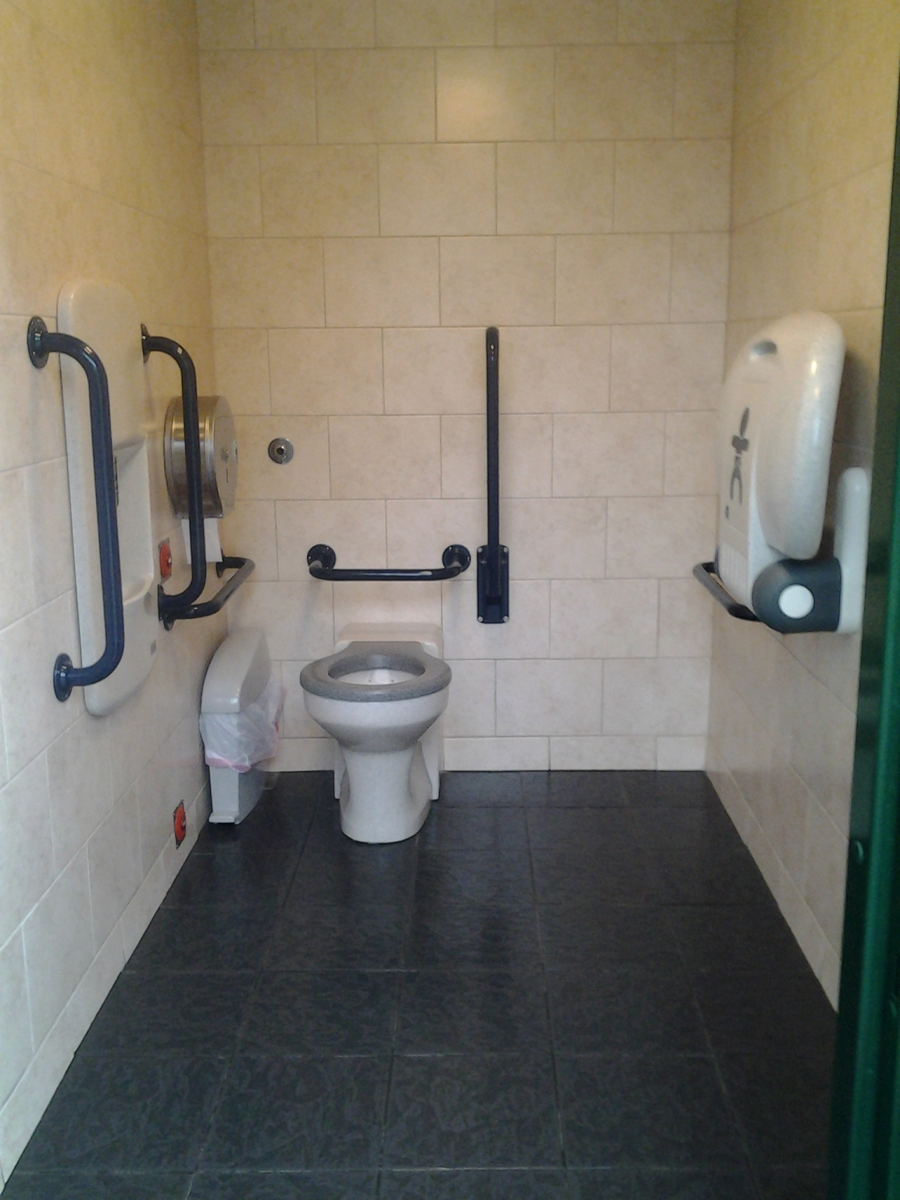
Continued/…..
More details of the improvement plans:

- 9 toilets in parks, play areas and green spaces: No of new cubicles
Royal Victoria Park play area 8 – due early 2015
Parade Gardens 2 – to complete 1 Dec
Memorial Park – Keynsham 2 - completed
Sydney Gardens 2 – to start 24 Nov
Alice Park 2 - completed
Henrietta Park 2 – due early 2015
Monksdale Road 2 – completed
Alexandra Park 2 – to start 24 Nov
The Shallows in Saltford 2 – to start 18 Nov

When big events are held in parks, organisers are required to hire in portable toilets. This will continue to be the case.

- The 4 other locations are: No of new cubicles
Monmouth Street 4 - completed
Riverside Coach Park tbc
Charlotte Street Car Park 4 - completed
Odd Down Park & Ride 2 - completed

- The current auto-loos at Charlotte Street and Shaftesbury Road will continue in operation until at least 2020;
- A new facility will open at Newbridge Park & Ride in early 2015;
- Temporary cleaning, locking and repairs only arrangement:
Ashton Way, Keynsham (until the new Council development opens later this month)
Gullock Tyning, Midsomer Norton (until mid-2015 when the leisure contract is awarded with public convenience provision included);
- We are continuing to work with local businesses in Larkhall Square and High Street, Weston on innovative arrangements to provide a public toilet service together;
- Paulton Parish Council have worked with the Council to take over fully running the public conveniences on a 15 year agreement;
- The Council is continuing to work with Batheaston Parish Council over the public toilets building in London Road car park in support of their Vision Plan;
- Former locations at Dominion Road – Twerton and Bradford Road - Combe Down (closed earlier in the summer) are now to be marketed for sale at auction in December. Peasedown St John (Greenlands Road car park) will be demolished to make way for extra parking spaces in the well-used car park.

