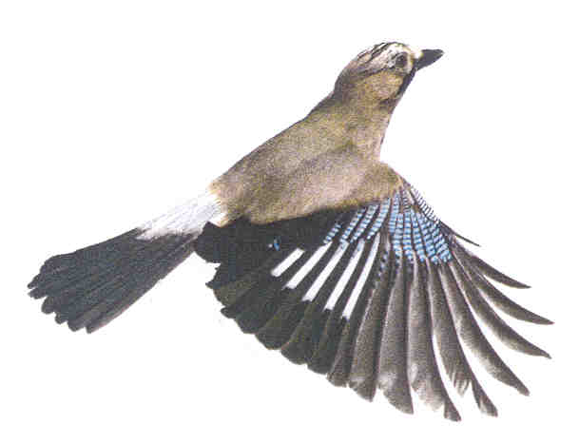Joint Local Access Forum (JLAF)
for Bath & North East Somerset, Bristol City and South Gloucestershire

Application for membership of the JLAF

To: Bath & North East Somerset, Bristol City and South Gloucestershire Councils

PRIVATE AND CONFIDENTIAL

To be considered for membership this year the deadline for receipt of applications is 9am on Thursday 14 June 2018

Introduction

The purpose of this application form is for you to provide the information necessary for the councils to select new voluntary members to the Joint Local Access Forum (the JLAF) and to administer the JLAF. Some questions are included to comply with the Local Access Forums (England) Regulations 2007 or to follow government guidance.

Please complete the form so that we know why you want to be a member of the JLAF, how you intend to contribute to the work of the JLAF and your aspirations for access to the outdoors. Provide any information that you consider relevant to this.

In appointing members, the councils will consider all new applications and the current membership of the JLAF to appoint a balanced forum with a broad range of interests, knowledge and experience. Members of the JLAF are not appointed as technical advisors or formal representatives of interest groups.

The names of JLAF members will be recorded in the minutes, which will be publicly available; other personal details will be disclosed only with your consent. Your completed application form will be retained for one year after your membership ends if you are successful or retained for one year after the application deadline if unsuccessful. Further information about how we will process your personal data can be found in the JLAF’s Privacy Notice which is available online at http://www.bathnes.gov.uk/services/streets-and-highway-maintenance/public-rights-way/joint-local-access-forum/minutes-past

Before you complete this form, you might find it useful to look at the papers of previous JLAF meetings. They are at http://www.bathnes.gov.uk/services/streets-and-highway-maintenance/public-rights-way/local-access-forum You can also download a copy of this application form from the website to complete and return by email.

If you have any questions about this application, please contact Graeme Stark, the Secretary of the JLAF, whose contact details are at the end of this form.

Please send completed application forms to the address at the end of this form
or to graeme_stark@bathnes.gov.uk.

This document about applying to join the Joint Local Access Forum can be made available in a range of languages, large print, Braille, on tape, electronic and accessible formats from Graeme Stark. Tel: (01225) 477650.
Personal details

Title | Surname
Forenames
Preferred name (if different)
Postal address
 | Postcode
E-mail address:
Daytime phone number
Evening phone number
May we contact you on these phone numbers? (Y/N)

Disabled People

We welcome applications from disabled people and can assist you in your application and role if you are appointed as a JLAF member. All information is treated in confidence and is used to help us to carry out our duties under the Equality Act 2010.

Do you consider yourself to be a disabled person under the terms of the Equality Act 2010?  A person is disabled if s/he has a physical or mental impairment that has a substantial long term adverse effect on his/her ability to carry out normal day to day activities | (Y/N)
Please specify the support (e.g. hearing loop, Braille documents, ramp or lift) you require:

Your area of interest

Legislation requires a balance in the membership between the three categories of members shown below.

- members representing the users of local rights of way or access land,
- (b) members representing the owners and occupiers of access land or land over which local rights of way subsist, or
(c) members representing any other interests especially relevant to the authorities’ areas (Bath & North East Somerset, Bristol and South Gloucestershire).
Please give a brief summary of any interest you have in one or more of these categories (for example, in work or for leisure, as a volunteer, professional, academic or involved in a business relevant to the work of the JLAF):

(a) Representing the users of local rights of way or access land
(for example, representing walkers, horse riders, carriage drivers, cyclists or motorists)

(b) Representing the landowners or occupiers of access land or land over which local rights of way exist (for example, do you own or occupy access land or land over which rights of way subsist, or represent such landowners or occupiers?)

(c) Representing any other relevant interests (do you have an interest in access not covered above, for example do you have an interest in tourism, nature conservation or in the provision of access for disabled people?)

Please also tick the one box below that you consider most relevant to you in your application to be a member of the JLAF:

(a) Representing the users of local rights of way or access land
(b) Representing the owners and occupiers of access land or land over which local rights of way subsist, or
(b) Representing any other interests especially relevant to the authority's area.

Why do you want to be a member of the JLAF?

Please include anything in the following space that you feel is relevant to your application for membership of the JLAF. The councils will also consider the information you have provided elsewhere on the form.

The councils particularly want to know:

- Why you want to join the JLAF
- What you can contribute
- What you want to achieve

You may also wish to consider including some of the following in your entry:

- Your relevant interests, pastimes or leisure activities
- Your knowledge of access, including your knowledge of public rights of way and of access land
- Any involvement or membership and any positions held (previous and current) in any organisations or clubs whose work is relevant to the JLAF
- Any other skills or experience which you may have which are relevant to the JLAF
- Areas where you feel you would be able to give particular advice
- Your views on access to the outdoors in both urban and rural areas, including the potential of access and the impact of access in rural and urban areas

Declaration of interest

Legislation places some limitations on who can be appointed as a member of the JLAF. For instance, there is a limit to the number of members of the JLAF who are also Councillors of the three councils involved in the JLAF. There is no bar on the appointment of local authority employees to the JLAF but the councils may avoid appointing any officer who has responsibilities for access or rights of way management in a local authority. This is because there might be a potential conflict of interest between their local authority duties and membership of an independent statutory body giving advice on how those duties should be carried out. Please therefore answer the following questions:

Are you an Elected Member or Senior Officer of Bath & North East Somerset Council, Bristol City Council or South Gloucestershire Council? | (Y/N)
If yes, which council and what is your position?

Are you otherwise employed by Bath & North East Somerset Council, Bristol City Council or South Gloucestershire Council? | (Y/N)
If yes, which council and in which department?

Are you related to any Elected Member or Senior Officer of any of the Constituent Councils (Bath & North East Somerset, Bristol City or South Gloucestershire Councils)? | (Y/N)
If yes, name of relative, in which council and in what position?

What is the relationship of this person to you?

I confirm that the details on this application form are correct.

Signature | Date

Please return your completed application form to:

Graeme Stark  Secretary to the JLAF  Lewis House  Manvers Street  Bath  BS31 1JG  Telephone: 01225 477650  Email: graeme_stark@bathnes.gov.uk |  | For administration:  Application  Received:

