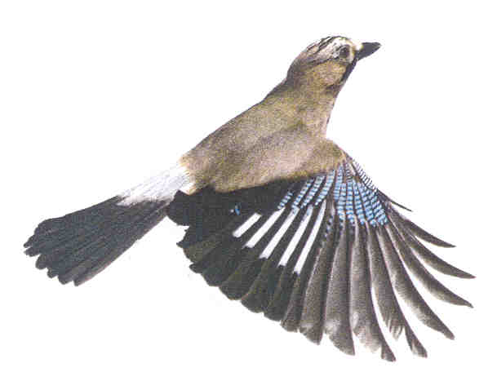Joint Local Access Forum (JLAF)
for Bath & North East Somerset, Bristol City and South Gloucestershire

JLAF Member Expenses Claim Form APR24-MAR25

When complete, return to:
Graeme Stark  Secretary to the JLAF  Bath & North East Somerset Council  Lewis House  Manvers Street  Bath  BA1 1JG |  | Please ensure that you have read the information overleaf
 |  | This form is for expenses incurred between 1 April 2024 & 31 March 2025
 |  | You can submit expense claim forms periodically, or in any case by the end of April 2025

Name:
Address:
 |  |  | Post code:
Telephone:
Travelling allowance
Date | Mode of transport (include cc if car or motor cycle) |  | Journey Details  (start, stops and end points, reason for journey) |  |  |  | Mileage/ cost of ticket (ticket/ receipt must be attached) |  |  | Expense claimed

Subsistence allowance
Date | Allowance (breakfast/ lunch/ tea/ evening meal/ absence overnight) |  |  | Reason for allowance claim / reason for journey |  |  | Cost (receipts must be attached) |  |  | Expense claimed (cost up to maximum allowance)

Care of children or dependants
Date | Number of children/ dependants |  | Period of care |  |  |  | Cost (receipts must be attached) |  |  | Expense claimed (cost up to maximum allowance)
Claim for month/year: |  | / |  |  | TOTAL CLAIM: |  |  |  | £
I certify that this claim is accurate and expenses were incurred on approved business of the Joint Local Access Forum of which I am a member and the expenses in this claim have not been reimbursed by any other source.
Signed: |  |  |  |  |  | Date:
BATH & NORTH EAST SOMERSET, BRISTOL CITY AND

SOUTH GLOUCESTERSHIRE COUNCILS
MILEAGE SUBSISTENCE AND CHILD CARE ALLOWANCES
PAYABLE TO MEMBERS OF THE JLAF – FOR EXPENSES INCURRED AFTER 1st APRIL 2024.
The Local Access Forums (England) Regulations 2007 provide for the appointing authority to meet any reasonable expenses incurred by a joint local access forum that they establish or by the members of the forum. The rates are based on these regulations with the Members Allowances Scheme of Bath & North East Somerset Council, and these regulations and the rules for Members Allowance Scheme shall be used in the application of these allowances.
Reasonable expenses incurred by the members of the forum are such expenses incurred by them in connection with their attendance at meetings of the forum and any other activities relating to the discharge of the functions of the forum, but only in respect of:-
(a) Travel and subsistence costs
- Any expenses of arranging for the care of their children or dependants.
The allowances will be reviewed from time to time by the Joint Local Access Forum Steering Group.
The allowances payable will be as follows:
Travelling Allowances
Travel by bicycle will be reimbursed at the rate of 20p per mile travelled.
Travel by public transport will be reimbursed at cost for journeys on a reasonable route by bus or second class rail. Receipts or tickets must be submitted with the claim.
Travel by motor cycle will be reimbursed at the rate of 24p per mile
Travel by car will be reimbursed at the rate of 45p per mile
Passengers: for both motorcycles and cars, the rate per mile is increased by 1p for each passenger - to a maximum of 4 passengers.
Subsistence Allowances
Where absence from normal place of residence is greater than 4 hours, but only in respect of activities outside of the Council's boundaries, subsistence claims will be met on the basis of actual expenditure subject to the following:
The expenditure is considered reasonable.
Receipts are submitted with the claim.
Claimant must be prepared to justify expenditure if asked to do so.

These rates shall be reduced by an appropriate amount in respect of any meal provided free of charge by an authority or body during the period to which the allowance relates.
Each claim is to be accompanied by the appropriate receipts.

Carer’s Allowance
The cost of arranging for the care of children or dependants by a registered carer will be reimbursed at actual cost to a maximum as shown below, subject to a maximum of 8 hours per occasion and the submission of copies of receipts for the expense incurred. Allowances are per child or person per hour of care.
Childcare (including after –school clubs) | £12 | Childcare for a child with a disability or special needs | £16 | Childcare for an adult with a disability or ill health | £16

A claim for travelling and subsistence allowances shall be made in writing periodically or at any time until the end of the month following the financial year (April to March) in respect of which the claim relates. Claims are to be submitted to the Secretary of the Joint Local Access Forum.
These rates are based on travel, subsistence and carer’s allowances as set within the Bath & North East Somerset Staff Allowances Scheme (the ‘Scheme’), as approved by Bath & North East Somerset Council
The Scheme is published on the internet at www.bathnes.gov.uk.
Any further reimbursement will only be paid following the agreement by the Councils prior to those expenses being incurred.

