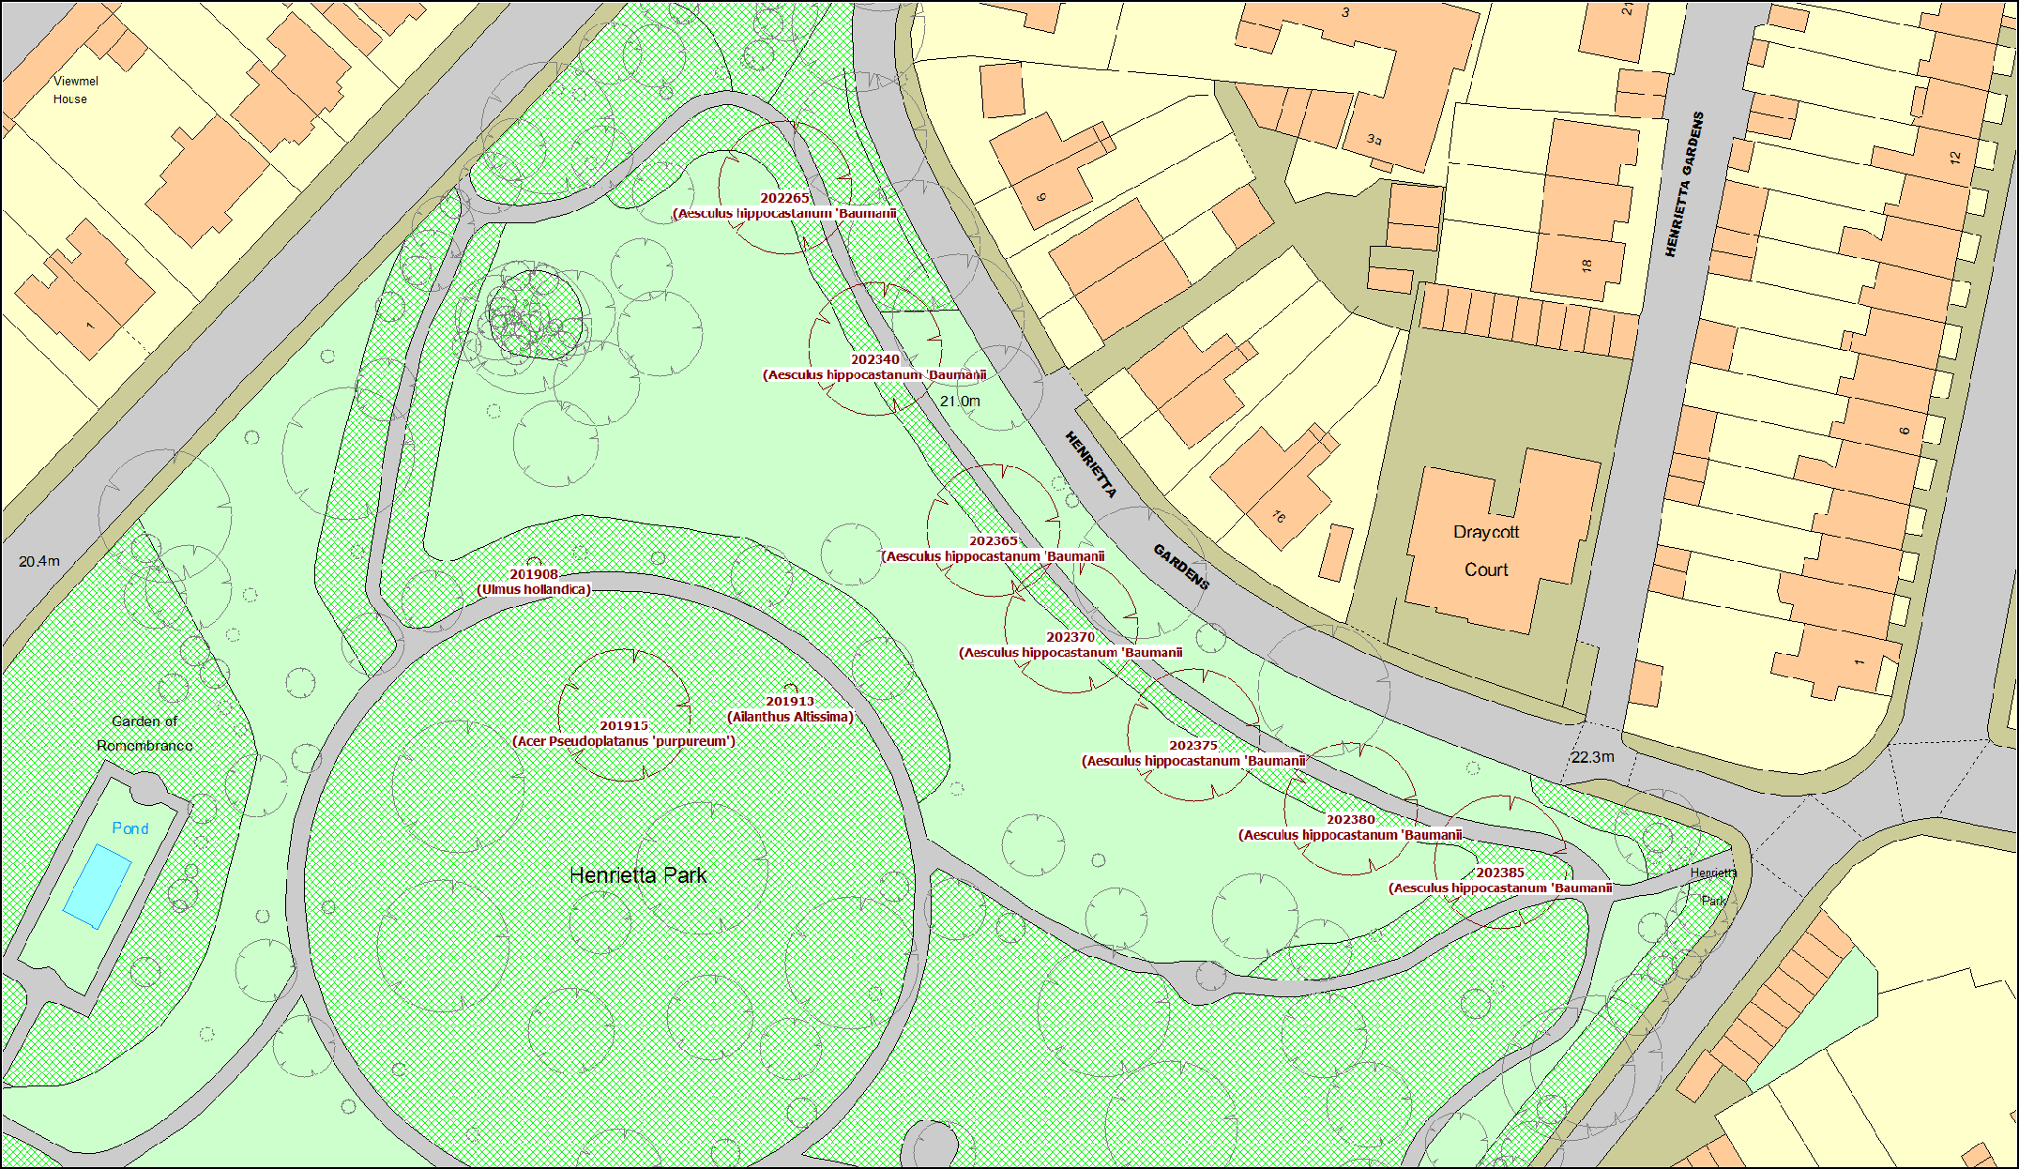

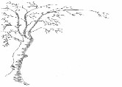 | Henrietta Park Champion Trees East 2018 Map | Scale | Unknown
 |  | Date | 30/04/2018

