Preliminary Evaluation of the Emotional Resilience Hubs at Secondary Schools
8

- Background

At a local and national level there is clear evidence of a rise in both emotional distress and mental ill-health within the 0-18 population. Many young people are experiencing problems which adversely affect their own learning, as well as the learning of their peers, and can be challenging to address within the school setting. This increase in need is placing great strain on both the pastoral systems of secondary schools and upon P/CAMHS (and other) services.

In discussion with B&NES Secondary School Head Teachers it was mooted that it may be possible to address some of the above problems through the development of a new approach which bridged the school-based pastoral system and P/CAMHS system.

The proposed service was built on an informal model provided to Chew Valley School during their experience throughout a crisis period when they received a tailored model of care, helping teachers, pastoral support staff, school nurses and pupils.

The proposal was to establish a system of school-based independent counsellors who, along with school staff, would be supported by mental health practitioners from the local CAMHS service. Independent counsellors would directly support the emotional health and wellbeing of pupils and, by preventing or limiting interrupted learning, facilitate improved academic achievement.

It is worth noting that the local need for more mental health support in schools reflects a national concern about the availability and quality of school-based early intervention provision in secondary schools. Please refer to Appendix 1 for a clear summary of the relevant issues.

In December 2014 schools, via the Schools Forum local arrangement, supported a request for £100,000 to fund the proposal: A 12 month pilot to create and evaluate ‘Emotional Resilience Hubs’ (£41,000) together with the provision of independent school based counselling (£59,000) in all 16 secondary schools in Bath and North East Somerset.

The combined counselling /school hub pilot aimed to achieve the following:

- Improved resilience, emotional wellbeing and mental health of young people of secondary school age
- Promote an increase in suitably qualified and experienced counsellors offering sessions in B&NES secondary schools
- Improve relationships between service providers relevant to young people’s emotional resilience.

- Proposed Pilot Service Model

CAMHS practitioners, from Oxford Health NHS Foundation Trust would support each secondary school on a monthly basis by offering a package of consultation, training and telephone support. It was envisaged that each school would create a pastoral ‘Hub’ comprising of the school based counsellors, pastoral leads and their school nurse who would all be supported by the CAMHS practitioner.

The model was designed to support selected school staff to increase their confidence and skills in supporting pupils struggling with mild mental health issues by providing;

  - Regular consultation to key ‘Hub’ staff (monthly, 3 hours - including CAMHS practitioner travel time).
  - Four full day training sessions to the wider school team about emotional resilience, key signs and symptoms of distress, managing common behaviour problems and developing personal coping strategies.
  - Ad hoc consultation by phone to discuss any individual pupils causing concern at school.
  - Joint training and awareness raising sessions to pupils by CAMHS staff and ex-CAMHS service users.
  - Occasional direct work with pupils.

Note: Several schools have historically commissioned independent student counselling. This did not preclude them from being part of the pilot and they were offered the same opportunity to have more counselling provision as well as a link worker from CAMHS for training, liaison etc.

- School Named linked CAMHS worker – facilitating Resilience Hubs

  - Commissioning
The contract with the CAMHS provider, Oxford Health NHS Foundation Trust, was varied to provide (from 1st June – 31st May) the support outlined above. It was agreed that support would be dovetailed to school timetables and individual school needs. Depending on the needs and requests from individual schools, the Hub meetings would involve talking about common ‘themes’, individual pupils, consultation, signposting to other services, referral advice and training.

  - Delivery
All schools were directly contacted by CAMHS and the agreed service model offered. Initially sign up was positive, with thirteen out of the sixteen secondary schools signed up to create a school Resilience Hub. However the table below indicates that some have chosen not to engage in the training and/or the Hub, and some began to engage but subsequently declined further sessions.

It is difficult to ascertain the reasons for this – there are probably a range of different issues at individual schools. Some schools have strong relationships with their school nurses and feel that nurses are the ‘natural’ point of contact for mental health concerns. Unfortunately, due to staff leaving, changes in some of the named CAMHS workers was necessary and this may well have impacted on some schools’ engagement

Each school made different choices about how to use the Hubs, some schools requested that the meetings are only on a ‘needs basis’ and invited CAMHS to attend when appropriate, other schools wanted infrequent Hubs but to use all of their allocated hours for training. Others used both the Hub meetings and the training to their fullest extent. The schools that also have Relate counselling as part of the pilot appeared to be a little more engaged with the Hubs.

Uptake of Hub support offer by schools:

School | Number of sessions provided | Training provided (hrs) | Travel time (hrs) | Hubs (inc travel) | Comments
Hayesfield (Training started in November) | 12 | 16 | 12 | 36
Writhlington (Training started in January) | 4 | 5 | 2.67 | 36
BCA (Training started in November) | 3 | 7 | 1 | 36
Chew Valley | 2 | 3.5 | 2 | 36
Norton Hill | 1 | 2 | 1 | 36
Oldfield | 3 | 3 | 1 | 36
Somervale | 1 | 2 | 3 | 11.5
Beechen Cliff (training started in January) | 4 | 10 | 4 | 6 | *Offered a monthly slot but only taken 2.
Wellsway | 0 | 0 | 0 | 15 | *5 hubs taken, school declined any further.
Aspire (and BSS) | 1 | 2 | 0.5 | 9 | *Offered a monthly slot but only taken 3.
Three ways | 1 | 1 | 1 | 6 | CAMHS attend school regularly
Ralph Allen | 0 | 0 | 0 | 9 | *Offered a monthly slot but only taken 3.
St Marks | 0 | 0 | 0 | 6 | *Offered a monthly slot but only taken 2.
St Gregory | 0 | 0 | 0 | 6 | *Offered a monthly slot but only taken 2.
Fosseway | 0 | 0 | 0 | declined | CAMHS attend school regularly
Broadlands | 0 | 0 | 0 | declined
Total | 32 | 51.5 | 25.67 | 282

(Data provided by Oxford Health NHS Foundation Trust, June 2016)

The table above indicates the approximate number of hours that has been provided to the schools for both training and Hub time. It is worth noting that it took schools some time to agree to meet and offer dates for training. Some schools then wished to break up the offer of training days into shorter sessions which impacted on travel and preparation time and was not a productive way for CAMHS staff to deliver the training sessions.

There are a number of ‘indirect’ hours not accounted for in this table e.g. the preparation time for the trainings sessions, the number of consultation phone calls about individual students and other queries, and the organisational time (telephone and face to face conversations about the project and arranging set-up meetings etc).

3.3 Review and Evaluation
A simple, easy to complete, evaluation form was devised at the start of the project to encourage school staff to complete the forms about their experiences of working with the Hub. Despite this, and despite prompting to complete, not many schools returned evaluation forms. Some schools were happy to give informal feedback including:-

- We feel that having a point of contact has enabled us to feel less anxious about certain students as we know that we will be given the advice from CAMHS about how to support and when to refer
- Training has enabled us to gain greater understanding of what the young people might be experiencing that have emotional and mental health difficulties. Providing opportunity to hear what they are already doing that’s beneficial and what else we can do to support.
- We have become more aware of the need for supervision where safeguarding leads are holding a significant concerns

Ultimately the aim was to provide enough significant direct and indirect CAMHS support in schools by supporting more school staff to feel sufficiently skilled in managing low level emotional and mental health issues and to feel confident about referring appropriately. It is not possible to state to what extent this has been successful and what the impact on young people has been as the evidence is not available. It is unlikely that any significant change would have occurred within such a short time frame but fully engaging schools obviously found the work useful.

- School-Based Counselling

  - Commissioning

As this was a pilot service for one year for a relatively low value a light touch procurement process was undertaken and an expression of interest request was issued to six local providers who were currently providing counselling/nurture services within the local area.

Relate Mid Wiltshire were awarded the contract, having been able to evidence flexibility in terms of the number of hours available to each school and therefore make a service available to all 16 schools within the total budget available. It was on this basis that Relate was awarded the contract on 10th April 2015.

  - Counselling Delivery

Commencing from 1st May 2015 Relate worked with the commissioner to provide the 16 schools with detailed information about the ‘Talking Spaces’ project and ‘Setting up Talking Spaces in your school’ . Despite correspondence from Ashley Ayre directly to head teachers during May, there were no immediate expressions of interest so the Relate Project Manager commenced a robust campaign of communications with all secondary schools via email, telephone and initial visits over June and July resulting in 6 schools signed up for specific days per week from September to December 2015 as follows:

School | Day of the Week | No of Hrs
Oldfield Academy | Mondays | 6
Wellsway | Mondays | 6
Chew Valley | Wednesdays | 6
BCA | Thursdays | 5
Hayesfield Girls | Thursdays | 7
Writhlington | Fridays | 6
Hayesfield Girls | Fridays | 5
 | total | 41

The Relate ‘Talking Spaces’ service in each school provided a bespoke independent counselling facility consisting of 1:1 professional counselling sessions and also a ‘Drop In’ space for short informal conversations usually held at lunch break. The independent specialist counselling service for pupils; delivered in school by qualified and experienced staff supported by a robust clinical supervision structure and child protection structure, aimed to improve the emotional resilience and wellbeing of young people struggling to cope with serious emotional distress. Due to the limited amount of counselling resource, in most schools pupils were referred by school staff (rather than by self-referral).

All six schools were aware that Relate could not guarantee the continuation of the above number of hours to the end of the Pilot (31/03/16) if other schools came on board. As the marketing and word of mouth recommendations continued, Ralph Allen and Norton Hill Schools expressed interest in having school-based counselling. In order to integrate these schools into the pilot the counselling hours and days per week from January to March 2016 were follows:

School | Day of the Week | No of Hrs
Oldfield Academy | Mondays | 6
Wellsway | Mondays | 6
Chew Valley | Wednesdays | 4
BCA | Thursdays | 5
Hayesfield Girls | Thursdays | 7
Writhlington | Fridays | 6
Norton Hill | Wednesdays | 4.5
Ralph Allen | Fridays | 4.5
 | total | 43

Number of children & young people supported

- 145 young people accessed counselling between September 2015 and March 2016.
- 112 used counselling sessions only,
- 13 young people used Drop In only and 20 used both services.
- By the end of March, 83 young people had completed their counselling course and 49 were ‘on-going’.

With £27,626 from the CAMHS Transformation Funding (NHS) the counselling service in the 8 schools was extended to complete the 15/16 academic year.

4.3 Feedback from School Based Counselling (Sept – March)

Key Findings
- Top Issues were family relationships of all kinds, anxiety and stress.
- 73% of pupils accessing the service had 3 or more presenting issues
- 100% of pupils reported that they felt helped and supported. Of these 90% rated ‘quite a bit’ or ‘a lot’.
- 98% of young people who completed counselling reported improvement in the problems they experienced. 78% of these rated the improvement as ‘quite a bit’ or ‘a lot’.
- 90% said they would recommend counselling to a friend
- 72% said they would see a counsellor again if they needed to.
- 63% were from single parent families and 2% were LAC
Schools Feedback
- 4 schools rated the overall service as Excellent and 4 rated it Very Good.
- 5 schools rated the difference made to pupils as ‘A Lot’ and 3 schools rated the difference as ‘Quite a bit’.

Relate’s Full report is here:

- Conclusions

In order to provide a more conclusive report and evidence any significant changes in the impact on schools, both for staff and for young people, it is necessary to continue the pilot. The counselling resources allocated were unable to deliver a comprehensive service to all schools and only eight schools were provided with Relate counselling services.

Although this may have been the result of a ‘slow uptake’ of the offer for schools, given the logistics required to provide a service and travel time for counsellors, concerns originally raised during the commissioning process about spreading the resources to thinly have been confirmed.

Oxford Health (CAMHS) have also expressed concerns about delivering this service robustly to all secondary schools (and Bath college which would also like a Hub) with the equivalent of one whole time equivalent member of staff. It has become evident to Oxford Health that during the pilot that the demands on staff have reduced resources available to deliver the core CAMHS services.

The schools’ inconsistent engagement with the Hubs mirrors the challenges encountered in similar national pilots. School staff can be overwhelmed with an ever increasing agenda and curriculum which makes it difficult to afford the time required to provide the necessary support to young people with early mental health issues. This is demonstrated through a comment received locally:-

‘Everything takes up so much time; it is something else to fit into an already very busy day. Although it is valued, it is another thing to do’.

Cultural change is a gradual process. CAMHS workers felt that some school staff required more time to embrace the cultural change needed to improve the chance of successfully embedding the pilot’s vision.

Nevertheless there continues to be an upward trend in low level mental health issues for young people and Future in Mind indicates there is strong national evidence that early intervention in school is very effective in preventing these issues becoming more entrenched. The long term impact on the individual pupils, their families, communities and the wide range of services that become involved with young people who develop moderate to serious mental health problems makes it worth continuing pilot, at least for another year.

- Recommendations

It is recommended that both aspects of the pilot continue for an additional 12 months to provide sufficient time to embed the model across all B&NES Secondary schools and both college sites. The majority of the funding will be provided by NHS CAMHS Transformation Funding, but the Schools Forum is being asked to contribute some funding for school counsellors during the academic year 16/17. An earlier request to Schools Forum was not possible – the September start date has meant the pilot evaluations have only recently been complete.

  - Continue the Resilience Hubs with the support of the named CAMHS worker.

The CAMHS Transformation Fund (NHS) will fund 2.0 WTE CAMHS practitioners to lead the secondary school Hubs and will also provide this support at both College sites. To ensure that the CAMHS link workers have sufficient time, the amount of training each school/college will be entitled to receive will be reduced to 2 days (which must be taken as whole or half days). This represents an offer of 36 training days on Mental Health Awareness for school staff. (No cost to Schools Forum)

  - Continue the provision of Relate independent counsellors at 8 schools (this offer will go first to those 8 schools who have already received this service during 15/16).
The CAMHS Transformation Fund (NHS) will fund 75% (£53,052) of this cost for 16/17. The 8 participating schools will need to agree to fund 25% (£17,683) of the cost from their own budgets. In the meantime Relate Wiltshire will prepare an application for a Voluntary Sector Grant to fund 50% of the cost for 17/18 and 18/19. If successful the contribution from the CAMHS Transformation Fund will reduce to 25% in 17/18 and 18/19 to match that required by the schools themselves. (No cost to Schools Forum)

6.3 The CAMHS Transformation Plan (NHS) subsidise counselling sessions commissioned by Bath College by £15,000, during 16/17. (No cost to Schools Forum).

6.4 Schools Forum provide up to a maximum of £64,400 to offer 100% of the cost of providing up to 5 hours counselling at the eight schools who were unable or reluctant to access the counselling offer in May 15.
Eight schools having 5 hours counselling per week across 35 weeks per academic year would cost approximately £64,400. It is highly unlikely that all eight schools will access the maximum number of hours offered. In addition, not every school currently receiving subsidised counselling from Relate may wish to continue hence one or two interested schools could join that ‘consortium’. Consequently the full £64,400 being requested from School Forum during 2016/17 is very unlikely to be required.

From 2017/18 all schools accessing a subsidised counselling service will be asked to contribute 25% of their schools’ costs. The long term vision is that all schools pay the full cost of their school-based counsellors (recognising that some schools already do.)

Summary of Request to Schools Forum
Schools Forum is being asked to agree to commit a maximum of £64,400 in 16/17 to fund independent school-based counsellors to the eight secondary schools who did not receive this service during 15/16. It is very unlikely that the full amount will be required.

All secondary schools are asked to work collaboratively with their named school link CAMHS practitioners (from Oxford Health NHS Foundations Trust), counsellors from Relate Wiltshire and any other voluntary counselling providers who may join the pilot. If not already identified, please nominate a named mental health lead staff member to be the first point of contact for all agencies wishing to ensure that the success of this pilot enjoyed by some schools is replicated in all B&NES secondary schools.

If Schools Forum agree to this funding request, a ‘light touch’ tender exercise will be required to secure an appropriate provider. School based counsellors would be employed to offer sessions as early as possible in the 16/17 academic year. The pilot implementation evidenced the long ‘lead in’ time required for both the commissioning process and the school arrangements for the face-to-face sessions to begin.

Any queries? Please contact the following:

Margaret Fairbairn, CCG commissioner: margaret_fairbairn@bathnes.gov.uk
Lisa Miller, CAMHS team leader: lisa.miller@oxfordhealth.nhs.uk
Pam Woods, Relate manager: pam@relatemidwiltshire.co.uk

Appendix One

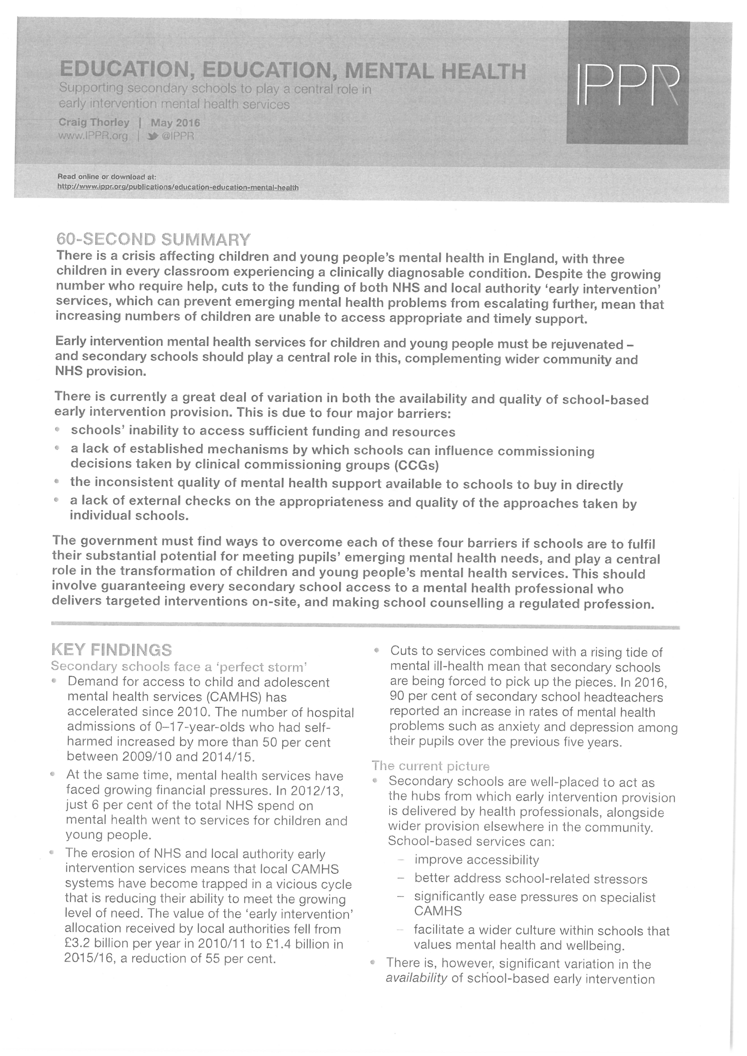

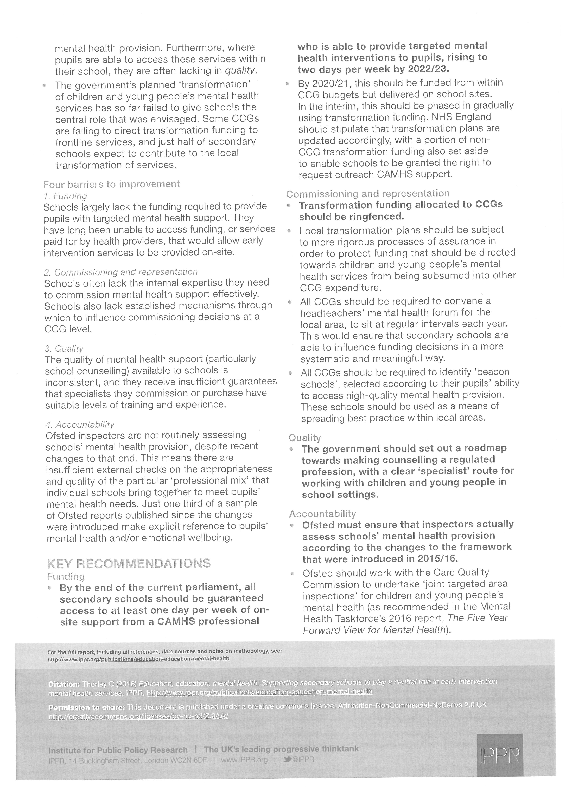

“Because teachers aren’t mental health professionals, nor should we expect them to be. Yet we can’t escape the fact that young people do spend lots of their time in school and so teachers do spot things. Often parents come to teachers to voice concerns about their child too. So it is vital we make it as easy as possible for teachers to interact with CAMHS” https://www.gov.uk/government/speeches/mental-health-pilots-where-next
Future in Mind; https://www.gov.uk/government/publications/improving-mental-health-services-for-young-people

