
Office Use Only, insert amount details for invoice/DD
Primary Denominational School Transport Application Form
Application form for September 2017
Closing date for on-time applications is 30th June 2017
Using BLOCK CAPITALS please COMPLETE and RETURN THIS FORM to the postal address of:
Passenger Transport, Lewis House, Manvers Street, Bath, BA1 1JG
Or scan & email to passenger_transport@bathnes.gov.uk

NB: Please read all terms and conditions before submitting this application.
DO NOT send any money with your application.

I wish to apply for transport to be arranged for my child(ren) under the terms of the Denominational Transport Scheme.
 | Child’s Surname | First Name | DOB | School in September
1.
2.
3.
 | Is there an elder sibling in receipt of subsidised transport to a denominational school (If Yes, please complete child’s details below)
 | Child’s Surname | First Name | DOB | School

Address:
 | Postcode:
Day time Tel No: |  |  |  |  | Email address: |  |  | ________________________________
If you are in receipt of a qualifying benefit you may be entitled to an exemption

Please tick the box if applicable: I am in receipt of a qualifying benefit:
(please also complete the form overleaf)
I certify that the information given on this form is to the best of my knowledge & belief correct. I have read the terms and conditions and I undertake to pay the appropriate fare. I understand that if this fare is not paid, permission to ride will be withdrawn

Signature of Parent/Carer: |  |  |  |  |  |  |  |  | Date:
Name of Parent/Carer
I have attached and signed the Direct Debit mandate: Yes No

I wish to make payment in full: Yes No

Exemption of charges

All pupils in Reception, Year 1 and Year 2 in state funded schools in England qualify for Universal Free School Meals. An exemption of the charges will only be made for children from low income families ie those who are in receipt of a qualifying benefit.
Exemption of the charge/ type of benefit |  |  | Evidence required with this application (if any)
Category A - Maximum Level of Working Tax Credit ( with no reduction due to income) |  |  | Inland Revenue Tax Credit Award Notice (Form TC602) to confirm that you are entitled– please note you must supply the full copy of your current (2016/17) Tax Credit Award notice (Form TC602)
Category B - Eligible by Benefits Based Free School Meals (Not Universal Free School Meals) |  |  | As you are already in receipt of Benefit based free school meals for your child(ren) you will already have submitted necessary documentary evidence and it is therefore not necessary to send in any further copies of your benefits as our existing records will checked.
Category C – Applying for consideration on basis of:-  Income Support,  Income Based only Job Seekers Allowance or  Income Related only Employment Support Allowance |  |  | The Local Authority will check eligible benefits on your behalf. No paper proof of benefit is usually required unless you have made a recent claim. If this is the case and you have paper evidence please forward this with the completed form to speed up your application. Your National Insurance Number and Date of Birth must be completed clearly and accurately on the form as incorrect data will lead to proof of benefit being refused. Alternatively if you prefer you can arrange for an officer of B&NES Council Connect, Job Centre or Benefit Agency to confirm entitlement in the section at the bottom of the previous page
Category C -Applying for consideration on basis of:-  Child Tax Credit (without any Working Tax Credit) and your annual household income (as assessed by HMRC) is below £16,190. |  |  | Provide all pages of your most recent Tax Credit Award Notice (Form TC602).
Category C -Applying for consideration on basis of:-  Pension Credit (Guarantee Element only) |  |  | Provide your most recent Pension Credit (M1000)
Category C -Applying for consideration on basis of:-  Asylum Seeker |  |  | Provide a letter from the National Asylum Support Service that confirms that you are receiving support under part V1 of the Immigration and Asylum Act 1999
Category C -Applying for consideration on basis of:- Universal Credit |  |  | Provide paper proof
Under which category of the fare-paying passenger scheme are you are making this application?
Exemption of Termly Charges (Please tick either Category A, B or C as appropriate)
(A) I am in receipt of Maximum Working Tax Credit (with no reduction due to income). I enclose the requested documentation as mentioned above
(B) I am currently in receipt of Benefit Based Free School Meals (no documents needed but existing records will be checked )
(C) I do not currently receive Benefit Based Free School Meals but I believe I am eligible as I am in receipt of the following benefits. I have read the notes above and am enclosing any requested documentation as appropriate:-
Income Support Income Based only Job Seekers Allowance Income Related only Employment Support Allowance
Child Tax Credit (but without any working tax credit) Pension Credit Support under part VI of the Immigration & Asylum Act 1999 Working Tax Credit run on Universal Credit
 | Surname | First Name |  | Date of Birth | National Insurance Number(see notes)
Parent 1
Parent 2

CONFIRMATION OF BENEFITS
This Certificate must only be completed by an officer of B&NES Council Connect, Job Centre or Benefit Agency
I certify that the above named person is receiving Income Support OR Income Based Job Seekers Allowance OR Income Related Employment Support Allowance  Name:  Signed:  Contact Telephone Number: | OFFICIAL STAMP of B&NES Council Connect, Job Centre or Benefit Agency  Do not use this section to confirm Child Tax Credit or Pension Credit

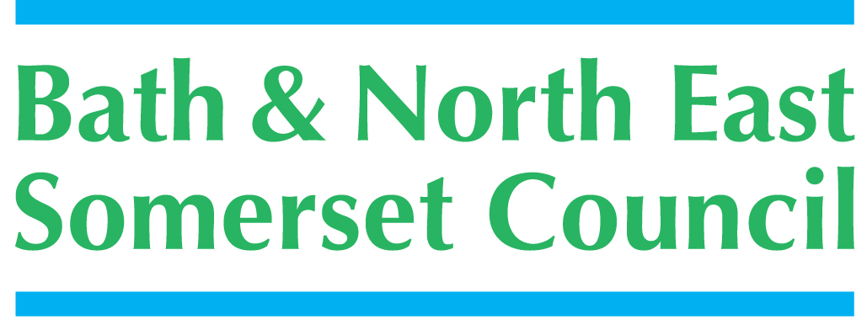 |  | Instruction to your  bank or building society  to pay by Direct Debit
Please fill in the whole form including official use box using a ball point pen and send it to: |  | Service user number

Passenger Transport  Bath and North East Somerset Council  Lewis House  Manvers Street  BATH  BA1 1JG |  |  |  |  |  |  |  |  |  |  |  |  |  |  |  |  |  |  |  | 7 | 6 | 0 | 5 | 8 | 6
FOR BATH & NORTH EAST SOMERSET COUNCIL OFFICIAL USE ONLY
This is not part of the instruction to your bank or building society.

Name(s) of account holder(s)
Bank/building society account number
Branch sort code |  |  |  |  |  |  |  |  |  |  |  |  |  |  |  |  |  |  |  | Instruction to your bank or building society  Please pay Bath & North East Somerset Council Direct Debits from the account detailed in this Instruction subject to the safeguards assured by the Direct Debit Guarantee. I understand that this Instruction may remain with Bath & North East Somerset Council and, if so, details will be passed electronically to my bank/building society.
Name and full postal address of your bank or building society
To: The Manager |  |  |  |  |  |  |  |  | Bank/building society
Address |  |  |  |  |  |  |  |  |  |  |  |  |  |  |  |  |  |  |  | Signature(s)
 |  |  |  |  |  |  |  |  |  | Postcode |  |  |  |  |  |  |  |  |  | Date
Reference
Banks and building societies may not accept Direct Debit Instructions for some types of account
DDI1

This guarantee should be detached and retained by the payer.


The
Direct Debit
Guarantee
- This Guarantee is offered by all banks and building societies that accept instructions to pay Direct Debits
- If there are any changes to the amount, date or frequency of your Direct Debit Bath & North East Somerset Council will notify you 10 working days in advance of your account being debited or as otherwise agreed. If you request Bath and North East Somerset Council to collect a payment, confirmation of the amount and date will be given to you at the time of the request.
- If an error is made in the payment of your Direct Debit, by Bath & North East Somerset Council or your bank or building society, you are entitled to a full and immediate refund of the amount paid from your bank or building society
– If you receive a refund you are not entitled to, you must pay it back when Bath & North East Somerset Council asks you to
- You can cancel a Direct Debit at any time by simply contacting your bank or building society. Written confirmation may be required. Please also notify us.

