BATH AND NORTH EAST SOMERSET

SUSTAINABLE CONSTRUCTION CHECKLIST SUPPLEMENTARY PLANNING DOCUMENT

ADOPTED NOVEMBER 2018
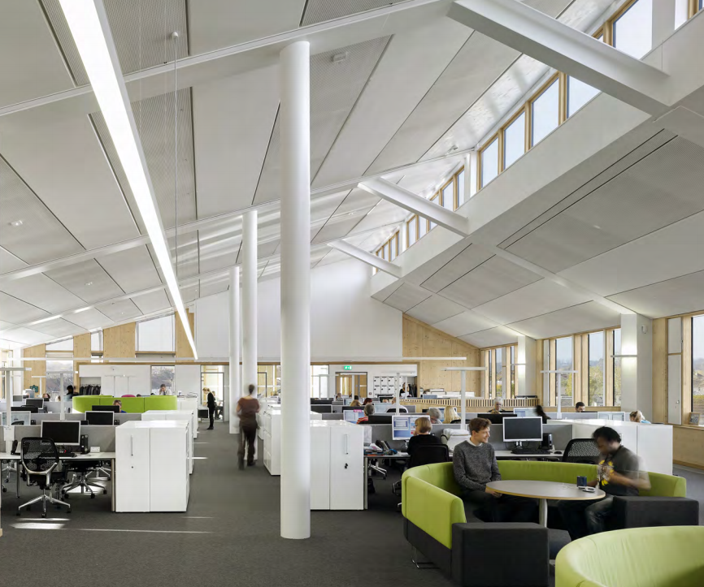

Contents
Contents 2
PART 1: GUIDANCE 3
Background 3
Scope, Definitions and Approach 3
SECTION 1: THE PROPOSAL 4
Tables 1.1 and 1.2 4
SECTION 2: ENERGY EFFICIENCY & RENEWABLE ENERGY 6
Placemaking Plan Energy Policies 6
Tables 2.2, 2.3 and 2.4: General Points 7
Track 1: Major new build developments - Tables 2.2 and 2.3 8
Track 2: Minor new build development - Table 2.4 10
Track 3: Major and medium development on existing buildings - Table 2.4 10
Track 4: Certified Passivhaus - Table 2.4 11
Exemptions 12
SECTION 3: DISTRICT HEATING (Table 3) 13
SECTION 4: WATER (Table 4) 14
SECTION 5: OVERHEATING 15
All Proposals: Table 5.1 15
Large Scale Development: Tables 5.2 to 5.4 16
SECTION 6: SUSTAINABLE CONSTRUCTION (Table 6) 20
SECTION 7: NON COMPLIANCE (Table 7) 21
APPENDIX: DOCUMENTATION EXAMPLES 22
1. Sample Part L output documents: 22
2. Microgeneration Certificate Scheme (MCS) Certificates 23
PART 2: THE CHECKLIST 25
SECTION 1: THE PROPOSAL 25
SECTION 2: ENERGY 28
SECTION 3: DISTRICT HEATING 31
SECTION 4: WATER 33
SECTION 5: OVERHEATING 34
SECTION 6: SUSTAINABLE CONSTRUCTION 38
SECTION 7: NON-COMPLIANCE 39

Cover image: Keynsham Civic Centre, the Council’s award-winning new sustainable office where design was used to deliver exemplary energy performance at no capital cost uplift

PART 1: GUIDANCE
The Guidance below sets out the rationale for the Sustainable Construction Checklist Supplementary Planning Document (SCC SPD) and how the Checklist in Part 2 should be completed.

Background
Environmental sustainability and climate change is a priority for Bath & North East Somerset Council. Our Environmental Sustainability and Climate Change Strategy sets a CO₂ reduction target for the area of 45% by 2029, in line with the government’s legally-binding target to cut national emissions 80% by 2050.
Development plays an important role in meeting this target, by minimising the emissions that cause climate change and future-proofing to cope with the climatic changes that will take place within the buildings’ lifetime. To reflect this, tackling climate change is a cross-cutting objective within the Placemaking Plan.

Scope, Definitions and Approach
Climate Change Policies: The SPD accompanies the key policies in the “Responding to Climate Change” section of the Placemaking Plan. Please review this section in full for complete policy wording and further policies that are not covered by the SPD. Please also refer to our existing Sustainable Construction and Retrofitting SPD for detailed guidance on the building types in our district, including historic buildings. Other aspects of sustainability such as transport, drainage and ecology are handled separately and are outside the scope of this SPD.

Which proposals need to complete the checklist?
- All new build proposals that require Building Regulations Part L certification
- All medium scale proposals or larger for works on existing buildings
- Householder applications are exempt

Definitions of development size used in tables below:
- Large Scale development: 50 dwellings + or 5000m² + of floor space
- Major development: 10 + dwellings or 1000m² + of floor space
- Medium development: 5-9 dwellings or 500m² to 999m² of floor space
- Minor development: 1-4 dwellings or up to 499m² floor space
Two stages of evidence submission: The Checklist and accompanying documentation is to be submitted where required (1) at the application stage in order to register an application and (2) post completion to discharge planning conditions.
Application Stages: The checklist is required in order to register all outline, full or reserved matters planning applications, except reserved matters applications for Access only, since factors relating to sustainability will be addressed in the majority of cases (e.g. building massing, form and orientation may be addressed in many Outline applications). Please see Table 1.2 for which sections to submit and when. We also advise that the checklist is submitted with pre-application proposals.
Change of Use: For change of use proposals, policies are applied to the proposed use. For example, if a non-residential building is being changed into dwellings, the proposal is to meet the requirements for dwellings.
Further documentation: The checklist should accompany documents that provide further detail, such as Sustainability Statements or Energy Strategies. Please reference where further information and drawings can be found.
Checklist Review: The checklist may be periodically updated to reflect changes in legislation, policy and practice.
Queries: Please call Planning Services on 01225 394041 or email development_management@bathnes.gov.uk.

SECTION 1: THE PROPOSAL

Tables 1.1 and 1.2

Table 1.1: The Proposal: Please input details of the proposal, stating the type and size of development and whether it is Large Scale, Major, Medium or Minor. Also note the type of application – if it is an Outline application please state which Matters have been reserved, or if it is a Reserved Matters application, please state which Matter/s the application covers.
Table 1.2: Summary of Checklist Requirements: This table summarises for applicants, planning officers and consultees the documentation required for different development and application types and whether the documentation has been provided.

SECTION 2: ENERGY EFFICIENCY & RENEWABLE ENERGY

Placemaking Plan Energy Policies

  - The SPD sets out the requirements for the two key energy policies:

- Core Policy 2 (CP2): Sustainable Construction: “All planning applications should include evidence that the standards below will be addressed... Maximising energy efficiency and integrating the use of renewable and low-carbon energy”

The SPD sets new benchmarks for demonstrating that energy efficiency has been “maximised” as required by CP2.

- Sustainable Construction Policy 1 (SCR1): On Site Renewable Energy: “Developers of Major proposals above a threshold of 1,000 square metres or 10 dwellings, excluding Industrial B2 and B8 uses, will be required to provide sufficient renewable energy generation to reduce carbon emissions from anticipated (regulated) energy use in the building by at least 10%”.
Energy Policy Requirements

  - The interaction of these policies is illustrated in the figure below:
Track 4
Certified Passivhaus
Track 3
Medium or major: Existing buildings
Track 2
Minor new build
Track 1
Major new build

CP2: 19% CO₂ overall emissions reduction, including…
SCR1: 10% emissions reduction from renewables
Evidence of Passivhaus design process and full certification
CP2 and SCR1: 10% CO₂ emissions reduction from renewables, or energy efficiency if renewables are not suitable for the existing building

CP2: 19% CO₂ emissions reduction from energy efficiency or renewables

  - Table 2.1: Summary of energy strategy: For Outline applications where little detail is known, please state which Reserved Matters applications will address the issues. Each section is to contain 500 words or less, summarising the approach and not simply cross-referencing other documents. Citations of specific documents should be made to provide further detail, e.g. roof layouts for PV, Sustainability Statements etc. If the proposal is not taking one of the approaches listed, please state why.

Tables 2.2, 2.3 and 2.4: General Points

  - Building Regulations Assessments: Policies CP2 and SCR1 address “regulated” emissions – those covered by Part L of the Building Regulations 2013. Applicants are to demonstrate policy compliance through the energy assessment methodology that is already required for Part L compliance. Energy Tables 2.2 and 2.4 require figures from these assessments.

  - Design stage and post-completion assessments documents needed: In line with the two-stage approach, energy tables demonstrating that the policy requirements have been met are to be submitted with the application and again post completion to discharge the condition. Energy tables are to be accompanied by the summary page from the Part L assessment/s to enable verification of the figures quoted in the Table.

  - An accredited independent energy assessor is to model building performance using a modelling tool approved for Part L compliance assessments e.g. the Standard Assessment Procedure (SAP) for residential development or the Simplified Building Energy Model (SBEM) model for non-residential development.

  - This approach means that applicants may need a Part L assessment earlier in the design process than previously. This is to ensure the design maximises energy efficiency gains from “passive design” from elements such as form, glazing and orientation. If these elements are not optimised at the earliest design stage, it becomes a lot harder and more expensive to achieve the energy performance required.

  - Multi- building developments: If the proposal contains a number of buildings types applicants are expected to:

- Demonstrate that a representative building from each building type is policy compliant, since the approach may be different for each type. For example, if a proposal contains large dwellings and small dwellings, non-residential buildings and works to existing buildings, a separate energy assessment and Table is required for a representative of each.

- Confirm in the Table that the site as a whole will be policy compliant, explaining if performance is to be balanced across the site, e.g. if some buildings exceed the policy in order to offset lower performance in other buildings.

During the pre-application process, planning officers can advise on the number of assessments required. Please copy and paste the required number of tables into the same Checklist document so they can be viewed together. Scheme drawings should note which buildings have been selected. If queries arise, the Council may require assessments for other buildings on the scheme.

  - Multiple-unit and mixed use buildings: If a building contains more than one unit e.g. subdivided offices, a terrace or a block of flats, Block Compliance with the policy is to be demonstrated, as would be required by the Building Regulations, e.g. one assessment is to be conducted for the whole building. The same applies to mixed use buildings.

  - Ventilation and Overheating: High energy performance can, and should, result in more healthy and comfortable buildings. However, it must be considered in conjunction with overheating (Section 5) and ventilation to avoid unintended consequences. For example, air tight buildings must be adequately ventilated to prevent occupants having to open the windows in winter and losing energy.

Track 1: Major new build developments - Tables 2.2 and 2.3

  - For Track 1, policies CP2 and SCR1 apply. The interaction of these policies is described below and in the figure overleaf.

  - CP2: A 19% reduction in regulated CO₂ emissions: The benchmark for demonstrating that energy efficiency has been “maximised”, as required by CP2, is an overall 19% reduction in regulated emissions. This is the equivalent of the energy requirement in the Code for Sustainable Homes Level 4.

  - SCR1: 10% emissions reduction through renewables: For major new-build developments, 10% of this overall 19% reduction is to come from renewable energy. For clarity, gas-fired Combined Heat and Power (CHP) is considered a low carbon rather than a renewable energy source so does not count towards the 10% reduction. The calculations for the 10% reduction use a baseline which takes energy reductions from efficiency measures into account, making the 10% proportionally smaller and reducing the requirement for renewables. This “rewards” energy efficient schemes.

  - Table 2.2: Since two policies; CP2 and SCR1 apply, two rounds of energy assessment are needed for Table 2.2:

- First round: Calculate CO₂ reductions from energy efficiency measures only, starting from a baseline of the Target Emissions Rate (TER) to produce a Dwelling Emissions Rate (DER) or Building Emissions Rate (BER) figure to use as the baseline for the second round of calculation. Measures can include mechanical ventilation and heat recovery (MVHR), Waste Water Heat Recovery (WWHR) or low carbon energy such as gas-fired Combined Heat and Power (CHP).

- Second round: Calculate the contribution of renewables by adding the renewable energy measures to the model. This should be at least 10% and the overall emissions should be at minimum 19% less than the TER.

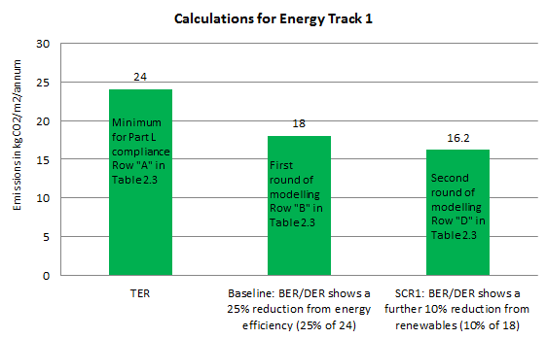
Example of Calculation for Energy Track 1
Overall emissions reduction of c. 33%, exceeding the 19% benchmark

  - Table 2.3: This is to be completed prior to occupation to discharge the planning condition, describing the renewables used and verifying that they are correctly commissions by attaching an MCS certificate for installations of up to 50kW (sample is included in the Appendix).

Track 2: Minor new build development - Table 2.4

  - Minor development is covered by Policy CP2 but not SCR1 so applicants can choose whether to use energy efficiency, low carbon energy or renewable energy to meet the requirement.

  - CP2: A 19% reduction in regulated CO₂ emissions: The benchmark for demonstrating that energy efficiency has been “maximised” as required by CP2 is a 19% reduction in regulated emissions. This is the equivalent of the energy requirement in the Code for Sustainable Homes (CfSH) Level 4.

  - Table 2.4: One energy assessment is required to demonstrate the 19% emissions reduction. A baseline of the Target Emissions Rate (TER) is to be used to produce a Dwelling Emissions Rate (DER) or Building Emissions Rate (BER) figure which is 19% lower than the TER.

Track 3: Major and medium development on existing buildings - Table 2.4

  - Track 3 applies to proposals of a medium scale or above; 5 + dwellings or 500m² + on existing buildings.

  - Existing buildings may have fewer options for improving energy performance and measures should be sensitive to the existing building. To reflect this, the requirements are lower:

- Lower benchmark for CP2: The benchmark for CP2 on medium scale development is lower than for new buildings; 10% compared to 19% for new buildings.

- Energy efficiency can be used on major proposals for SCR1 compliance: Existing buildings may not be suitable for renewable energy. In this case, a 10% reduction in emissions can be achieved through energy efficiency.

  - The reduction in emissions is to be achieved on the area within the planning application only, not the rest of the existing building that is outside the area of the planning application. So, for example, if an extension is being applied for, to an existing building, and the rest of the building is outside the application “red line” then the Checklist would only apply to the extension.

  - Table 2.4: The table should demonstrate a 10% improvement in regulated CO₂ emissions compared to a baseline building that meets the requirements of Part L1B for residential developments and Part L2B for non-domestic buildings. The baseline building/dwelling(s) should be modelled as follows:

- Geometry and space types as per the proposed building
- Building fabric and glazing U-values as per the requirements of Part L2B/Part L1B. Performance of thermal elements or controlled fittings that are not upgraded should be estimated as per the non-domestic EPC Conventions guidance/SAP guidance for existing dwellings
- Air tightness of the building envelope should be estimated as per the non-domestic EPC Conventions guidance/SAP guidance for existing dwellings
- New building services systems as per the minimum requirements of the Non-Domestic Building Services Compliance Guide/Domestic Building Services Compliance Guide
- Retained building services systems as per non-domestic EPC Conventions guidance/SAP guidance for existing dwellings

The proposed building/dwelling(s) should be modelled as the proposed design. Any retained systems or fabric that is not upgraded should have the same performance as the baseline building/dwellings(s).

  - Historic Buildings: Proposals for works to historic buildings will be judged on their own merits, taking into account the significance and character of the building and its setting. All Listed Building Consent applications must provide full details of energy measures including their impact on fabric or building function. Further guidance is provided in the Council’s Sustainable Construction and Retrofitting SPD, including advice on listed buildings.

Track 4: Certified Passivhaus - Table 2.4

  - Proposals certified to the Passivhaus standard for new build or Enerphit for existing buildings will be considered to be compliant with SCR1 and CP2 and do not need to incorporate renewables to address SCR1.

Passivhaus projects use rigorous design and construction to provide a high level of occupant comfort and use very little energy for heating and cooling. Passivhaus buildings have been shown to mitigate the “performance gap” commonly found in new build projects, whereby energy use once occupied is significantly higher than predicted at the design stage.

  - Evidence to be provided: In order to qualify for Track 4, full applications or Outline/ Reserved Matters applications for Appearance and Layout are to be accompanied by

- Sign-off documentation from a Passivhaus Certifier (as opposed to a Passivhaus designer) confirming that the design is Passivhaus compliant.

- A written statement signed by the developer and the Passivhaus certified designer working on the scheme confirming that Passivhaus professionals will be employed throughout the development process and that the scheme will be able to achieve full certification.

- A summary output document from the Passivhaus Planning Platform (PHPP) software indicating that the design is Passivhaus compliant at this stage of development.

- A completed Table 2.4 as per the methodology for Track 2 and supporting part L documents, which should show that emissions reductions are sufficient to achieve the 19% CO2 reduction benchmark for Policy CP2.

  - There are a range of Passivhaus standards and these may change. During the pre-application process, planning officers can advise on which of these will qualify for Track 4.

  - If a multiple-building proposal contains some units that are to be certified to Passivhaus and some that aren’t, those that are not to be certified will need to meet the usual requirements of the Energy Tracks above.

  - Achievement of Passivhaus certification will be conditioned, to be discharged by submission of a Passivhaus certification document prior to occupation.

  - If Passivhaus certification is not achieved upon completion, the benchmarks set for SCR1 and CP2 in the other Tracks are to be met in order to discharge the condition.

Exemptions

  - Our studies have shown that B2 and B8 industrial uses may find it more difficult to increase energy performance, so no benchmarks are set for these uses. Applicants are still required to maximise energy performance, in line with CP2, so will need to complete Table 2.1.

SECTION 3: DISTRICT HEATING (Table 3)

  - Background: District heating can reduce CO₂ emissions by using a renewable or low carbon heat source.

  - Placemaking Plan Policy CP4 - Table 3: Below are excerpts from the Policy CP4:

Development within Heat Network Priority Areas “will be expected to incorporate infrastructure for district heating, and will be expected to connect to existing systems where and when this is available, unless demonstrated that this would render development unviable”.

For development in these Priority areas, full compliance with CP4 is required, as set out in Table 3.

“Development within the Heat Network Opportunity Areas will be encouraged to incorporate infrastructure for district heating, and will be expected to connect to any existing suitable systems (including systems that will be in place at the time of construction), unless it is demonstrated that this would render development unviable”.

For development in the Opportunity Areas, we expect to see consideration of heat networks as set out in Table 3.

  - Maps: To determine if policy CP4 applies, please check the GIS layers on the Council’s My Maps application; these maps may change as our evidence base is refined. These maps replace the “yellow circle” demarcations of Heat Network Priority Areas that are shown in the Placemaking Plan (p72 and 73). The yellow circles representing Heat Network Opportunity Areas in the Placemaking Plan can still be used.

  - Table 3: CP4 only covers relatively limited areas. In light of this, guidance for the completion of Table 3 is contained in the accompanying “Heat Networks Guidance Note”.

  - Development type/ scale: Whilst all scales of development in the Heat Network areas are expected to consider heat networks, it is understood that heat networks may be unfeasible for some developments e.g. individual dwellings or refurbishments of small non-residential units. In these cases, please provide an explanation in Question 13.

SECTION 4: WATER (Table 4)

  - Efficient use of water is important now and will become increasingly crucial as the climate changes.

  - Policy SCR5: Water Efficiency states that:

- All dwellings will be expected to meet the national optional Building Regulations requirement for water efficiency of 110 litres per person per day;
- Rainwater harvesting or other methods of capturing rainwater for use by the residents (e.g. water butts) will be required for all residential development, where technically feasible

  - Table 4: Water: Full applications or Outline/ Reserved Matters applications applying for Appearance for residential proposals are to complete Table 4. Mixed use proposals should provide an assessment for the residential element of the scheme.

  - Major residential applications are to attach either

- The outputs of a Part G Water Calculator (widely available online) to illustrate the water efficiency strategy and demonstrate that the standard has been met OR
- If the “fittings” approach is being taken to Part G compliance, to state that the consumption of fittings will not exceed the requirements in the table for the 110 litre “Optional standard” in the Part G document.

  - Pre-applications are encouraged to provide an outline of their approach to water efficiency in the narrative section of the table.

SECTION 5: OVERHEATING

All Proposals: Table 5.1

  - Climate change is already causing overheating and this is likely to worsen over the lifetime of the buildings as per the chart above. Globally, the average surface temperature has risen about 0.9 degrees Centigrade since the late 19th century, a change driven largely by increased carbon dioxide and other human-made emissions into the atmosphere. For the UK as a whole, summer 2018 was the joint hottest on record together with 2006, 2003 and 1976.The design of buildings should ensure comfortable conditions for future occupants without relying on carbon intensive air conditioning. Policy CP2 states that all proposals should have “consideration of climate change adaptation” and overheating is a major element of this. All proposals are to respond to overheating, with specific performance benchmarks for Large Scale development.

  - Table 5.1: Overheating mitigation strategy: Full applications or Outline/ Reserved Matters applications for Appearance are to include Table 5.1 stating how the Cooling Hierarchy has been implemented. The table contains examples of measures for the following approaches:

- Minimising internal heat generation through energy efficient design
- Reducing the amount of heat entering the building in summer
- Use of thermal mass (when carefully designed) and high ceilings to manage the heat within the building
- Passive ventilation
- Mechanical ventilation

  - Overheating should be considered alongside other design criteria. Proposals should respond to their context and the measures set out in Table 5.1 will not be suitable in all cases. We expect to see the optimisation of measures that do not increase CO₂ emissions as opposed to active cooling e.g. air conditioning.

Large Scale Development: Tables 5.2 to 5.4

  - CIBSE Assessment: Large Scale new-build development (50 dwellings + or 5000m² + of floor space) is encouraged to show leadership in tackling overheating.

  - The compliance tools for Building Regulations are not intended to accurately evaluate overheating, so Large Scale proposals are to use the more sophisticated CIBSE standards TM52 for non-residential development and TM59 for residential development.

  - Assessment to be conducted at the application stage and again to discharge the condition: It is acknowledged that overheating modelling at the pre-planning stage may not reflect the details of the final design or completed building/s and may rely on proxy figures. However, checking modelling outputs at the application stage is the most robust way for the Council to determine whether the design will in principle meet the benchmark. Once the initial modelling has been submitted with the application, further modelling is not expected until post-completion condition discharge, however we recommend that applicants re-run the modelling if there are major design changes during the planning process to ensure the design will still address overheating.

  - The CIBSE methodologies use the criteria below:

- TM59 & TM52: “Hours of Exceedance”, a measure of how often the temperature exceeds a threshold comfort temperature during a typical warm season, and sets a limit of 3% of occupied hours.
- TM52: “Daily Weighted Exceedance”; the severity of overheating within any one day. The limit is no more than 6 hours a day above the thermal comfort threshold.
- TM52: “Upper Limit Temperature” which sets an absolute maximum temperature for a room beyond which the level of overheating is unacceptable.

  - Multiple Buildings: Proposals with multiple buildings are to assess a representative sample of each building type. For apartment buildings this could be a representative sample of dwellings within the apartment block. Please consult with an officer during the pre-application process about how many assessments are needed.

  - Current and future climate scenarios: Since the buildings constructed today will still be occupied in 2050, it is important to consider how buildings will perform under future conditions. The CIBSE assessment should be run twice with the following data files/ scenarios:

- Current Climate: CIBSE Design Summer Year (DSY1) for the 2020s, high emissions, 50th probability scenario (Swindon data should be used for this and all other modelling using CIBSE files).

- Future Climate: 2050 files, medium emissions, 50th probability scenario. Applicants can select whether to use the CIBSE 2050 data files or those available from the PROMETHEUS project or its successor, Project COLBE which use climate change models and will shortly be available at a 5km grid resolution, including for Bath.

  - Policy benchmark: Large-scale development will be expected to meet the CIBSE TM59 or TM52 standard for the 2020s scenario (CIBSE DSY1), showing that active cooling is not needed for comfort in the current climate.

  - We expect most residential development to achieve a “pass” for the current climate, and most non-residential development also, unless there are exceptional circumstances, e.g. a deep-plan office building. If the proposal cannot achieve a pass without active cooling, Table 5.4 “Active Cooling” is to be used. It is understood that the future climate scenarios are more difficult. If a pass is not possible, applicants are asked to state how the building could be modified to address overheating in the future, preferably without air conditioning.

  - Table 5.2: Overheating in residential development: Large residential proposals of 50 units or more should conduct the assessment for CIBSE TM59 “Design methodology for the assessment of overheating risk in homes”. Outputs are to be used to complete Table 5.2. The CIBSE assessment is to be undertaken on a baseline building with no active cooling, to demonstrate that passive measures have been maximised. As noted above, two assessments are to be undertaken, for the current and future climate respectively.

  - Table 5.3: Overheating in non-residential development: Large non-residential proposals of more than 5000m² are to use the methodology in CIBSE TM52 “The Limits of Thermal Comfort: Avoiding Overheating in European Buildings”. Modelling should be conducted for the part of the building that has the greatest risk of overheating as per the CIBSE methodology. The CIBSE assessment is to be undertaken on a baseline building with no active cooling, to demonstrate how passive measures have been maximised.

  - Policy benchmark: Meet the CIBSE standard in the current climate: Proposals are to achieve a “pass” for the current climate, meeting criteria A and B (hours of exceedance in living rooms, kitchens and bathrooms and hours of exceedance in bedrooms).

  - Table 5.4: Active Cooling: For some large proposals (e.g. offices with deep floorplates) active cooling may be needed and may be a more energy efficient way to meet the requirements of TM52 (e.g. when compared to increasing non-cooled airflow). If this is shown to be the case, active cooling systems that exceed the requirements of Part L are to be used.

  - To verify compliance, the Part L output report’s ‘HVAC Systems Performance’ table is to be attached. This compares the cooling demand of the actual and notional buildings for different building elements. Applicants should reduce the actual cooling demand below that of the notional Part L compliant cooling demand for each of the non-domestic spaces in the development where an active cooling load exists. This may mean that more than one table is completed.

  - The results should be used to complete Table 5.4 and the output document from the Part L assessment containing the HVAC Systems Performance table is to be attached to the application.

  - Exemptions: Large proposals are expected to conduct an assessment as above unless the applicant can demonstrate exceptional circumstances where opportunities for reducing cooling demands via passive measures are constrained, for example industrial buildings including warehouses used for storage purposes; supermarkets; cinemas or theatres; laboratories or temporary structures. In such cases, the exemption should be stated in “Non-Compliance” Section 7 with reference to this paragraph.

  - In the case of query during the application process, the full written report using the CIBSE methodology including modelling outputs, or direct contact with modelling personnel may be required for verification.

SECTION 6: SUSTAINABLE CONSTRUCTION (Table 6)

  - Background: CP2 sets out requirements for aspects of sustainable construction that are more difficult to verify through a standard methodology e.g. a part L Assessment for energy or a CIBSE Overheating Assessment. Compliance with these requirements will be assessed on a case-by-case basis.

  - Table 6: Sustainable Construction: Full applications or Outline/ Reserved Matters applications for Appearance are to complete this table to demonstrate how they have responded to the issues in Policy CP2 listed in bold below. Links to suggested approaches to are provided:

  - Minimisation of waste and maximising of recycling of any waste generated during construction and in operation: Production of a Site Waste Management Plan (SWMP) in line with WRAP guidance can enable the best use to be made of waste materials produced during construction. The Home Quality Mark provides useful criteria for designing waste and recycling facilities for domestic properties, the BREEAM criteria for waste can inform non-domestic projects.

  - Efficiency in materials use, including the type, life cycle and source of materials to be used: A review of how the environmental impact of materials is assessed is provided by the UK Green Building Council. For the impact of particular materials, please see the Building Research Establishment’s (BRE) Green Guide to Specification. For example, applicants could commit to using only materials rated “A” or “B” on the Green Guide.

  - Flexibility and adaptability, allowing future modification of use or layout, facilitating future refurbishment and retrofitting: The principles of Lifetime Homes can be followed, enabling buildings to adapt to be suitable for occupants at all life stages and be adaptable for future uses.

  - Consideration of climate change adaptation: A review of measures to adapt to the changing climate is provided in the Technology Strategy Board’s document “Designing for Future Climate”. Water and overheating are considered separately in the Checklist.

SECTION 7: NON COMPLIANCE (Table 7)

  - We expect development to be able to meet the benchmarks above. Local and national evidence indicates that this is achievable within viability constraints.

  - If non-compliance with any of the Sustainability requirements above is proposed, please complete Table 7. A full open-book viability test or technical rationale may be required, in which case the applicant is likely to be required to pay the cost for an independent review of the evidence submitted as the basis for non-compliance.

  - In the case of proposed non-compliance, the Checklist is to be completed in full, stating clearly which sections are non-compliant and why.

APPENDIX: DOCUMENTATION EXAMPLES

Sample Part L output documents:

Where Part L documents are required the TER and BER/DER should be clearly displayed on the output documents as illustrated below.

- SAP summary for dwellings
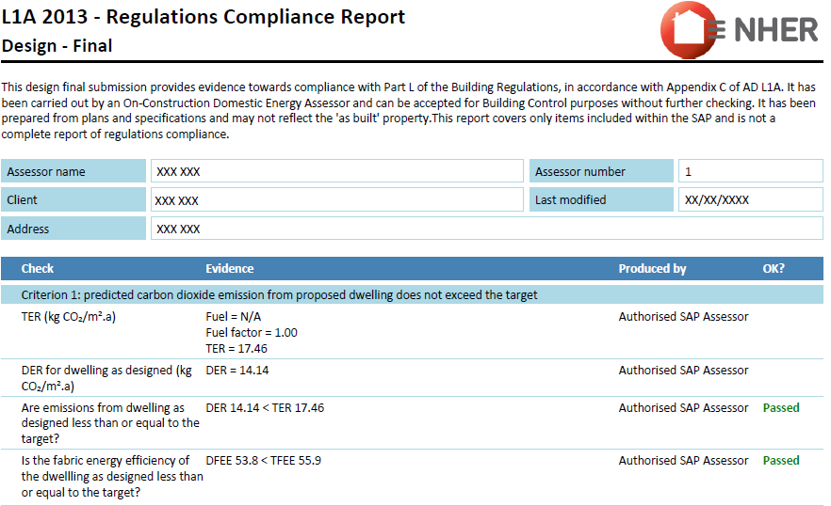
Below is an excerpt from a sample Part L document with the TER and BER/DER circled:

Sample Calculations
To meet the CP2 benchmark for new build, the DER figure above (14.14) must be 19% lower than the TER figure (17.46). The calculation is therefore:

17.46- 14.14 = 3.32
3.32 / 17.46 x 100 = 19.01
= 19.01 %

So this example meets the CP2 benchmark.

- BRUKL summary for non-residential

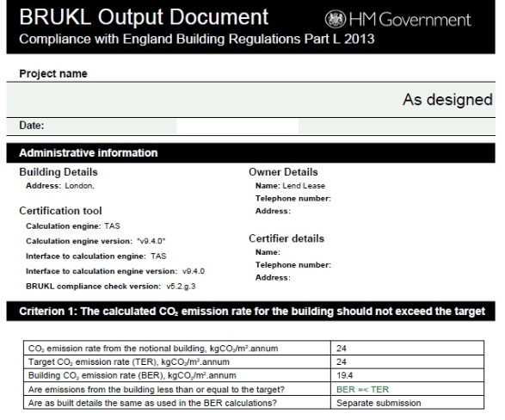

Sample Calculations
To meet the CP2 benchmark for new build, the BER figure above (19.4) must be 19% lower than the TER figure (24). The calculation is therefore:

24 - 19.4 = 4.6
4.6 / 24 x 100 = 19.16
= 19.16 %

So this example meets the CP2 benchmark.

Microgeneration Certificate Scheme (MCS) Certificates

An MCS Certificate is produced by the renewable energy installer stating that the equipment is live and connected (example below). It has the necessary detail to verify the information provided in Energy Table 2.
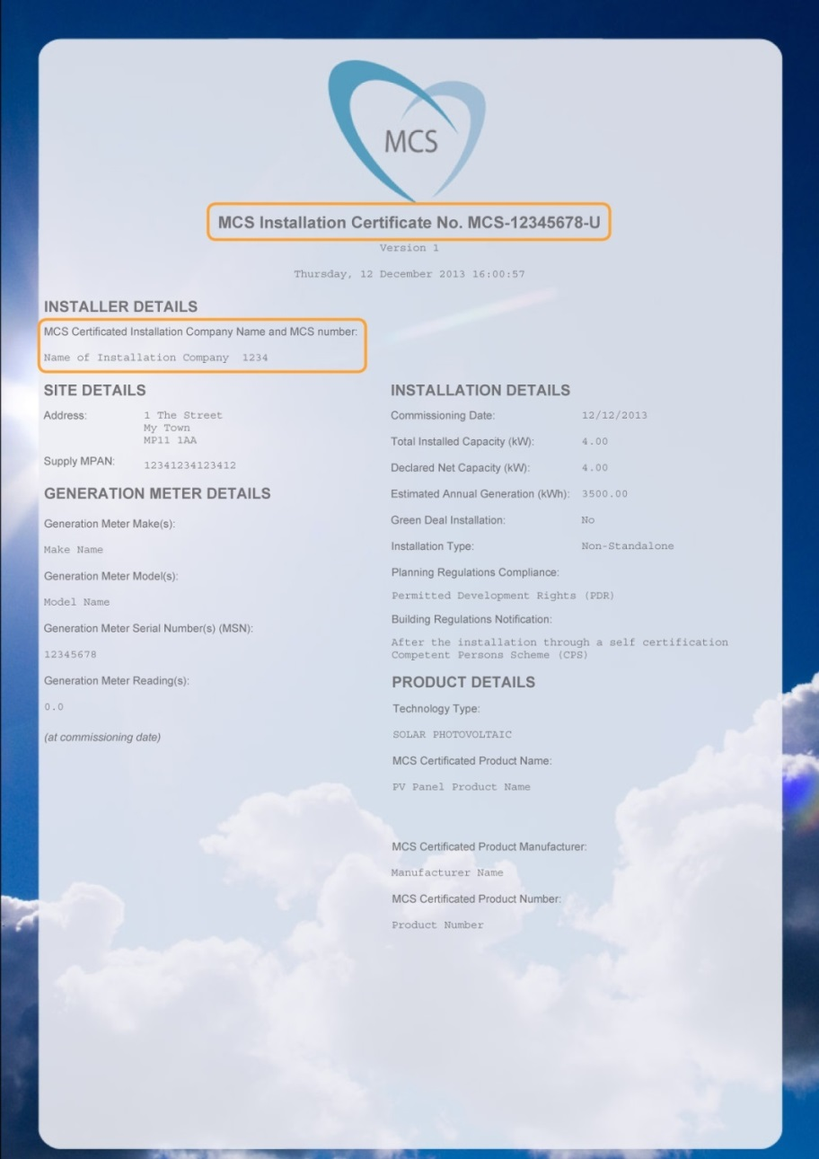

PART 2: THE CHECKLIST

Which proposals need to complete the checklist?
- All new build proposals that require Building Regulations Part L certification
- All proposals for works on existing buildings that have 5 or more dwellings or 500m² or more within the red line.
- Householder applications are exempt.

Definitions of development size for use in tables below:
- Large Scale development: 50 dwellings + or 5000m² + of floor space
- Major development: 10 + dwellings or 1000m² + of floor space.
- Medium development: 5-9 dwellings or 500m² to 999m² of floor space.
- Minor development: 1-4 dwellings or up to 499m² floor space.

SECTION 1: THE PROPOSAL

TABLE 1.1: THE PROPOSAL

Required for: All applications within the scope of the Checklist

Name of Proposal
Brief description e.g. residential, commercial, and size | [Insert text here]
Type of application e.g. Pre-Application, Outline, Full, Condition Discharge, Reserved Matters (noting Matters Reserved) | [Insert text here]
Tick if the application is a Reserved Matters application for Access | ☐Tick here – no further information required to accompany this application

TABLE 1.2 SUMMARY OF CHECKLIST REQUIREMENTS

SECTION 2: ENERGY
Applies to: Full applications or outline applications and post completion to discharge condition. Please note multi-building developments may need more than one table per track to represent all building types.

Track | Development Type: Tick to indicate which development type/s your proposal contains | The boxes below indicate requirements at the different planning stages. Please tick to indicate completion.
 |  | Outline or reserved matters applications if not applying for Appearance | Full applications OR  Outline or reserved matters applications applying for Appearance | All applications for discharge of post-completion Conditions
Track 1 | ☐ Major new build residential development  ☐ Major new build non-residential development | ☐ Table 2.1: Summary of Energy Strategy | ☐ Table 2.1: Summary of Energy Strategy  ☐ Table 2.2: Calculations  ☐ Part L design stage document/s for energy efficiency measures  ☐ Part L design stage document/s for energy efficiency and renewable energy measures | ☐ Table 2.2 Calculations  ☐ Table 2.3: Renewable Technologies for Track 1  ☐ Part L post-completion document/s for renewables  ☐ Part L post completion document/s for energy efficiency  ☐ MCS Certificate/s
Track 2 | ☐ Minor new build residential development  ☐ Minor new build non -residential development | ☐ Table 2.1: Summary of Energy Strategy | ☐ Table 2.1: Summary of Energy Strategy  ☐ Table 2.4 Calculations  ☐ Part L design stage document/s | ☐ Table 2.4 Calculations  ☐ Part L post completion document/s
Track 3 | ☐ Major or medium works to existing buildings | ☐ Table 2.1: Summary of Energy Strategy | ☐ Table 2.1: Summary of Energy Strategy  ☐ Table/s 2.4 Calculations  ☐ Part L design stage document/s | ☐ Table 2.4 Calculations  ☐ Part L post completion document/s
Track 4 | ☐ Passivhaus | ☐ Table 2.1: Summary of Energy Strategy | ☐ Table 2.1: Summary of Energy Strategy  ☐ Statement from Passivhaus Certifier, designer and summary of outputs from design stage PHPP  ☐ Table/s 2.4  ☐ Part L design stage document/s | ☐ Table 2.4  ☐ Part L post completion document/s  ☐ Passivhaus certification
Exempt | ☐ Industrial B2 or B8 uses: Table 2.1: Summary of Energy Strategy only, no calculations required
SECTION 3: DISTRICT HEATING
Applies to: Full applications or outline/ reserved matters applications for appearance within a Heat Network Area. May be required post-completion to discharge a condition.

☐ Proposal is within Bath or Keynsham Heat Network Priority Area
☐ Relevant sections of Table 5 completed and documentation attached where requested
☐ Proposal is within a Heat Network Opportunity Area
☐ Relevant sections of Table 5 completed and documentation attached where requested
☐ Proposal is not within a Heat Network Priority or Opportunity Area (no tables or documentation required)
SECTION 4: WATER
Applies to: Full applications or outline/ reserved matters applications for Appearance for residential development and for post-completion condition discharge
☐The proposal is, or contains elements of, residential development
☐Table 4 has been completed and supporting documentation attached as required
☐The proposal is wholly non- residential (no tables or documentation required)
SECTION 5: OVERHEATING
Applies to: Full applications or outline/ reserved matters applications that address appearance. Please tick below to confirm that the correct tables have been completed and evidence attached where needed. These tables may also be required post-completion for discharge of conditions.
☐The proposal is Large Scale Residential (50 dwellings +)
☐Table 5.1
☐Table 5.2: Modelling cover sheets for “current climate” and “future climate” are attached
☐The proposal is Large Scale Non-Residential (5000m² + of floor space to be created)
☐Table 5.1
☐Table 5.3: Modelling cover sheets for “current climate” and “future climate” are attached
☐The proposal is Large Scale and using Table 5.4: Active Cooling
☐Table 5.1
☐Table 5.4: Part L “HVAC Systems Performance” table is attached
☐The proposal is smaller than Large Scale
☐Table 5.1 only

SECTION 6: SUSTAINABLE CONSTRUCTION
Required For: All full applications or outline/ reserved matters applications.
☐Table 6

SECTION 2: ENERGY

TABLE 2.1: SUMMARY OF ENERGY STRATEGY

All required sections are to be completed in 500 words or less per section. A summary is to be provided of the approach, not simply a reference to other documents, although additional detail should be signposted via references to named documents and drawings. Outline applications should state if reserved matters applications will contain further detail.

1 & 2 below required for all applications, inc. outline applications where appearance is Reserved
- Passive design e.g. building form, orientation and shading, including orientation of roofs to maximise solar energy potential. Please note - this is an important consideration for Layout, so applications covering Layout should provide a full explanation of the approach.
[Insert text here]

- Renewable and low carbon energy e.g. solar energy, biomass, heat pumps, solar thermal, heat networks and Combined Heat & Power (CHP). Please cite any drawings of renewable/low carbon technology.
[Insert text here]

3- 7 below required for Full or Reserved Matters applications for Appearance
- Energy efficiency e.g. materials with high energy performance (lower U values than required by Part L), minimisation of thermal bridging, appliances, insulation, low energy fixtures, heat recovery e.g. Mechanical Ventilation with Heat Recovery (MVHR), Waste Water Heat Recovery (WWHR)
[Insert text here]

- Heating, cooling and hot water e.g. air source heat pumps, responsive heating controls, underfloor heating, WWHR, MVHR
[Insert text here]
- Ventilation and indoor air quality e.g. airtightness performance, natural or mechanical ventilation, windows, use of low Volatile Organic Compound (VOC) materials. Where wood burners are to be used, comment on the mitigation of impacts on external and internal air quality. Note how the building will be ventilated in winter other than by opening windows if a high airtightness target is proposed.
[Insert text here]

- Thermal Bridging reduction: Please list in further detail the ways in which thermal bridging will be minimised.
[Insert text here]
- Energy Performance Gap: Please note how the Performance Gap will be addressed both during and after construction, e.g. as required by the Soft Landings process:
- Construction management practices
- Aftercare and post-occupation measures to ensure correct commissioning (including seasonal commissioning) and thorough handover
- Post-occupation performance monitoring to record whether targets are met in-use.
[Insert text here]

- Smart infrastructure e.g. smart meters and appliances, energy storage, electric vehicle charging, building management systems.
[Insert text here]
TABLE 2.2: CALCULATIONS FOR TRACK 1

Required for:
- Full applications or outline/ reserved matters applications for Appearance
- To discharge the condition prior to occupation

For multiple building proposals, please state which building is being assessed, the reason for selecting this building as an example of building type, and a reference to where the building can be found on the drawings. |  | [Insert text here]
For multiple building developments, please highlight Yes or No to indicate whether the proposal as a whole will meet the benchmark for Energy Track 1 and how; e.g. if some buildings will have lower energy performance but be offset by others with higher performance. |  | Yes/No (please underline)  [Insert text here]
A | Baseline emissions |  | kg CO₂/m²
B | Emissions after Energy Efficiency and Low Carbon measures (baseline for SCR1 compliance) |  | kg CO₂/m²
C | % CO₂ reduction from Energy Efficiency measures only (A-B)/A*100 |  | %
D | Emissions after Renewables are added to the Energy Efficiency Measures |  | kg CO₂/m²
E | Further % CO₂ reduction from Renewables only.  At least 10% to comply with SCR1 (B-D)/B*100 |  | %
F | CO₂ savings from all measures- Renewable and Energy Efficiency |  | kg CO₂/m²
G | % CO₂ reduction from all measures.  At least 19% to comply with CP2 (A -F)/A*100 |  | %
☐ Please tick to confirm that the two sets of design stage or post-completion Part L SAP/SBEM summary documents are attached. This is required for registration of the application:

- The reduction in CO₂ from energy efficiency measures only (C)
- The overall reduction once renewables are added (G)

Name of independent accredited assessor conducting the assessment: [Insert text here]

TABLE 2.3: RENEWABLE TECHNOLOGIES FOR TRACK 1

Required for: Post-completion condition discharge

Technology type (e.g. PV, solar thermal, biomass) | Description | Capacity from this technology (kW) | Estimated annual generation (kWh) | Total CO₂ saving from this technology (kg CO₂/m²)
Sample: Solar PV | 28m² of 345W PV panels, 16% efficiency | 3kWp | 2550 kWh | 1045
[add lines as needed]
TOTAL
☐ Please tick to confirm that the MCS Certificate is attached showing that the renewable technologies cited in this table have been installed and are operational (for installations of up to 50kW). This is required for discharge of the condition.

TABLE 2.4: CALCULATIONS FOR TRACKS 2, 3 AND 4

Required for: Full applications or outline/ reserved matters applications for Appearance and for post-completion condition discharge
For multiple building proposals, please state which building this is an assessment for; the reason for selecting this building as an example of building type, and a reference to where the building can be found on the drawings. |  | [Insert text here]
For multiple building developments, please highlight Yes or No to indicate whether the proposal as a whole will comply with Energy Track 1 and note how; e.g. if some buildings will have lower energy performance and be offset by others with higher performance. |  | Yes/No (please underline)  [Insert text here]
A | Baseline emissions |  | kg CO₂/m²
B | Emissions after All Measures (Renewables plus Energy Efficiency Measures) |  | kg CO₂/m²
C | Tracks 2 and 4: Percentage CO₂ reduction from all measures should be at least 19% (A-B)/A*100 |  | %
 | Track 3: Percentage CO₂ reduction from all measures should be at least 10% (A-B)/A*100 |  | %
☐ Please tick to confirm that design stage/post-completion SAP/SBEM Part L summary documents are attached. This is required for registration of the application:
Name and company of accredited independent assessor: [Insert text here]

SECTION 3: DISTRICT HEATING
TABLE 3: DISTRICT HEATING

Required for: Full applications or outline/ reserved matters applications for Appearance within a Heat Network Priority Area or Heat Network Opportunity Area. Pre-applications are encouraged to respond to questions 1 - 5. See Section 3 of the Guidance and the separate “Heat Networks Guidance Note” for further detail and types and scales of development that may be considered for exemption.

1 | Is the proposal in a Heat Network Priority Area? | Yes | No
2 | Is the proposal in a Heat Network Opportunity Area? | Yes | No
If “Yes” to Question 1 (Priority Area), at least one of Questions 3-5 must also be a “Yes”

If “Yes” to Question 2 (Opportunity Area), please complete the table. If Questions 3-5 are “No” please explain further in Question 13.

3 | Does the proposal include a heat network? If “Yes” please complete question 8. | Yes | No
4 | Does the proposal include connection to an existing heat network? If “Yes” please complete question 8. | Yes | No
5 | Is the proposal future-proofed to connect to future heat networks? If so, the answer to Questions 9- 12 should be “Yes” | Yes | No
6 | If the proposed development is in proximity to an existing district heating scheme (e.g. Bath Western Riverside), has the incumbent district heating operator been contacted to discuss the potential for connection to the existing network? Proof of contact with the operator may be required. | Yes | No
7 | If the proposed development is a large scale multi-building development (e.g. over 500 residential units and/or over 10,000m² of non-residential floor space – in particular with hotels, hospitals, leisure centres or student residences), has an open-book viability assessment for district heating been carried out and full report attached? | Yes | No
8 | If a heat network or connection to a heat network is proposed, has a document providing further details been attached? Please reference below.  If a fossil-fuelled heat source is proposed please summarise below the strategy for switching to a renewable heat source in the future. Where a mix of energy sources is being proposed e.g. biomass with backup gas boilers, please explain how it will be ensured that post-occupation the energy mix will be as is stated in the Checklist (e.g. not just using the backup gas boilers). | Yes | No
 | [Insert text here]
Future Proofing
9 | Single heat source: If the development includes residential apartment buildings, is heating provided to the apartments from a single central heat source as opposed to heating plant for individual units? Please explain in Question 13 if the answer is “no”. | Yes | No
10 | Protected Pipe Routes: (a) Has a potential intake route for district heating pipe to the building(s) been identified and safeguarded? (b) Have the pipe routes been safeguarded to connect from the building plant room to the route of the district heating network? Enterprise Area applications please reference the “Potential District Heating Cluster” map in the Heat Networks Guidance Note. Please note below the document and page number containing the drawing/s upon where these measures are identified. | Yes | No
 | [Insert text here]
11 | Plant room location: Is the heating plant room(s) in a location that allows access for district heating pipe (e.g. located on ground floor, adjacent to public highway) Please note below the document and page number containing the drawing/s upon where these measures are identified. | Yes | No
 | [Insert text here]
12 | Plant room design: Does the plant room design allow for future connection e.g. space allowed for installation of a plate heat exchanger and additional plant as required? Please note below, including summary calculations for space allocated, and reference the document and page number showing where this is included in drawings. | Yes | No
 | [Insert text here]
13 | Please add any further information
 | [Insert text here]

SECTION 4: WATER

TABLE 4: WATER

Required for: Full applications or outline/ reserved matters applications for Appearance for residential development, or the residential element of a mixed use scheme. Pre-applications within this scope are encouraged to provide a summary of the approach in the box below. See Section 4 of the Guidance for details.

Outline below the approach to water efficiency e.g. greywater or rainwater harvesting, low-flow rate sanitary ware and white goods

[Insert text here]

Please tick both boxes below to confirm compliance
☐ The 110 litres per person per day requirement will be met

☐ Rainwater harvesting or other methods of capturing rainwater for use by the residents (e.g. water butts) has been included

Please tick one of the boxes below to confirm compliance

☐ If the Water Calculator approach to Part G compliance has been taken, please attach the output from an accredited Part G water calculator, demonstrating compliance with the 110 litre “Optional Standard” This is required for registration of the application. OR

☐ If the “fittings” approach to Part L compliance is being used, please tick here to confirm that fittings will not exceed the consumption levels set out in the table for the 110 litre standard in the Part G document.

SECTION 5: OVERHEATING

TABLE 5.1: OVERHEATING MITIGATION STRATEGY

Required for: Full applications or outline/ reserved matters applications that address appearance. Encouraged for pre-application proposals. See Section 5 of the Guidance for details.

Please describe how the Cooling Hierarchy has been followed. All sections are to be completed giving a summary of the response to the issue and cross-referencing where further detail can be found, in 500 words or less per section.

Minimising internal heat generation through energy efficient design: For example, passive design that minimises solar gain on south facing facades in buildings likely to overheat e.g. offices; heat distribution infrastructure within buildings should be designed to minimise pipe lengths, particularly lateral pipework in corridors of apartment blocks, and adopting pipe configurations which minimise heat loss e.g. twin pipes.

[Insert text here]

Reducing the amount of heat entering the building in summer: For example, through use of carefully designed shading measures, including balconies, louvres, internal or external blinds, shutters, careful planting of trees and vegetation to provide shade. Please also state the glazing ratios.
[Insert text here]

Use of thermal mass and high ceilings to manage the heat within the building: When carefully designed, exposed thermal mass (dense materials that can absorb and release heat slowly) can help to absorb excess heat within the building. Please cite floor to ceiling heights.

[Insert text here]

Passive ventilation: For example, through the use of openable windows, cross-ventilation, dual aspect units, designing in the ‘stack effect’

[Insert text here]

Mechanical ventilation: Mechanical ventilation can be used to make use of ‘free cooling’ where the outside air temperature is below that in the building during summer months. If MVHR is used, please confirm that there is a by-pass on the heat recovery system for summer mode operation.

[Insert text here]

TABLE 5.2: OVERHEATING IN RESIDENTIAL DEVELOPMENT – CIBSE TM59
Required For: Full applications or outline/ reserved matters applications for Appearance for large scale residential proposals. The proposal should achieve a “pass” in the current climate scenario to comply with CP2 and set out an overheating future proofing scenario in Table 5.4
Zone Name and Room Use |  | Criterion A: Hours of exceedance for living rooms, kitchens and bedrooms |  |  |  |  | Criterion B: Hours of exceedance for bedrooms only |  |  |  |  |  |  |  |  |  | Result  To meet the bench  mark, Criteria A & B to be met for current climate
 |  | A. Occupied Hours |  | B.  Max. no. hours exceedance (3% occupied hours) |  | C. Calculated No. hours exceeding Comfort Range – Not to exceed “B” |  |  |  | D.  Annual Night time occupied hours |  |  |  | E.  Max. no. hours exceedance (1% occupied hours) | F.  Calculated no. hours exceeding Comfort Range – Not to exceed “E”
Example: Bedroom 1 |  | 3,672 |  | 110 |  | 90 |  |  |  | 3285 |  |  |  | 32 | 25 |  | Pass ☒
Example: Living room |  | 1,989 |  | 59 |  | 40 |  |  |  | n/a |  |  |  | n/a | n/a |  | Pass ☒
CURRENT CLIMATE - CIBSE DSY1. Results expressed in hours
[Add rows as needed] |  |  |  |  |  |  |  |  |  |  |  |  |  |  |  |  | Pass ☐
FUTURE CLIMATE: Results expressed in hours
Add rows as needed] |  |  |  |  |  |  |  |  |  |  |  |  |  |  |  |  | Pass ☐
☐ Please tick to verify that modelling cover sheets for “current climate” and “future climate” assessments are attached summarising performance and that a written report for TM59 has been produced in line with the CIBSE methodology. This is required for registration of the application
☐ For accommodation with vulnerable occupants such as babies, elderly or disabled people, tick to verify that the Type 1 occupancy parameters in CIBSE TM52 been used
Which building/s were selected to model and why? Please reference the relevant plans |  |  |  |  |  |  |  |  |  |  | [Insert text here]
Which part/s of the building/s were selected to model and why? Please reference the relevant drawings |  |  |  |  |  |  |  |  |  |  | [Insert text here]
Modelling inputs including the climate datasets, locations, software used and emissions scenario |  |  |  |  |  |  |  |  |  |  | [Insert text here]
If the standard has not been met for the future climate scenario please state how the design enables further measures to be applied in the future |  |  |  |  |  |  |  |  |  |  | [Insert text here]
Name and company of independent assessor conducting the assessment: [Insert text here]
TABLE 5.3: OVERHEATING IN NON-RESIDENTIAL DEVELOPMENT – CIBSE TM52
Required For: Full applications or outline/ reserved matters applications for Appearance for large scale non-residential proposals. The proposal should achieve a “pass” in the current climate scenario to comply with CP2.
Zone Name (E.g. stairwell) | Room use (e.g. circulation space) |  | Criterion 1: Hours of exceedance  Maximum number of hours internal temperature above outside temperature |  |  |  |  |  |  |  |  |  | Criterion 2: Daily weighted exceedance |  |  | Criterion 3: Upper limit temperature |  | Results  To meet the bench  mark, 2 out of 3 criteria to be met for the current climate
 |  |  | A.  Occupied Hours – will depend on use type |  | B.  Maximum number of hours of exceedance (3% occupied hours) |  |  |  | C.  Calculated no. hours exceeding comfort range - Not to exceed “B” |  |  |  | D.  Calculated peak daily weighted exceedance –to be under 6 hours |  |  | E.  Calculated no. hours exceeding absolute limit – to be zero hours
CURRENT CLIMATE (CIBSE DSY1): Results expressed in hours
[Add rows below] |  |  |  |  |  |  |  |  |  |  |  |  |  |  |  |  |  | Pass ☐
FUTURE CLIMATE: Results expressed in hours
[Add rows below] |  |  |  |  |  |  |  |  |  |  |  |  |  |  |  |  |  | Pass ☐
☐ Please tick to verify that modelling cover sheets for “current climate” and “future climate” assessments are attached summarising performance and that a written report for TM59 has been produced in line with the CIBSE methodology. This is required for registration of the application
☐ For accommodation with vulnerable occupants such as babies, elderly or disabled people, tick to verify that the Type 1 occupancy parameters in CIBSE TM52 been used
Which building/s were selected to model and why? Please reference the relevant plans |  |  |  |  |  |  |  |  |  |  |  | [Insert text here]
Which part/s of the building/s were selected to model and why? Please reference the relevant drawings |  |  |  |  |  |  |  |  |  |  |  | [Insert text here]
Modelling inputs including the climate datasets, locations, software used and emissions scenario |  |  |  |  |  |  |  |  |  |  |  | [Insert text here]
If the standard has not been met for the future climate scenario please state how the design enables further measures to be applied in the future |  |  |  |  |  |  |  |  |  |  |  | [Insert text here]
Name and company of independent assessor conducting the assessment: [Insert text here]

TABLE 5.4: ACTIVE COOLING
Required For: Full applications or outline/ reserved matters applications for Appearance for large scale residential or non-residential proposals.
Please describe below why active cooling would result in lower CO2 emissions whilst meeting the CIBSE TM52 requirement than alternatives, and outline the active cooling strategy. Include the type of plant and efficiencies, and if renewable cooling sources such as ground or river water cooling are to be used.
[Insert text here]

Please insert below the figures from the BRUKL “HVAC Systems Performance” table | Area weighted average building cooling demand (MJ/m2)
Actual (must be lower than the notional value): | [Insert text here]
Notional: | [Insert text here]
☐ Part L output section containing the “HVAC Systems Performance” table is attached. This is required for registration of the application.

SECTION 6: SUSTAINABLE CONSTRUCTION

TABLE 6: SUSTAINABLE CONSTRUCTION

Required For: Full applications or outline/ reserved matters applications. See Section 6 of the Guidance for resources. All sections are to be completed giving a summary of the response to the issue and cross-referencing where further detail can be found, in 500 words or less per section.

Minimisation of waste and maximising of recycling of any waste generated during construction and in operation:
[Insert text here]

Efficiency in materials use, including the type, life cycle and source of materials to be used:
[Insert text here]

Flexibility and adaptability, allowing future modification of use or layout, facilitating future refurbishment and retrofitting:
[Insert text here]

Climate change adaptation other than overheating e.g. heavy rain, flooding, landslide. Measures might include slope stabilisation, Sustainable Urban Drainage Systems (SUDS), oversized gutters:
[Insert text here]

Please note any sustainability standards to be sought e.g. BREEAM, Home Quality Mark, or other energy targets
[Insert text here]

SECTION 7: NON-COMPLIANCE

TABLE 7: NON-COMPLIANCE

We expect development to be able to comply with the requirements above. If non-compliance with any of the Sustainability requirements above is proposed on the grounds of viability or technical feasibility, a full open-book viability test or technical rationale is likely to be required and the applicant will be expected to pay the cost for an independent review to determine its validity.

In the case of proposed non-compliance, the Checklist is still to be completed in full, making it clear which sections are non-complaint.

Please tick here if non-compliance with any of the policies above is proposed ☐

Please summarise below the policies for which non-compliance is proposed and summarise the rationale for non-compliance, and reference the background reports.

[Insert text here]

☐ If non-compliant on cost/viability grounds: An open-book viability test is attached
☐ If non-compliant on technical feasibility: An open-book technical rationale is attached

Bath and North East Somerset Environmental Sustainability and Climate Change Strategy 2016-2020 http://www.bathnes.gov.uk/sites/default/files/siteimages/Environment/Sustainability/new_structure_esp_strat_version_9_-_web.pdf
http://www.bathnes.gov.uk/services/planning-and-building-control/planning-policy/placemaking-plan
http://www.bathnes.gov.uk/services/planning-and-building-control/planning-policy/supplementary-planning-documents-spds/sustain
If Part L, or the methodology used to calculate compliance, is updated, the compliance requirement for this policy may also be updated
Passive design maximises the use of 'natural' sources of heating, cooling and ventilation to create comfortable conditions inside buildings. This is as opposed to 'active' design; using active building services systems to create comfortable conditions, such as boilers and chillers, mechanical ventilation, electric lighting, renewable energy and so on.
When determining the baseline, it should be assumed that the heating would be provided by gas boilers and that any active cooling would be provided by electrically powered equipment.
The target CO₂ emission rate (TER) sets a minimum allowable standard for the energy performance of a building to comply with Part L of the Building Regulations and is defined by the annual CO₂ emissions of a notional building of same type, size and shape to the proposed building. TER is expressed in annual kg of CO₂ per m².
The DER and BER is a calculation of the CO₂ emissions for the building as actually specified. For more information, see the Designing Buildings Wiki.
http://www.passivhaustrust.org.uk/
http://www.zerocarbonhub.org/current-projects/performance-gap
http://www.passivhaustrust.org.uk/certification.php
https://isharemaps.bathnes.gov.uk/atmycouncil.aspx?MapSource=BathneS%2Fplanning&St
Part G 2016 Amendments, Page 19: https://assets.publishing.service.gov.uk/government/uploads/system/uploads/attachment_data/file/504207/BR_PDF_AD_G_2015_with_2016_amendments.pdf
Nasa 2018: https://climate.nasa.gov/evidence/
Met Office 2018: https://www.metoffice.gov.uk/news/releases/2018/end-of-summer-stats
Approaches to overheating are summarised in the Zero Carbon Hub’s leaflet: http://www.zerocarbonhub.org/sites/default/files/resources/reports/ZCH-OverheatingLeaflet-5-TechnicalSolutions-S_0.pdf
Links to the CIBSE standards can be found here: https://www.cibse.org/news-and-policy/policy/overheating-position-statement
http://emps.exeter.ac.uk/engineering/research/cee/research/prometheus/downloads/
http://projectcolbe.org/
https://www.cibsejournal.com/technical/using-tm59-to-assess-overheating-risk-in-homes/
http://www.wrap.org.uk/sites/files/wrap/WMM%20guide%20Mid%20level.pdf
https://www.homequalitymark.com/standard
https://www.bre.co.uk/greenguide/podpage.jsp?id=2126
http://www.lifetimehomes.org.uk/
http://www.arcc-network.org.uk/wp-content/D4FC/01_Design-for-Future-Climate-Bill-Gething-report.pdf

