BATH AND NORTH EAST SOMERSET

SUSTAINABLE CONSTRUCTION CHECKLIST SUPPLEMENTARY PLANNING DOCUMENT

ADOPTED NOVEMBER 2018
Version 2 Minor Revisions: February 2020
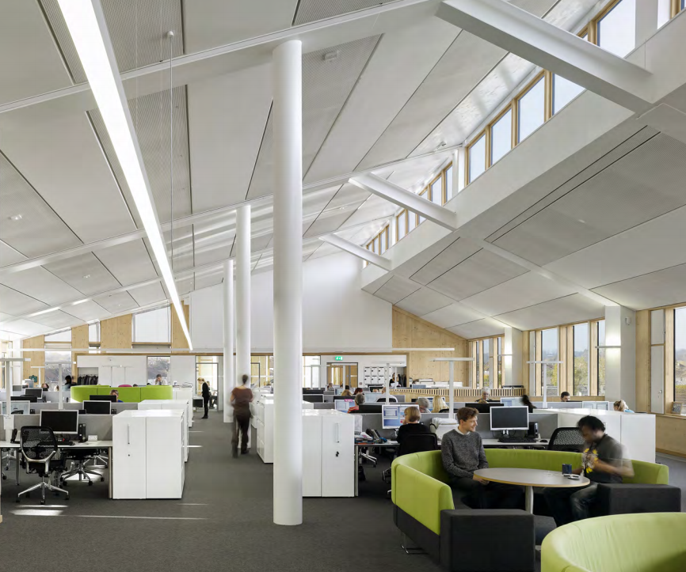

Keynsham Civic Centre, the Council’s award-winning sustainable office

PART 1: GUIDANCE 3
Background 3
Which applications need to complete the Checklist? 3
SECTION 1: THE PROPOSAL 5
Tables 1.1 and 1.2 5
SECTION 2: ENERGY EFFICIENCY & RENEWABLE ENERGY 6
Placemaking Plan Energy Policies 6
Table 2.1: Summary of Energy Strategy 7
Table 2.2: Proposals with more than one building type 7
Tables 2.3, 2.4 and 2.5: General Points 7
Track 1: Major new build developments - Table 2.3 8
Track 2: Non-major new build development - Table 2.4 10
Track 3: Medium development or larger on existing buildings - Table 2.5 10
Track 4: Certified Passivhaus - Table 2.4 11
Exemptions 12
SECTION 3: DISTRICT HEATING (Table 3) 13
SECTION 4: WATER (Table 4) 14
SECTION 5: OVERHEATING 15
All Proposals: Table 5.1 15
Large Scale Development: Tables 5.2 to 5.4 16
SECTION 6: SUSTAINABLE CONSTRUCTION (Table 6) 19
SECTION 7: NON COMPLIANCE (Table 7) 20
APPENDIX 1: SAMPLE CONDITIONS 21
APPENDIX 2: DOCUMENTATION AND CALCULATION EXAMPLES 25
Sample Part L output documents 25
Microgeneration Certificate Scheme (MCS) Certificates 27
Passivhaus Certificate: 28
PART 2: THE CHECKLIST 29
SECTION 1: THE PROPOSAL 29
SECTION 2: ENERGY 33
SECTION 3: DISTRICT HEATING 38
SECTION 4: WATER 40
SECTION 5: OVERHEATING 41
SECTION 6: SUSTAINABLE CONSTRUCTION 45
SECTION 7: NON-COMPLIANCE 46

PART 1: GUIDANCE
The Guidance below sets out the rationale for the Sustainable Construction Checklist Supplementary Planning Document (SCC SPD) and how the Checklist in Part 2 should be completed.

Background

  - On the 14th March 2019, a motion to declare a Climate Emergency was adopted unanimously by Bath and North East Somerset Council. The motion pledged the Council to providing the leadership to enable Bath & North East Somerset district to become carbon neutral by 2030.

  - Responding to climate change was already a cross-cutting objective within the B&NES Placemaking Plan. This SPD provides detailed instructions on how to meet the requirements in the “Responding to Climate Change” section of the Placemaking Plan. Please review this section in full for complete policy wording and further policies that are not covered by the SPD.

  - For further guidance please refer to the Sustainable Construction and Retrofitting SPD which looks at the building types in our district, including historic buildings. Other aspects of sustainability such as transport, drainage and ecology are handled separately with Planning Services and are outside the scope of this SPD.

Which applications need to complete the Checklist?

  - Type of proposal: The following need to complete the relevant parts of the Checklist:

- All new build proposals (one dwelling or more, or any amount of commercial floorspace created) that require Building Regulations Part L certification. This includes new buildings erected on the site of existing buildings that are demolished.

- All medium scale proposals or larger for works on existing buildings, e.g. extensions that create more than 5 dwellings or 500m² of commercial floor space, or conversions of buildings with more than 5 dwellings or 500m² commercial floor space.

- Householder applications and proposals that are smaller than medium scale on existing buildings are exempt

  - Below are definitions of development size for the purposes of the Checklist:
- Large Scale development: 50 dwellings + or 5000m² + of commercial floor space. This definition is used only in the Overheating policy.

- Major development: 10 + dwellings or 1000m² + of commercial floor space

- Medium development: 5-9 dwellings or 500m² to 999m² of commercial floor space. This definition applies only to proposals on existing buildings.

  - Two stages of evidence submission: The Checklist and accompanying documentation is to be submitted twice:

- At the application stage in order to register an application

- Post completion with a discharge application to demonstrate compliance with the conditions, where required.

  - Type of Application: Outline, Full, Reserved Matters and Condition Discharge Applications are likely to need sections of the Checklist to capture factors such as massing, form and orientation that may be proposed in Outline applications. Please see Table 1.2 for which sections to submit and when. We also advise that the checklist is submitted with pre-application proposals. Reserved Matters application for Access only do not have to complete the Checklist.

  - Change of Use proposals: Policies are applied to the proposed use. For example, if a non-residential building is being changed into dwellings, the proposal should respond to the requirements for dwellings.

  - Further documentation: The checklist should accompany documents that provide further detail, such as Sustainability Statements or Energy Strategies. Please reference where further information and drawings can be found.

  - Submission format: The Checklist should be submitted in its original format and layout, as a Word document or converted into a PDF. It should be attached as a separate document accompanying the application. Please delete Part 1: Guidance and only submit Part 2: The Checklist. Please title the document “Sustainable Construction Checklist”.

  - Supporting documents should be combined and submitted as a single separate document titled “Sustainable Construction Checklist Supporting Documents” with a Table of Contents stating which documents are included.

  - Checklist Review: The checklist may be periodically updated to reflect changes in legislation, policy and practice.

  - Queries: Please call Planning Services on 01225 394041 or email development_management@bathnes.gov.uk.

SECTION 1: THE PROPOSAL

Tables 1.1 and 1.2

Table 1.1: The Proposal: Please input details of the proposal, stating the type and size of development. Also note the type of application – if it is an Outline application please state which Matters have been reserved, or if it is a Reserved Matters application, please state which Matter/s the application covers.
Table 1.2: Summary of Checklist Requirements: This table summarises the documentation required for different development and application types and whether the documentation has been provided.

SECTION 2: ENERGY EFFICIENCY & RENEWABLE ENERGY

Placemaking Plan Energy Policies

  - The SPD sets out the requirements for two key energy policies in the Placemaking Plan:

- Core Policy 2 (CP2): Sustainable Construction: “All planning applications should include evidence that the standards below will be addressed... Maximising energy efficiency and integrating the use of renewable and low-carbon energy”

The SPD sets benchmarks for demonstrating that energy efficiency has been “maximised” as required by CP2.

- Sustainable Construction Policy 1 (SCR1): On Site Renewable Energy: “Developers of Major proposals above a threshold of 1,000 square metres or 10 dwellings, excluding Industrial B2 and B8 uses, will be required to provide sufficient renewable energy generation to reduce carbon emissions from anticipated (regulated) energy use in the building by at least 10%”.
Energy Policy Requirements

  - The interaction of these policies is illustrated below:
Track 4
Certified Passivhaus
Track 3
Medium or major: Existing buildings
Track 2
Minor new build
Track 1
Major new build

CP2: 19% CO₂ overall emissions reduction, including…
SCR1: 10% emissions reduction from renewables
Evidence of Passivhaus design process and full certification
CP2 and SCR1: 10% CO₂ emissions reduction from renewables, or energy efficiency if renewables are not suitable for the existing building

CP2: 19% CO₂ emissions reduction from energy efficiency or renewables

Table 2.1: Summary of Energy Strategy

  - Each section is to contain 500 words or less, summarising the approach. References to other documents accompanying the application should be made to provide further detail, e.g. roof layouts for PV, Sustainability Statements etc, however even if a Sustainability or Energy strategy is submitted, its content is to be summarised in the Checklist for ease of assessment. For Outline applications where little detail is known, please state which Reserved Matters applications will address the issues.

  - Renewable Energy: If the application needs to include a Part L assessment, please include detail of renewable energy technologies for the site as a whole in Table 2.1. Please use the assumptions and figures inputted into the Part L software or extrapolate from the assessments if it is a multi-building development.

Table 2.2: Proposals with more than one building type

  - For developments with multiple buildings, site-wide compliance is to be demonstrated in this Table.

  - Energy assessments are to be produced for a representative building from each building type. For example, if a proposal contains a mix of detached 2 and 3 bedroom houses a separate energy assessment is required for a representative of each.

  - The workings for the calculation of site-wide compliance are to be set out clearly. The results for the representative buildings can be averaged based on the number of each building type in the proposal. Applicants should note if performance has been balanced between higher and lower performing buildings.

  - If a single building contains more than one unit e.g. subdivided offices, a terrace or a block of flats, Block Compliance with the policy is to be demonstrated as would be required by the Building Regulations. One assessment is to be conducted for the whole building and Table 2.2 is not needed.

Tables 2.3, 2.4 and 2.5: General Points

  - Applicants should tick whether the table is being completed for a single building or for a multi-building site, as detailed in Table 2.2.

  - Building Regulations Assessments: Policies CP2 and SCR1 address “regulated” emissions – those covered by Part L of the Building Regulations 2013. Applicants are to demonstrate compliance using the energy assessment methodology that is already required for Part L compliance, using a modelling tool approved for Part L assessments e.g. the Standard Assessment Procedure (SAP) for residential development or the Simplified Building Energy Model (SBEM) model for non-residential development.

  - The Summary and Inputs sheets from the Part L assessment/s are to be included with the application. This will enable verification of the figures cited in the Tables and the assumptions used in the model.

  - An accredited independent energy assessor is to conduct the modelling. The Accreditation reference number for the assessor is required.

  - This approach means that applicants may need a Part L assessment earlier in the design process than previously. This is to maximise energy efficiency gains from “passive design” of glazing, form and orientation. If these elements are not optimised at the earliest design stage, it becomes a lot harder and more expensive to achieve the energy performance required.

  - Ventilation and Overheating: Energy efficiency must be considered in conjunction with overheating (Section 5) and ventilation. For example, air tight buildings must be adequately ventilated so occupants don’t have to open the windows in winter and lose energy.

Track 1: Major new build developments - Table 2.3

  - For Track 1, policies CP2 and SCR1 apply. The interaction of these policies is described below.

  - CP2: A 19% reduction in regulated CO₂ emissions: The benchmark for demonstrating that energy efficiency has been “maximised”, as required by CP2, is an overall 19% reduction in regulated emissions.

  - SCR1: 10% emissions reduction through renewables: For major new-build developments, 10% of this overall 19% reduction is to come from renewable energy.

  - Gas-fired Combined Heat and Power (CHP) is considered a low carbon rather than a renewable energy source so does not count towards the 10% reduction for SCR1 (though it can count towards the overall 19% reduction).

  - SCR1 compliance is calculated against a baseline which takes energy reductions from efficiency measures into account. This means that energy efficient schemes will need less renewable energy to comply with SCR1.

  - Table 2.3: Since both CP2 and SCR1 apply, two rounds of energy assessment are needed for Table 2.3:

- First round of assessment: CO₂ reductions from energy efficiency measures only are calculated, starting from a baseline of the Target Emissions Rate (TER) to produce a Dwelling Emissions Rate (DER) or Building Emissions Rate (BER) figure. This BER/DER is the baseline for the second round of assessment. Measures can include mechanical ventilation and heat recovery (MVHR), Waste Water Heat Recovery (WWHR) or low carbon energy such as gas-fired Combined Heat and Power (CHP).

- Second round of assessment: Calculate the contribution of renewables by adding the renewable energy measures to the model. This should be at least 10% and the overall emissions should be at minimum 19% less than the TER.

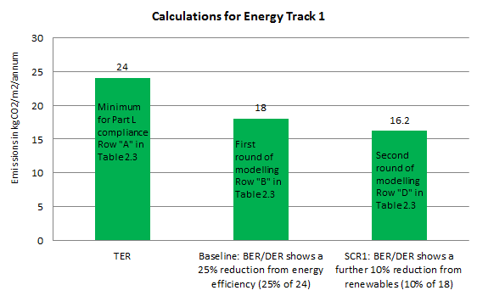
Example of Calculation for Energy Track 1
Overall emissions reduction of c. 33%, exceeding the 19% benchmark

Track 2: Non-major new build development - Table 2.4

  - Non-major development of less than 10 dwellings or 1000m² of commercial floorspace is covered by Policy CP2 but not SCR1, so applicants can choose whether to use energy efficiency, low carbon energy or renewable energy to meet the requirement.

  - CP2: A 19% reduction in regulated CO₂ emissions is the benchmark for demonstrating that energy efficiency has been “maximised” as required by CP2.

  - Table 2.4: An energy assessment is required to demonstrate the 19% emissions reduction. A baseline of the Target Emissions Rate (TER) is to be used to produce a Dwelling Emissions Rate (DER) or Building Emissions Rate (BER) figure which is 19% lower than the TER.

Track 3: Medium development or larger on existing buildings - Table 2.5

  - Track 3 applies to proposals of medium scale or above; 5 + dwellings or 500m² + on existing buildings, e.g. large extensions or changes of use.

  - Existing buildings may have fewer options for improving energy performance and measures should be sensitive to the existing building. To reflect this, the requirements are lower:

- Lower benchmark: The benchmark for CP2 on existing buildings is 10% compared to 19% for new buildings.

- On major developments energy efficiency can be used instead of renewables for the 10% reduction required by SCR1, since existing buildings may be less suitable for renewable energy.

  - The reduction in emissions is to be achieved on the area within the planning application only, not the rest of the existing building that is outside the area of the planning application. So, for example, if an extension is being applied for, to an existing building, and the rest of the building is outside the application “red line” then the Checklist would only apply to the extension.

  - Table 2.5: The table should demonstrate a 10% improvement in regulated CO₂ emissions compared to the BER or DER of a notional baseline building that meets the requirements of Part L1B for residential developments and Part L2B for non-domestic buildings. The baseline BER/DER should be modelled as follows:

- Geometry and space types as per the proposed building
- Building fabric and glazing U-values as per the requirements of Part L2B/Part L1B. Performance of thermal elements or controlled fittings that are not upgraded should be estimated as per the non-domestic EPC Conventions guidance/SAP guidance for existing dwellings
- Air tightness of the building envelope should be estimated as per the non-domestic EPC Conventions guidance/SAP guidance for existing dwellings
- New building services systems as per the minimum requirements of the Non-Domestic Building Services Compliance Guide/Domestic Building Services Compliance Guide
- Retained building services systems as per non-domestic EPC Conventions guidance/SAP guidance for existing dwellings

The proposed building should be modelled as the proposed design. Any retained systems or fabric that is not upgraded should have the same performance as the baseline building.

  - Historic Buildings: Proposals for works to historic buildings will be judged on their own merits, taking into account the significance and character of the building and its setting. All Listed Building Consent applications must provide full details of energy measures including their impact on fabric, appearance or building function. Further guidance and case studies are provided in the Council’s Energy Efficiency & Renewable Energy Guidance for Listed Buildings and Undesignated Historic Buildings.

Track 4: Certified Passivhaus - Table 2.4

  - Proposals certified to the Passivhaus standard for new build or Enerphit for existing buildings will be considered to be compliant with SCR1 and CP2 and do not need to incorporate renewables to address SCR1.

Passivhaus projects use rigorous design and construction detailing to provide a high level of occupant comfort and use very little energy for heating and cooling. Passivhaus buildings have been shown to mitigate the “performance gap” commonly found in new build projects, whereby post-occupancy energy use is significantly higher than is predicted at the design stage.

  - Evidence to be provided: In order to qualify for Track 4, full applications or Outline/ Reserved Matters applications for Appearance and Layout are to be accompanied by

- Sign-off documentation from a Passivhaus Certifier (as opposed to a Passivhaus designer) confirming that the design is Passivhaus compliant.

- A written statement signed by the developer and the Passivhaus certified designer working on the scheme confirming that Passivhaus professionals will be employed throughout the development process and that the scheme will be able to achieve full certification.

- A summary output document from the Passivhaus Planning Platform (PHPP) software indicating that the design is Passivhaus compliant at this stage of development.

  - There are a range of Certified Passivhaus standards, all are considered to qualify for Track 4.

  - If a multiple-building proposal contains some units that are to be certified to Passivhaus and some that are not, those that are not to be certified will need to meet the usual requirements of the Energy Tracks above.

  - Achievement of Passivhaus certification will be conditioned, to be discharged by submission of a Passivhaus certification document prior to occupation.

  - If Passivhaus certification is not achieved upon completion the development will need to meet the requirements of the non-Passivhaus Energy Track for its scale and type. Energy Table/s and supporting documentation are to be submitted with the condition discharge application, showing that the benchmarks set for SCR1 and/or CP2 have been met.

Exemptions

  - Our studies have shown that B2 and B8 industrial uses may find it more difficult to increase energy performance, so no benchmarks are set for these uses. Applicants are still required to maximise energy performance, in line with CP2, so will need to complete Table 2.1.

SECTION 3: DISTRICT HEATING

  - Background: In some areas, district heating/ heat networks can reduce CO₂ emissions by using a shared renewable or low carbon heat source. The Council has conducted extensive research into heat networks to identify the opportunity areas.

  - Placemaking Plan Policy CP4 - Table 3: Below are excerpts from the Policy CP4:

Development within Heat Network Priority Areas “will be expected to incorporate infrastructure for district heating and will be expected to connect to existing systems where and when this is available, unless demonstrated that this would render development unviable”.

For development in these Priority areas, full compliance with CP4 is required, as set out in Table 3.

“Development within the Heat Network Opportunity Areas will be encouraged to incorporate infrastructure for district heating and will be expected to connect to any existing suitable systems (including systems that will be in place at the time of construction), unless it is demonstrated that this would render development unviable”.

For development in the Opportunity Areas, we expect to see consideration of heat networks as set out in Table 3.

  - Maps: To determine if policy CP4 applies, please check the GIS layers on the Council’s My Maps application; these maps may change as our evidence base is refined. These maps replace the “yellow circle” demarcations of Heat Network Priority Areas that are shown in the Placemaking Plan (p72 and 73). The yellow circles representing Heat Network Opportunity Areas in the Placemaking Plan can still be used.

  - Table 3: Full guidance for the completion of Table 3 is contained in the “Heat Networks Guidance Note” that accompanies this SPD and can be found on the same webpage.

  - Development type/ scale: Whilst all scales of development in the Heat Network areas are expected to consider heat networks, it is understood that heat networks may be unfeasible for some developments e.g. individual dwellings or refurbishments of small non-residential units. In these cases, please provide an explanation in Question 13.

SECTION 4: WATER

  - Efficient use of water is important now and will become increasingly crucial as the climate changes.

  - Policy SCR5: Water Efficiency states that:

- All dwellings will be expected to meet the national optional Building Regulations requirement for water efficiency of 110 litres per person per day;
- Rainwater harvesting or other methods of capturing rainwater for use by the residents (e.g. water butts) will be required for all residential development, where technically feasible

  - Table 4: Water: Full applications or Outline/ Reserved Matters applications applying for Appearance for residential proposals are to complete Table 4. Mixed use proposals should provide an assessment for the residential element of the scheme.

  - Major residential applications are to attach either

- The outputs of a Part G Water Calculator (widely available online) to illustrate the water efficiency strategy and demonstrate that the standard has been met OR
- If the “fittings” approach is being taken to Part G compliance, to state that the consumption of fittings will not exceed the requirements in the table for the 110 litre “Optional standard” in the Part G document.

  - Pre-applications are encouraged to provide an outline of their approach to water efficiency in the narrative section of the table.

SECTION 5: OVERHEATING

All Proposals: Table 5.1

  - Climate change is already causing overheating. Policy CP2 states that all proposals should have “consideration of climate change adaptation” Climate science indicates the temperature will be significantly warmer over the lifetime of the buildings. Building design should eliminate or minimise the need for air conditioning (active cooling) in a warmer climate to reduce CO2 emissions and the urban heat island effect.

  - Table 5.1: Overheating mitigation strategy: Full applications or Outline/ Reserved Matters applications for Appearance are to include Table 5.1 stating how the Cooling Hierarchy has been implemented, as below:

- Minimising internal heat generation through energy efficient design
- Reducing the amount of heat entering the building in summer
- Use of thermal mass (when carefully designed) and high ceilings to manage the heat within the building
- Passive ventilation
- Mechanical ventilation

  - Overheating should be considered alongside other design criteria. Proposals should respond to their context and the example measures in Table 5.1 will not be suitable in all cases.

Large Scale Development: Tables 5.2 to 5.4

  - Large scale definition: Large scale new-build developments (50 dwellings + or 5000m² + of floor space) should show leadership in tackling overheating. This includes proposals which in total meet the criteria for large scale, e.g. a mixed-use development with 20 residential units plus 4500m² floor space.

  - CIBSE Assessment The compliance tools for Building Regulations are not intended to accurately evaluate overheating, so Large Scale proposals are to use the more sophisticated CIBSE standards TM52 for non-residential development and TM59 for residential development. The CIBSE methodologies use the criteria below:

- TM59 & TM52: “Hours of Exceedance”, a measure of how often the temperature exceeds a threshold comfort temperature during a typical warm season and sets a limit of 3% of occupied hours.
- TM52: “Daily Weighted Exceedance”; the severity of overheating within any one day. The limit is no more than 6 hours a day above the thermal comfort threshold.
- TM52: “Upper Limit Temperature” which sets an absolute maximum temperature for a room beyond which the level of overheating is unacceptable.

  - Modelling Requirements: The CIBSE assessment should be run twice with the following data files/ scenarios:

- Current Climate using CIBSE Design Summer Year (DSY1) for the 2020s, high emissions, 50th probability scenario (Swindon data should be used for this and all other modelling using CIBSE files).

- Future Climate: Since the buildings constructed today will still be occupied in 2050, it is important to consider how buildings will perform under future conditions.2050 files, medium emissions, 50th probability scenario. Applicants can use the CIBSE 2050 data files, or those from Project COLBE which use climate change models at a 5km grid resolution.

  - Policy benchmark: Meet the CIBSE TM59 or TM52 standard for the 2020s scenario (CIBSE DSY1), showing that active cooling is not needed in the current climate, meeting criteria A and B (hours of exceedance in living rooms, kitchens and bathrooms and hours of exceedance in bedrooms). This is very likely to mean the use of external shading such as brise soleil, which should be incorporated in the drawings, and the specification of openable windows.

  - Policy Benchmark: Outline a strategy for the future climate showing how the building has been future-proofed to enable further passive overheating measures, e.g. the ability to install further external shading, deciduous trees that will reach maturity over the lifetime of the building.

  - Table 5.2: Overheating in residential development: Large residential proposals of 50 units or more should conduct the assessment for CIBSE TM59 “Design methodology for the assessment of overheating risk in homes”. Outputs are to be used to complete Table 5.2. The CIBSE assessment is to be undertaken on a baseline building with no active cooling, to demonstrate that passive measures have been maximised. We expect most residential development to achieve a “pass” for the current climate without active cooling.

  - Table 5.3: Overheating in non-residential development: Large non-residential proposals of more than 5000m² are to use the methodology in CIBSE TM52 “The Limits of Thermal Comfort: Avoiding Overheating in European Buildings”. Modelling should be conducted for the part of the building that has the greatest risk of overheating as per the CIBSE methodology. The CIBSE assessment is to be undertaken on a baseline building with no active cooling, to demonstrate how passive measures have been maximised.

  - Table 5.4: Active Cooling: It is acknowledged that for some proposals e.g. offices with deep floorplates active cooling may be needed and may be a more energy efficient way to meet the requirements of TM52 when compared to increasing non-cooled airflow. If this is shown to be the case, active cooling systems are to exceed the requirements of Part L.

  - To verify compliance, the Part L output report’s ‘HVAC Systems Performance’ table is to be attached. This compares the cooling demand of the actual and notional buildings. Applicants should reduce the actual cooling demand below that of the notional Part L compliant cooling demand for each of the non-domestic spaces in the development where an active cooling load exists. This may mean that more than one copy of Table 5.4 is completed.

  - The output and inputs documents from the Part L assessment containing the HVAC Systems Performance table are to be attached to the application.

  - Assessment at the application stage and again to discharge the condition: Whilst overheating modelling at the pre-planning stage may not reflect the details of the final design, modelling at an early stage ensure that consideration of overheating is embedded at an early stage. Overheating should then be considered throughout the design and build process, ensuring that the building is still compliant in order to discharge the planning condition.

  - Multiple Buildings: Proposals with multiple buildings are to assess a representative sample of each building type. For apartment buildings this could be a representative sample of dwellings within the apartment block. Please consult during the pre-application process about how many assessments are needed.

  - Exemptions: Large proposals are expected to conduct an assessment as above unless the applicant can demonstrate exceptional circumstances where opportunities for reducing cooling demands via passive measures are constrained, for example industrial buildings including warehouses used for storage purposes; supermarkets; cinemas or theatres; laboratories or temporary structures. In such cases, the exemption should be stated in “Non-Compliance” Section 7 with reference to this paragraph.

  - In the case of query during the application process, the full written report using the CIBSE methodology including modelling outputs, or direct contact with modelling personnel may be required for verification.

SECTION 6: SUSTAINABLE CONSTRUCTION (Table 6)

  - Background: CP2 sets out requirements for aspects of sustainable construction that are more difficult to verify through a standard methodology. Compliance with these requirements will be assessed on a case-by-case basis.

  - Table 6: Sustainable Construction: Full applications or Outline/ Reserved Matters applications for Appearance are to complete this table to demonstrate how they have responded to the issues in Policy CP2 listed in bold below. Links to suggested approaches to are provided:

  - Minimisation of waste and maximising of recycling of any waste generated during construction and in operation: Production of a Site Waste Management Plan (SWMP) in line with WRAP guidance can enable the best use to be made of waste materials produced during construction. The Home Quality Mark provides useful criteria for designing waste and recycling facilities for domestic properties, the BREEAM criteria for waste can inform non-domestic projects.

  - Efficiency in materials use, including the type, life cycle and source of materials to be used: A review of how the environmental impact of materials is assessed is provided by the UK Green Building Council. For the impact of particular materials, please see the Building Research Establishment’s (BRE) Green Guide to Specification. For example, applicants could commit to using only materials rated “A” or “B” on the Green Guide.

  - Flexibility and adaptability, allowing future modification of use or layout, facilitating future refurbishment and retrofitting: The principles of Lifetime Homes can be followed, enabling buildings to adapt to be suitable for occupants at all life stages and be adaptable for future uses.

  - Consideration of climate change adaptation: A review of measures to adapt to the changing climate is provided in the Technology Strategy Board’s document “Designing for Future Climate”. Water and overheating are considered separately in the Checklist.

SECTION 7: NON-COMPLIANCE (Table 7)

  - We expect development to be able to meet the benchmarks above. Local and national evidence indicates that this is achievable within viability constraints.

  - If non-compliance with any of the Sustainability requirements above is proposed, please complete Table 7. A full open-book viability test or technical rationale may be required, in which case the applicant is likely to be required to pay the cost for an independent review of the evidence submitted as the basis for non-compliance.

  - In the case of proposed non-compliance, the Checklist is to be completed in full, stating clearly which sections are non-compliant and why.

APPENDIX 1: SAMPLE CONDITIONS
Please find below sample conditions to ensure compliance with the policies in the Placemaking Plan/ Checklist SPD. The actual wording of the condition may vary depending on the application.

Energy Conditions

Track 1 (Major New Build Development)

Prior to first occupation of the development hereby approved the following tables (as set out in the Council’s Sustainable Construction Supplementary Planning Document, Adopted November 2018) shall be completed in respect of the completed development and submitted for approval to the local planning authority together with the further documentation listed below:

- Table 2.1 Energy Strategy (including detail of renewables)
- Table 2.2 Proposals with more than one building type (if relevant)
- Table 2.3 (Calculations);
- Building Regulations Part L post-completion documents for renewables;
- Building Regulations Part L post-completion documents for energy efficiency;
- Microgeneration Certification Scheme (MCS) Certificate/s (if renewables have been used)

Reason: To ensure that the approved development complies with Policy SCR1of the Placemaking Plan (renewable energy) and Policy CP2 of the Core Strategy (sustainable construction).

Track 2 (Non-major New Build Development)

Prior to first occupation of the development hereby approved the following tables (as set out in the Council’s Sustainable Construction Supplementary Planning Document, Adopted November 2018) shall be completed in respect of the completed development and submitted for approval to the local planning authority together with the further documentation listed below:

- Table 2.1 Energy Strategy (including detail of renewables)
- Table 2.2 Proposals with more than one building type (if relevant)
- Table 2.4 (Calculations);
- Building Regulations Part L post-completion documents
- Microgeneration Certification Scheme (MCS) Certificate/s (if renewables have been used)

Reason: To ensure that the approved development complies with Policy CP2 of the Core Strategy (sustainable construction).

Track 3 (Major or Medium Works to an Existing Building)

Prior to first occupation of the development hereby approved the following tables (as set out in the Council’s Sustainable Construction Supplementary Planning Document, Adopted November 2018) shall be completed in respect of the completed development and submitted for approval to the local planning authority together with the further documentation listed below:

- Table 2.1 Energy Strategy (including detail of renewables)
- Table 2.2 Proposals with more than one building type (if relevant)
- Table 2.4 (Calculations);
- Building Regulations Part L post-completion documents
- Microgeneration Certification Scheme (MCS) Certificate/s (if renewables have been used)

Reason: To ensure that the approved development complies with Policy SCR1of the Placemaking Plan (renewable energy) and Policy CP2 of the Core Strategy (sustainable construction).

Track 4 (Passivhaus)

Prior to first occupation of the development hereby approved the following tables (as set out in the Council’s Sustainable Construction Supplementary Planning Document, Adopted November 2018) shall be completed in respect of the completed development and submitted for approval to the local planning authority together with the further documentation listed below:

- Passivhaus Certification by accredited Passivhaus Certifier
- Table 2.1: Summary of Energy Strategy (including detail of renewables)

If Passivhaus certification is not achieved, the documentation for compliance with the relevant Energy Track shall be submitted.

Reason: To ensure that the approved development complies with Policy SCR1of the Placemaking Plan (renewable energy) and Policy CP2 of the Core Strategy (sustainable construction).

Water Conditions

The dwellings hereby approved shall be constructed to meet the national optional Building Regulations requirement for water efficiency of 110 litres per person per day.

Reason: In the interests of water efficiency in accordance with Policy SCR5 of the Placemaking Plan

Overheating Conditions

Large Scale Residential (50+) Dwellings

Prior to first occupation of the development hereby approved the following tables (as set out in the Council’s Sustainable Construction Supplementary Planning Document, Adopted November 2018) shall be completed in respect of the completed development and submitted, along with supporting documents, to the local planning authority:

- Table 5.1
- Table 5.2
- Table 5.4 (if using active cooling)

Reason: To ensure that the approved development complies with Policy CP2 of the Core Strategy (sustainable construction).

Large Scale Non-Residential (5000m²+ floor space created)

Prior to first occupation of the development hereby approved the following tables (as set out in the Council’s Sustainable Construction Supplementary Planning Document, Adopted November 2018) shall be completed in respect of the completed development and submitted, along with the supporting documents required, to the local planning authority for approval:

- Table 5.1
- Table 5.3
- Table 5.4 (if using active cooling)

Reason: To ensure that the approved development complies with Policy CP2 of the Core Strategy (sustainable construction).

All Development below the Above Thresholds

Prior to first occupation of the development hereby approved Table 5.1 as set out in the Council’s Sustainable Construction Supplementary Planning Document, Adopted November 2018) shall be completed in respect of the completed development and submitted to the local planning authority.

Reason: To ensure that the approved development complies with Policy CP2 of the Core Strategy (sustainable construction).

District Heating Conditions

For applications within the Heat Network Priority Areas that are proposing to “future proof” to connect to heat networks:

Prior to first occupation of the development hereby approved a document demonstrating how the building has been futureproofed for connection to a district heating network shall be provided for approval. The document should state the preferred intake route for the district heating pipework to the heating plant room(s). The document should show how the building design follows the relevant clauses of Objective 3.4 “To Design or Modify Suitable Space Heating and Domestic Hot Water Services Systems” of the CIBSE & ADE Heat Networks: Code of Practice for the UK. Where a clause is not relevant the document should state why. Multi-residential buildings should also demonstrate how the design follows the relevant clauses of Objective 3.9 “To Achieve an Efficient Heat Distribution System Within a Multi-residential Building and Reduce Risk of Overheating”.

APPENDIX 2: DOCUMENTATION AND CALCULATION EXAMPLES

Sample Part L output documents: Where Part L documents are required the TER and BER/DER should be clearly displayed on the output documents as illustrated below.

- SAP summary for dwellings
Below is an excerpt from a sample SAP Part L document with the TER and DER circled:

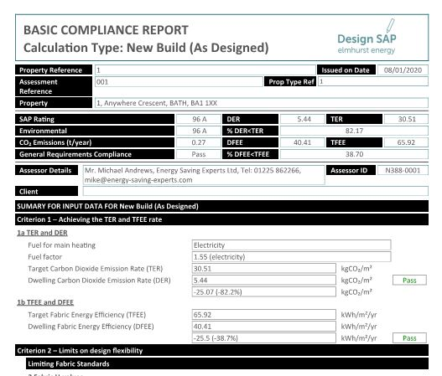

Sample Calculations
To meet the CP2 benchmark for new build, the DER figure above (5.44) must be 19% lower than the TER figure (30.51). The calculation is therefore:

30.51 – 5.44 = 25.07
25.07 / 30.51 x 100 = 82.16
= 82.16% reduction in emissions

This example meets the CP2 benchmark.

- BRUKL summary for non-residential
- Below is an excerpt from a sample SBEM Part L document with the TER and BER circled:

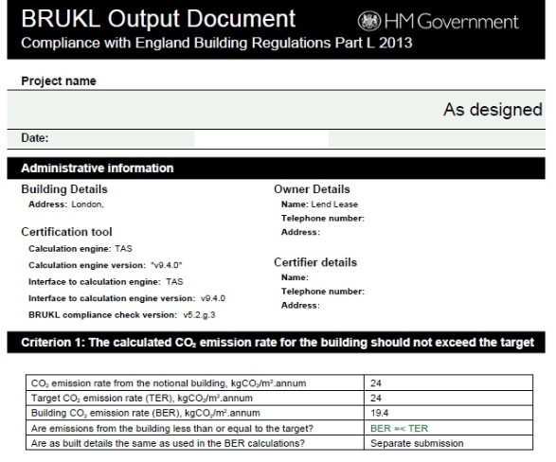

Sample Calculations
To meet the CP2 benchmark for new build, the BER figure above (19.4) must be 19% lower than the TER figure (24). The calculation is therefore:

24 - 19.4 = 4.6
4.6 / 24 x 100 = 19.16
= 19.16% reduction in emissions

This example meets the CP2 benchmark.

Microgeneration Certificate Scheme (MCS) Certificates: An MCS Certificate is produced by the renewable energy installer stating that the equipment is live and connected (example below). It has the necessary detail to verify the information provided in Energy Table 2.
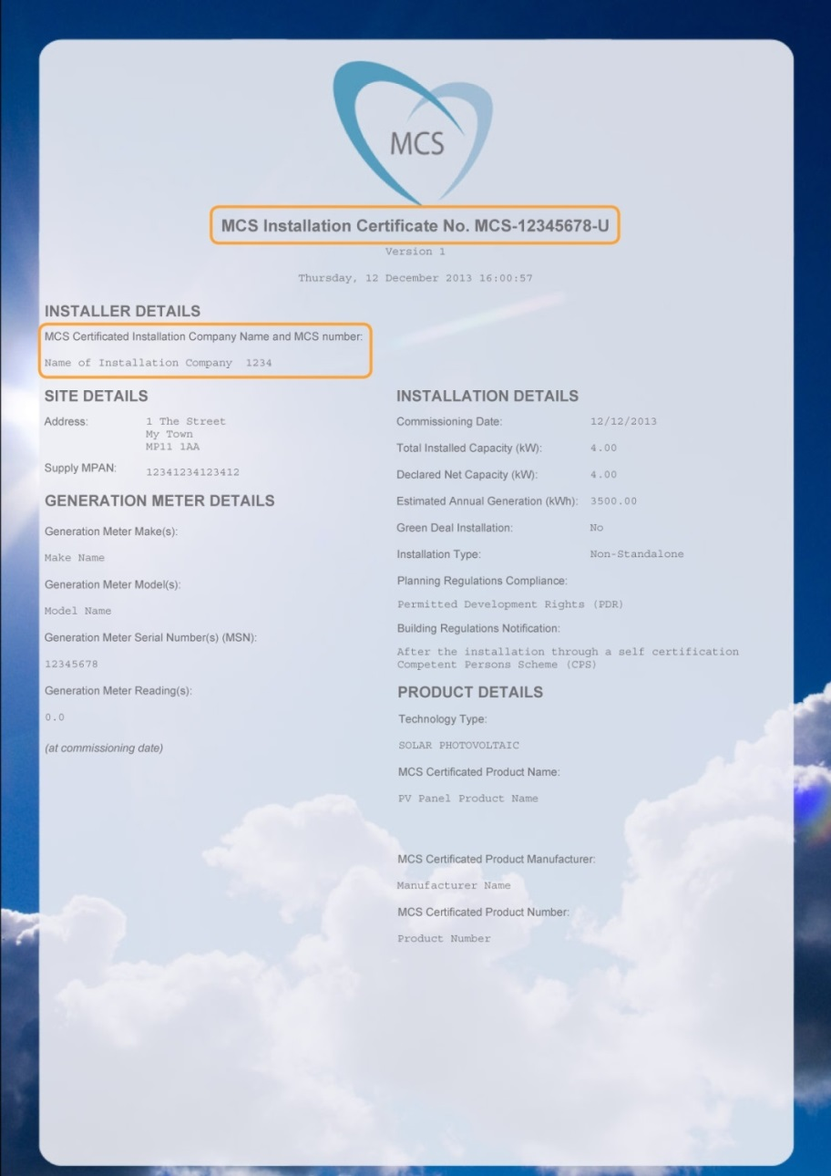

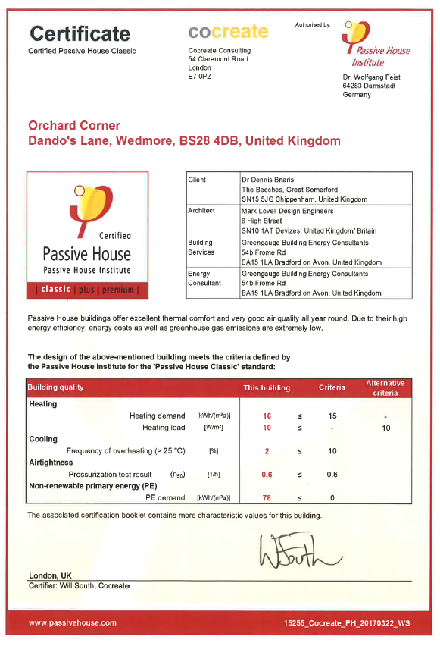
Passivhaus Certificate: Required for Track 4 condition discharge.

PART 2: THE CHECKLIST

SECTION 1: THE PROPOSAL

TABLE 1.1: THE PROPOSAL

Required for: All applications within the scope of the Checklist

Name of Proposal | [Insert text here]
Brief description e.g. residential, commercial, and size | [Insert text here]
Type of application e.g. Pre-Application, Outline, Full, Condition Discharge, Reserved Matters (noting Matters Reserved) | [Insert text here]

TABLE 1.2 SUMMARY OF CHECKLIST REQUIREMENTS

SECTION 2: ENERGY
Applies to: Full applications or outline applications and post completion to discharge condition. Please note multi-building developments may need more than one table per track to represent all building types.

Track | Development Type: Tick to indicate which development type/s your proposal contains | The boxes below indicate requirements at the different planning stages. Please tick to indicate completion.
 |  | Outline or reserved matters applications if not applying for Appearance | Full applications OR  Outline or reserved matters applications applying for Appearance | All applications for discharge of post-completion Checklist Conditions
Track 1 | ☐ Major new build residential development  ☐ Major new build non-residential development | ☐ Table 2.1: Summary of Energy Strategy | ☐ Table 2.1: Summary of Energy Strategy  ☐ Table 2.3: Calculations  ☐ Part L design stage document/s for energy efficiency measures  ☐ Part L design stage document/s for energy efficiency and renewable energy measures  ☐Table 2.2 for developments with more than one building type | ☐ Table 2.1: Summary of Energy Strategy  ☐ Table 2.3 Calculations  ☐ Part L post-completion document/s for energy efficiency  ☐ Part L post completion document/s for energy efficiency and renewable energy measures  ☐ MCS Certificate/s  ☐Table 2.2 for developments with more than one building type
Track 2 | ☐ Non-major new build residential development  ☐ Non-major new build non -residential development | ☐ Table 2.1: Summary of Energy Strategy | ☐ Table 2.1: Summary of Energy Strategy  ☐ Table 2.4 Calculations  ☐ Part L design stage document/s  ☐Table 2.2 for developments with more than one building type | ☐ Table 2.1: Summary of Energy Strategy  ☐ Table 2.4 Calculations  ☐ Part L post completion document/s  ☐Table 2.2 for developments with more than one building type
Track 3 | ☐ Medium scale or larger works to existing buildings | ☐ Table 2.1: Summary of Energy Strategy | ☐ Table 2.1: Summary of Energy Strategy  ☐ Table/s 2.5 Calculations  ☐ Part L design stage document/s  ☐Table 2.2 for developments with more than one building type | ☐ Table 2.1: Summary of Energy Strategy  ☐ Table 2.5 Calculations  ☐ Part L post completion document/s  ☐Table 2.2 for developments with more than one building type
Track 4 | ☐ Passivhaus, all scales | ☐ Table 2.1: Summary of Energy Strategy | ☐ Table 2.1: Summary of Energy Strategy  ☐ Statement from Passivhaus Certifier, designer and summary of outputs from design stage PHPP | ☐ Table 2.1: Summary of Energy Strategy  ☐ Passivhaus Certificate  Note: If certification is not achieved, the relevant table/s from the tracks above are to be attached for condition discharge.
Exempt | ☐ Industrial B2 or B8 uses: Table 2.1: Summary of Energy Strategy only, no calculations required

Please note – this table continues overleaf
SECTION 3: DISTRICT HEATING
Applies to: Full applications or outline/ reserved matters applications for Appearance within a Heat Network Area. May be required post-completion to discharge a condition.

☐ Proposal is within Bath or Keynsham Heat Network Priority Area
☐ Relevant sections of Table 5 completed and documentation attached where requested
☐ Proposal is within a Heat Network Opportunity Area
☐ Relevant sections of Table 5 completed and documentation attached where requested
☐ Proposal is not within a Heat Network Priority or Opportunity Area (no tables or documentation required)
SECTION 4: WATER
Applies to: Full applications or outline/ reserved matters applications for Appearance for residential development and for post-completion condition discharge
☐The proposal is, or contains elements of, residential development
☐Table 4 has been completed and supporting documentation attached as required
☐The proposal is wholly non- residential (no tables or documentation required)
SECTION 5: OVERHEATING
Applies to: Full applications or outline/ reserved matters applications for Appearance. Please tick below to confirm that the correct tables have been completed and evidence attached where needed. These tables may also be required post-completion for discharge of conditions.
☐The proposal is Large Scale Residential (50 dwellings +)
☐Table 5.1
☐Table 5.2: Modelling cover sheets for “current climate” and “future climate” are attached
☐The proposal is Large Scale Non-Residential (5000m² + of floor space to be created)
☐Table 5.1
☐Table 5.3: Modelling cover sheets for “current climate” and “future climate” are attached
☐The proposal is Large Scale and using Table 5.4: Active Cooling
☐Table 5.1
☐Table 5.4: Part L “HVAC Systems Performance” table is attached
☐The proposal is smaller than Large Scale
☐Table 5.1 only

SECTION 6: SUSTAINABLE CONSTRUCTION
Required For: All full applications or outline/ reserved matters applications.
☐Table 6

SECTION 2: ENERGY

TABLE 2.1: SUMMARY OF ENERGY STRATEGY

All required sections are to be completed in 500 words or less per section. A summary is to be provided of the approach, not simply a reference to other documents, although additional detail should be signposted via references to named documents and drawings. Outline applications should state if reserved matters applications will contain further detail.

1 and 2 below required for all applications, including outline applications where appearance is Reserved
- Passive design e.g. building form, orientation and shading, including orientation of roofs to maximise solar energy potential. Please note - this is an important consideration for Layout, so applications covering Layout should provide a full explanation of the approach.
[Insert text here]

- Renewable and low carbon energy e.g. solar energy, biomass, heat pumps, solar thermal, heat networks and Combined Heat & Power (CHP). Please cite any drawings of renewable/low carbon technology.
[Insert text here]

Total Renewable Energy on the whole proposal – please complete if submitting Part L calculations (taken from SAP/SBEM inputs)
Technology type (e.g. PV) | Description: Number and location of installations | Total site-wide capacity (kWp) | Estimated total annual generation (kWh) | Total CO₂ saving from this technology (kgCO2)
[insert text and add rows as needed]
3- 7 below required for Full or Reserved Matters applications for Appearance
- Energy efficiency e.g. higher elemental performance than Part L notional U values, appliances, low energy fixtures.
[Insert text here]

- Heating, cooling and hot water e.g. heat pumps, responsive heating controls, underfloor heating, mechanical ventilation with heat recovery, waste water heat recovery.
[Insert text here]

- Ventilation and indoor air quality e.g. airtightness performance, natural or mechanical ventilation, windows, use of low Volatile Organic Compound materials. Where wood burners are to be used, comment on the mitigation of impacts on external and internal air quality. Note how the building will be ventilated in winter other than by opening windows if a high airtightness target is proposed.
[Insert text here]

- Thermal Bridging reduction: Please list in further detail the ways in which thermal bridging will be minimised, and how thermal bridges have been modelled in the Part L calculations e.g. assuming
[Insert text here]
- Energy Performance Gap: Please note how the Performance Gap will be addressed both during and after construction, e.g. as required by the Soft Landings process:
- Construction management practices
- Aftercare and post-occupation measures to ensure correct commissioning (including seasonal commissioning) and thorough handover
- Post-occupation performance monitoring to record whether targets are met in-use.
[Insert text here]

- Smart infrastructure e.g. smart meters and appliances, energy storage, electric vehicle charging, building management systems.
[Insert text here]

TABLE 2.2: PROPOSALS FOR MORE THAN ONE BUILDING TYPE
Required for developments with more than one type of building where compliance is to be proposed for the whole site, for:

- Full applications or outline/ reserved matters applications for Appearance
- To discharge the condition prior to occupation

Representative Buildings: Please note below a representative of each building type e.g. two bedroom/ 3 bedroom dwellings/ commercial/ low rise flat

Building |  | Building type represented | Number of buildings of this type | TER | DER/BER |  | % reduction
1. [insert text and add rows as needed]
Site-wide compliance calculations: Please set out below how site-wide compliance was calculated, see guidance for detail on how to do this.

[Insert text and calculations here]

TABLE 2.3: CALCULATIONS FOR TRACK 1 (Major new build residential and non-residential development)

Required for:
- Full applications or outline/ reserved matters applications for Appearance
- To discharge the condition prior to occupation

Please tick:
☐ The proposal, and the figures in the table, are for a single building
☐ The proposal is for multiple buildings and the table is for site-wide compliance. Table 2.2 has been completed showing how this has been calculated.

A | TER Baseline emissions |  |  |  |  | kg CO₂/m²
B | BER/ DER Emissions after Energy Efficiency and Low Carbon measures (baseline for SCR1 compliance) |  |  |  |  | kg CO₂/m²
C | % CO₂ reduction from Energy Efficiency measures only (A-B)/A*100 |  |  |  |  | %
D | BER/ DER Emissions after Renewables are added to the Energy Efficiency Measures |  |  |  |  | kg CO₂/m²
E | Further % CO₂ reduction from Renewables only.  At least 10% to comply with SCR1 (B-D)/B*100 |  |  |  |  | %
F | CO₂ savings from all measures- Renewable and Energy Efficiency |  |  |  |  | kg CO₂/m²
G | % CO₂ reduction from all measures.  At least 19% to comply with CP2 (A -D)/A*100 |  |  |  |  | %
☐ Please tick to confirm that the two sets of design stage or post-completion Part L SAP/SBEM summary and input documents are attached. This is required for registration of the application:

- The reduction in CO₂ from energy efficiency measures only (C)
- The overall reduction once renewables are added (G)

☐ For discharge applications, please tick to confirm that the MCS Certificate is attached showing that any renewable technologies cited in this table are installed and operational (for installations of up to 50kW).

Name and registration number of independent accredited assessor conducting the assessment: [Insert text here]

TABLE 2.: CALCULATIONS FOR TRACKS 2 (New build – non-major)

Required for: Full applications or outline/ reserved matters applications for Appearance and for post-completion condition discharge.
Please tick:
☐ The proposal, and the figures in the table below, are for a single building
☐ The proposal is for multiple buildings so the table below demonstrates site-wide compliance; Table 2.2 has been completed showing how this has been calculated.

For multiple building proposals, please state which building this is an assessment for; the reason for selecting this building as an example of building type, and a reference to where the building can be found on the drawings. |  | [Insert assessment results here]
For multiple building developments, please highlight Yes or No to indicate whether the proposal as a whole will comply with Energy Track 1 and note how; e.g. if some buildings will have lower energy performance and be offset by others with higher performance. |  | [Insert calculations and supporting text here]
A | TER Baseline emissions |  | kg CO₂/m²
B | DER/ BER Emissions after All Measures (Renewables plus Energy Efficiency Measures) |  | kg CO₂/m²
C | Tracks 2 and 4: Percentage CO₂ reduction from all measures should be at least 19% (A-B)/A*100 |  | %
☐ Please tick to confirm that design stage/post-completion SAP/SBEM Part L summary and input documents are attached. This is required for registration of the application

☐ For discharge applications, please tick to confirm that the MCS Certificate is attached showing that the renewable technologies cited in this table have been installed and are operational (for installations of up to 50kW).

Name, reference number and company of accredited independent assessor: [Insert text here]

TABLE 2.5: CALCULATIONS FOR TRACK 3: Medium or larger development on existing buildings

Please tick:
☐ The proposal, and the figures in the table below, are for a single building
☐ The proposal is for multiple buildings so the table below demonstrates site-wide compliance; Table 2.2 has been completed showing how this has been calculated.

A | DER/ BER Baseline emissions from Notional Building | kg CO₂/m²
B | DER/ BER Emissions after All Measures (Renewables plus Energy Efficiency Measures) | kg CO₂/m²
 | Percentage CO₂ reduction from all measures should be at least 10% (A-B)/A*100 | %
☐ Please tick to confirm that design stage/post-completion SAP/SBEM Part L summary and input documents are attached. This is required for registration of the application

☐ For discharge applications, please tick to confirm that the MCS Certificate is attached showing that any renewable technologies cited in this table have been installed and are operational.

Name, reference number and company of accredited independent assessor: [Insert text here]

SECTION 3: DISTRICT HEATING

TABLE 3: DISTRICT HEATING

Required for: Full applications or outline/ reserved matters applications for Appearance within a Heat Network Priority Area or Heat Network Opportunity Area. Pre-applications are encouraged to respond to questions 1 - 5. See Section 3 of the Guidance and the separate “Heat Networks Guidance Note” for further detail and types and scales of development that may be considered for exemption.

1 | Is the proposal in a Heat Network Priority Area? | Yes | No
2 | Is the proposal in a Heat Network Opportunity Area? | Yes | No
If “Yes” to Question 1 (Priority Area), at least one of Questions 3-5 must also be a “Yes”

If “Yes” to Question 2 (Opportunity Area), please complete the table. If Questions 3-5 are “No” please explain further in Question 13.

3 | Does the proposal include a heat network? If “Yes” please complete question 8. | Yes | No
4 | Does the proposal include connection to an existing heat network? If “Yes” please complete question 8. | Yes | No
5 | Is the proposal future-proofed to connect to future heat networks? If so, the answer to Questions 9- 12 should be “Yes” | Yes | No
6 | If the proposed development is in proximity to an existing district heating scheme (e.g. Bath Western Riverside), has the incumbent district heating operator been contacted to discuss the potential for connection to the existing network? Proof of contact with the operator may be required. | Yes | No
7 | If the proposed development is a large scale multi-building development (e.g. over 500 residential units and/or over 10,000m² of non-residential floor space – in particular with hotels, hospitals, leisure centres or student residences), has an open-book viability assessment for district heating been carried out and full report attached? | Yes | No
8 | If a heat network or connection to a heat network is proposed, has a document providing further details been attached? Please reference below.  If a fossil-fuelled heat source is proposed please summarise below the strategy for switching to a renewable heat source in the future. Where a mix of energy sources is being proposed e.g. biomass with backup gas boilers, please explain how it will be ensured that post-occupation the energy mix will be as is stated in the Checklist (e.g. not just using the backup gas boilers). | Yes | No
 | [Insert text here]
Future Proofing
9 | Single heat source: If the development includes residential apartment buildings, is heating provided to the apartments from a single central heat source as opposed to heating plant for individual units? Please explain in Question 13 if the answer is “no”. | Yes | No
10 | Protected Pipe Routes: (a) Has a potential intake route for district heating pipe to the building(s) been identified and safeguarded? (b) Have the pipe routes been safeguarded to connect from the building plant room to the route of the district heating network? Enterprise Area applications please reference the “Potential District Heating Cluster” map in the Heat Networks Guidance Note. Please note below the document and page number containing the drawing/s upon where these measures are identified. | Yes | No
 | [Insert text here]
11 | Plant room location: Is the heating plant room(s) in a location that allows access for district heating pipe (e.g. located on ground floor, adjacent to public highway) Please note below the document and page number containing the drawing/s upon where these measures are identified. | Yes | No
 | [Insert text here]
12 | Plant room design: Does the plant room design allow for future connection e.g. space allowed for installation of a plate heat exchanger and additional plant as required? Please note below, including summary calculations for space allocated, and reference the document and page number showing where this is included in drawings. | Yes | No
 | [Insert text here]
13 | Please add any further information
 | [Insert text here]

SECTION 4: WATER

TABLE 4: WATER

Required for: Full applications or outline/ reserved matters applications for Appearance for residential development, or the residential element of a mixed-use scheme. Pre-applications within this scope are encouraged to provide a summary of the approach in the box below. See Section 4 of the Guidance for details.

Outline below the approach to water efficiency e.g. low-flow rate sanitary ware and white goods. Please also describe rainwater harvesting methods to be used.

[Insert text here]

Please tick both boxes below to confirm compliance
☐ The 110 litres per person per day requirement will be met

☐ Rainwater harvesting or other methods of capturing rainwater for use by the residents (e.g. water butts) has been included

Please tick one of the boxes below to confirm compliance

☐ If the Water Calculator approach to Part G compliance has been taken, please attach the output from an accredited Part G water calculator, demonstrating compliance with the 110 litre “Optional Standard” This is required for registration of the application. OR

☐ If the “fittings” approach to Part L compliance is being used, please tick here to confirm that fittings will not exceed the consumption levels set out in the table for the 110-litre standard in the Part G document.

SECTION 5: OVERHEATING

TABLE 5.1: OVERHEATING MITIGATION STRATEGY

Required for: Full applications or outline/ reserved matters applications that address appearance. Encouraged for pre-application proposals. See Section 5 of the Guidance for details.

Please describe how the Cooling Hierarchy has been followed. All sections are to be completed giving a summary of the response to the issue and cross-referencing where further detail can be found, in 500 words or less per section.

Minimising internal heat generation through energy efficient design: For example, passive design that minimises solar gain on south facing facades in buildings likely to overheat e.g. offices; heat distribution infrastructure within buildings should be designed to minimise pipe lengths, particularly lateral pipework in corridors of apartment blocks, and adopting pipe configurations which minimise heat loss e.g. twin pipes.

[Insert text here]

Reducing the amount of heat entering the building in summer: For example, through use of carefully designed shading measures, including balconies, louvres, internal or external blinds, shutters, careful planting of trees and vegetation to provide shade. Please also state the glazing ratios and explanation of mitigation of overheating/ daylight if the overall ratio is greater than 20% or smaller than 15%.
[Insert text here]

Use of thermal mass and high ceilings to manage the heat within the building: When carefully designed, exposed thermal mass (dense materials that can absorb and release heat slowly) can help to absorb excess heat within the building. Please cite floor to ceiling heights.

[Insert text here]

Passive ventilation: For example, through the use of openable windows, cross-ventilation, dual aspect units, designing in the ‘stack effect’

[Insert text here]

Mechanical ventilation: Mechanical ventilation can be used to make use of ‘free cooling’ where the outside air temperature is below that in the building during summer months. If Mechanical Ventilation with Heat Recovery (MVHR) is used, please confirm that there is a by-pass on the heat recovery system for summer mode operation.

[Insert text here]

TABLE 5.2: OVERHEATING IN RESIDENTIAL DEVELOPMENT – CIBSE TM59
Required For: Full applications or outline/ reserved matters applications for Appearance for large scale residential proposals. The proposal should achieve a “pass” in the current climate scenario to comply with CP2 and set out an overheating future proofing scenario in Table 5.4
Zone Name and Room Use |  | Criterion A: Hours of exceedance for living rooms, kitchens and bedrooms |  |  |  |  | Criterion B: Hours of exceedance for bedrooms only |  |  |  |  |  |  |  |  |  | Result  To meet the bench  mark, Criteria A & B to be met for current climate
 |  | A. Occupied Hours |  | B.  Max. no. hours exceedance (3% occupied hours) |  | C. Calculated No. hours exceeding Comfort Range – Not to exceed “B” |  |  |  | D.  Annual Night time occupied hours |  |  |  | E.  Max. no. hours exceedance (1% occupied hours) | F.  Calculated no. hours exceeding Comfort Range – Not to exceed “E”
Example: Bedroom 1 |  | 3,672 |  | 110 |  | 90 |  |  |  | 3285 |  |  |  | 32 | 25 |  | Pass ☒
Example: Living room |  | 1,989 |  | 59 |  | 40 |  |  |  | n/a |  |  |  | n/a | n/a |  | Pass ☒
CURRENT CLIMATE - CIBSE DSY1. Results expressed in hours
[Add rows as needed] |  |  |  |  |  |  |  |  |  |  |  |  |  |  |  |  | Pass ☐
FUTURE CLIMATE: Results expressed in hours
Add rows as needed] |  |  |  |  |  |  |  |  |  |  |  |  |  |  |  |  | Pass ☐
☐ Please tick to verify that modelling cover sheets for “current climate” and “future climate” assessments are attached summarising performance and that a written report for TM59 has been produced in line with the CIBSE methodology. This is required for registration of the application
☐ For accommodation with vulnerable occupants such as babies, elderly or disabled people, tick to verify that the Type 1 occupancy parameters in CIBSE TM52 been used
Which building/s were selected to model and why? Please reference the relevant plans |  |  |  |  |  |  |  |  |  |  | [Insert text here]
Which part/s of the building/s were selected to model and why? Please reference the relevant drawings |  |  |  |  |  |  |  |  |  |  | [Insert text here]
Modelling inputs including the climate datasets, locations, software used and emissions scenario |  |  |  |  |  |  |  |  |  |  | [Insert text here]
If the standard has not been met for the future climate scenario, please outline the future proofing strategy; how the current design enables future measures |  |  |  |  |  |  |  |  |  |  | [Insert text here]
Name and company of independent assessor conducting the assessment: [Insert text here]

TABLE 5.3: OVERHEATING IN NON-RESIDENTIAL DEVELOPMENT – CIBSE TM52
Required For: Full applications or outline/ reserved matters applications for Appearance for large scale non-residential proposals. The proposal should achieve a “pass” in the current climate scenario to comply with CP2.
Zone Name (E.g. stairwell) | Room use (e.g. circulation space) |  | Criterion 1: Hours of exceedance  Maximum number of hours internal temperature above outside temperature |  |  |  |  |  |  |  |  |  | Criterion 2: Daily weighted exceedance |  |  | Criterion 3: Upper limit temperature |  | Results  To meet the bench  mark, 2 out of 3 criteria to be met for the current climate
 |  |  | A.  Occupied Hours – will depend on use type |  | B.  Maximum number of hours of exceedance (3% occupied hours) |  |  |  | C.  Calculated no. hours exceeding comfort range - Not to exceed “B” |  |  |  | D.  Calculated peak daily weighted exceedance –to be under 6 hours |  |  | E.  Calculated no. hours exceeding absolute limit – to be zero hours
CURRENT CLIMATE (CIBSE DSY1): Results expressed in hours
[Add rows below] |  |  |  |  |  |  |  |  |  |  |  |  |  |  |  |  |  | Pass ☐
FUTURE CLIMATE: Results expressed in hours
[Add rows below] |  |  |  |  |  |  |  |  |  |  |  |  |  |  |  |  |  | Pass ☐
☐ Please tick to verify that modelling cover sheets for “current climate” and “future climate” assessments are attached summarising performance and that a written report for TM52 has been produced in line with the CIBSE methodology. This is required for registration of the application
☐ For accommodation with vulnerable occupants such as babies, elderly or disabled people, tick to verify that the Type 1 occupancy parameters in CIBSE TM52 been used
Which building/s were selected to model and why? Please reference the relevant plans |  |  |  |  |  |  |  |  |  |  |  | [Insert text here]
Which part/s of the building/s were selected to model and why? Please reference the relevant drawings |  |  |  |  |  |  |  |  |  |  |  | [Insert text here]
Modelling inputs including the climate datasets, locations, software used and emissions scenario |  |  |  |  |  |  |  |  |  |  |  | [Insert text here]
If the standard has not been met for the future climate scenario, please outline the future proofing strategy; how the current design enables future measures |  |  |  |  |  |  |  |  |  |  |  | [Insert text here]
Name and company of independent assessor conducting the assessment: [Insert text here]

TABLE 5.4: ACTIVE COOLING

Required For: Full applications or outline/ reserved matters applications for Appearance for large scale residential or non-residential proposals.
Please describe below why active cooling would result in lower CO2 emissions whilst meeting the CIBSE TM52 requirement than alternatives and outline the active cooling strategy. Include the type of plant and efficiencies, and if renewable cooling sources such as ground or river water cooling are to be used.
[Insert text here]

Please insert below the figures from the BRUKL “HVAC Systems Performance” table | Area weighted average building cooling demand (MJ/m2)
Actual (must be lower than the notional value): | [Insert text here]
Notional: | [Insert text here]
☐ Part L output section containing the “HVAC Systems Performance” table is attached. This is required for registration of the application.

SECTION 6: SUSTAINABLE CONSTRUCTION

TABLE 6: SUSTAINABLE CONSTRUCTION

Required For: Full applications or outline/ reserved matters applications. See Section 6 of the Guidance for resources. All sections are to be completed giving a summary of the response to the issue and cross-referencing where further detail can be found, in 500 words or less per section.

Minimisation of waste and maximising of recycling of any waste generated during construction and in operation:
[Insert text here]

Efficiency in materials use, including the type, life cycle and source of materials to be used:
[Insert text here]

Flexibility and adaptability, allowing future modification of use or layout, facilitating future refurbishment and retrofitting:
[Insert text here]

Climate change adaptation other than overheating e.g. heavy rain, flooding, landslide. Measures might include slope stabilisation, Sustainable Urban Drainage Systems (SUDS), oversized gutters:
[Insert text here]

Please note any sustainability standards to be sought e.g. BREEAM, Home Quality Mark, or other energy targets
[Insert text here]

SECTION 7: NON-COMPLIANCE

TABLE 7: NON-COMPLIANCE

We expect development to be able to comply with the requirements above. If non-compliance with any of the Sustainability requirements above is proposed on the grounds of viability or technical feasibility, a full open-book viability test or technical rationale is likely to be required and the applicant will be expected to pay the cost for an independent review to determine its validity.

In the case of proposed non-compliance, the Checklist is still to be completed in full, making it clear which sections are non-complaint.

Please tick here if non-compliance with any of the policies above is proposed ☐

Please summarise below the policies for which non-compliance is proposed and summarise the rationale for non-compliance and reference the background reports.

[Insert text here]

☐ If non-compliant on cost/viability grounds: An open-book viability test is attached
☐ If non-compliant on technical feasibility: An open-book technical rationale is attached

http://www.bathnes.gov.uk/services/planning-and-building-control/planning-policy/placemaking-plan
http://www.bathnes.gov.uk/services/planning-and-building-control/planning-policy/supplementary-planning-documents-spds/sustain
If Part L, or the methodology used to calculate compliance, is updated, the compliance requirement for this policy may also be updated
Passive design maximises the use of 'natural' sources of heating, cooling and ventilation to create comfortable conditions inside buildings. This is as opposed to 'active' design; using active building services systems to create comfortable conditions, such as boilers and chillers, mechanical ventilation, electric lighting, renewable energy and so on.
When determining the baseline, it should be assumed that the heating would be provided by gas boilers and that any active cooling would be provided by electrically powered equipment.
The target CO₂ emission rate (TER) sets a minimum allowable standard for the energy performance of a building to comply with Part L of the Building Regulations and is defined by the annual CO₂ emissions of a notional building of same type, size and shape to the proposed building. TER is expressed in annual kg of CO₂ per m².
The DER and BER is a calculation of the CO₂ emissions for the building as actually specified.
https://www.bathnes.gov.uk/services/planning-and-building-control/planning-policy/supplementary-planning-documents-spds/sustain
http://www.passivhaustrust.org.uk/
http://www.zerocarbonhub.org/current-projects/performance-gap
http://www.passivhaustrust.org.uk/certification.php
https://isharemaps.bathnes.gov.uk/atmycouncil.aspx?MapSource=BathneS%2Fplanning&St
Part G 2016 Amendments, Page 19: https://assets.publishing.service.gov.uk/government/uploads/system/uploads/attachment_data/file/504207/BR_PDF_AD_G_2015_with_2016_amendments.pdf
Approaches to overheating are summarised in the Zero Carbon Hub’s leaflet: http://www.zerocarbonhub.org/sites/default/files/resources/reports/ZCH-OverheatingLeaflet-5-TechnicalSolutions-S_0.pdf
Links to the CIBSE standards can be found here: https://www.cibse.org/news-and-policy/policy/overheating-position-statement
http://projectcolbe.org/
https://www.cibsejournal.com/technical/using-tm59-to-assess-overheating-risk-in-homes/
http://www.wrap.org.uk/sites/files/wrap/WMM%20guide%20Mid%20level.pdf
https://www.homequalitymark.com/standard
https://www.bre.co.uk/greenguide/podpage.jsp?id=2126
http://www.lifetimehomes.org.uk/
http://www.arcc-network.org.uk/wp-content/D4FC/01_Design-for-Future-Climate-Bill-Gething-report.pdf
U values measure energy loss so lower is better. Below are key “Part L concurrent notional dwelling specifications (p25)”. These U values, if adopted across the board, will ensure Part L compliance, so to meet the policy through fabric improvement, on balance these values would need to be lower: External walls 0.18W/m²K, roof 0.13W/m²K, floor 0.13 W/m²K, glazing 1.4W/m²K. Note – these are different for non-residential development.
Notional Part L air tightness is 5m³/h/m^{2 .} This measures air lost through draughts so a higher value is more draughty. If a higher value is proposed, the design will need to compensate for energy lost.
Thermal bridging can be minimised by using Accredited Details and/or “Y” values that exceed the default linear transmittance values in Table K1 in Sap 2012. If the default values have been used, other design elements will need to compensate for energy lost through thermal bridging.

