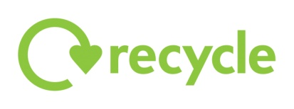\\seth\Shared$\Housing Services\Housing Standards\Licensing\Discretionary Licensing\Project\13f0069dda694ec2800f8eb2ec1c3f92BNES_logo_small.gif

**Recycling & rubbish collections**

**ENTER ADDRESS**

**The collection day for: ENTER ADDRESS**

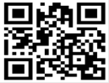 **is**

**ENTER DAY**

**Recycling is collected weekly, household and garden waste is collected fortnightly.**

**Enter your postcode at bathnes.gov.uk to find out which week you are on.**

Put out your recycling and rubbish for collection by **7am** on your collection day, or as late as possible **after 8pm** the previous evening at the front edge of your property

**Please note that you can be fined for leaving your recycling and rubbish out at the wrong time or place**

**For more details contact Council Connect on 01225 39 40 41,** [**councilconnect@bathnes.gov.uk**](mailto:councilconnect@bathnes.gov.uk) **or visit** [**www.bathnes.gov.uk/wasteservices**](http://www.bathnes.gov.uk/wasteservices)

****

**POLICE NOTICE: LOCK IT OR LOSE IT!  SECURE ALL DOORS AND WINDOWS WHEN YOU GO OUT**

To be displayed in the property