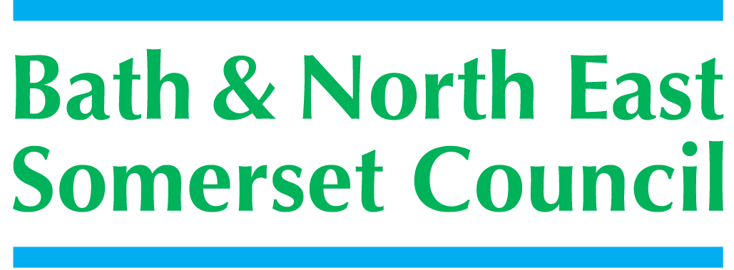**j**

**Children and Young People’s Plan**

**2014 – 2017**

**Summary**

The vision for children and young people in Bath and North East Somerset is that

***“All children and young people will enjoy childhood and be well prepared for adult life***

Bath and North East Somerset –

*The* place to live, work and visit

The Children and Young People’s Plan (CYPP) 2014/17 is the commissioning and delivery plan which outlines how the partner agencies on the Children’s Trust Board will work together to improve the health and wellbeing of children and young people across B&NES.

The CYPP will ensure that all relevant agencies and service providers, work together so that resources are joined up, deliver good value for money and clearly target the children and young people who most need them.

The CYPP is structured around three key outcomes, which were identified following consultation with children, young people and parents and carers.

The Outcomes Framework identifies how we will commission and deliver services in order to make a positive difference to the lives of children, young people and their families

**Children and Young People are Healthy**

* All children and young people maintain a healthy weight
* All children and young people have good emotional wellbeing and resilience
* All children and young people are free from misuse of substances

**Children and Young People are Safe**

* Workforce are skilled to meet the safeguarding needs of children and young people from early help through to statutory social care
* Staffs in all agencies working with children and young people have increased awareness in how to recognise risk of potential self harm and suicide.
* Increased understanding and awareness of risk and appropriate interventions and support available.
* Injury Prevention
* Improving ‘Early Help’ offer to families and signposting to other services
* Ensuring children and young people’s life chances are not adversely affected as a result of Domestic Abuse
* Children and young people with special circumstances are safeguarded
* Children in care
* Care leavers
* Children with disabilities

**Children and Young People have Equal Life Chances**

* All children and young people in care make the same or better progress in educational attainment as their peers
* Including children and young people on;
* Free school meals
* Child Protection plans
* Challenging behaviour
* With SEN
* Young people aged 16-19 are in education, training and employment including young people with EHC plans
* Children and young people up to 25 with SEN and disabled young people:
* Enjoy good health
* Lead fulfilling independent lives and participate fully in the life of their community
* Children are identified and supported through seamless transition stages, from early years to adolescence and early adulthood
* Children and young people are active citizens who feel they have a voice and influence.
* Vulnerable children and young people and their families receive timely and effective early intervention to ensure:
* Parents are confident and able to support and meet the needs of their children.
* Children and young people are resilient and confident and able to make positive choices.

Following wide consultation the experiences of young people, professionals, partners and residents of our communities have helped shape this new plan. By sharing good practice and listening to the views of all those involved in the consultation we will commission and provide services that best support the needs of children and young people in Bath & North East Somerset.

For further information about the Childrens Trust Board and for a link to the full CYPP 2014-2017 please visit:

<http://www.bathnes.gov.uk/services/children-young-people-and-families/strategies-policies-planning/childrens-trust>

Safeguarding of children is first and foremost in all our discussions and working practices. For more information on the work of the Local Safeguarding Children Board (LSCB) please visit:

<http://www.bathnes.gov.uk/services/children-young-people-and-families/child-protection/local-safeguarding-children-board>

This plan has been jointly led by the Children Trust Board and the Local Authority with input from the Health and Wellbeing Board and the B&NES Clinical Commissioning Group. It has been closely aligned to the Health & Wellbeing Strategy for more details please visit:

<http://www.bathnes.gov.uk/sites/default/files/joint_health_wellbein_strategy.pdf>

**Further information for parents / carers, children and young people can be obtained from the Family Information Service fis@bathnes.gov.uk**