

**THE VIRTUAL SCHOOL FOR**

**CHILDREN IN CARE**

**TRAINING PROGRAMME 2013-2014**

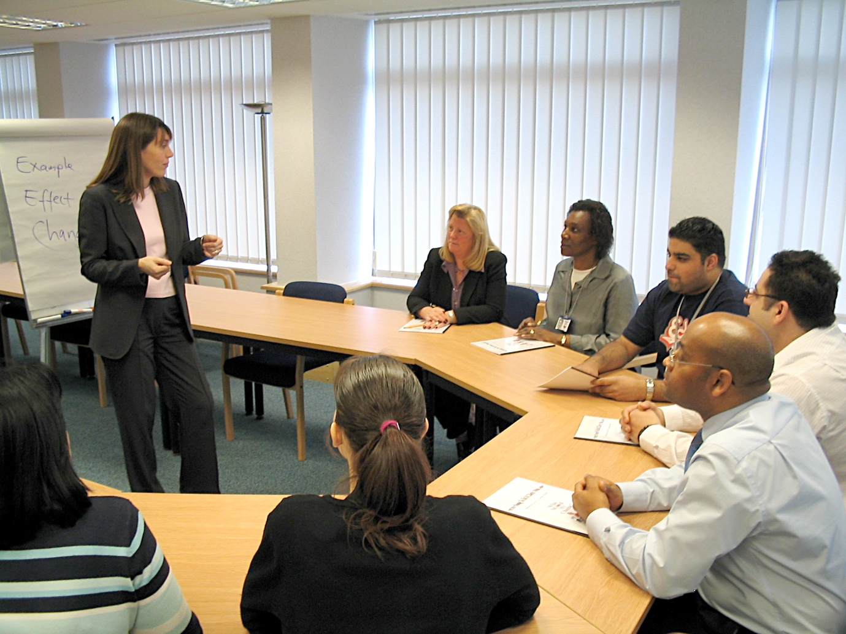

|  |
| --- |
| **C:\Program Files\Microsoft Office\Media\CntCD1\ClipArt3\j0234303.wmfC:\Program Files\Microsoft Office\Media\CntCD1\ClipArt3\j0234303.wmf**  **Children in Care**  **Champions** |
| These three sessions will provide support and training for all adults who work with children in care in schools. |
|  |
| **Thursday 7th November 2013, 1.30pm to 4.30pm (lunch from 12.30pm if pre-ordered) at Fry’s Training & Conference Centre, Keynsham**   * Writing outstanding Personal Education Plans * Hearing the voice of the child – some practical approaches * Ofsted and children in care – what are they looking for?   **Dates of future session for your diary:**  Thursday 27th February 2014 and Thursday 19th June 2014  We’ll plan content on the basis of feedback from earlier sessions but possible topics include:   * Using Pupil Premium Plus * Effective multi agency working * Looking after other people’s children – the role of foster carers * Planning for transitions   All three sessions are from 1.30pm to 4.30pm at Fry’s Training & Conference Centre, Keynsham. |
| **Who should attend?** |
| * Designated teachers and other staff in schools who work with children in care * All interested health and social care professionals |
| **Costs** |
| There is no charge for this training. |
| **How to sign up** |
| E mail [virtual_school@bathnes.gov.uk](mailto:virtual_school@bathnes.gov.uk) by the preceding Friday. Please tell us if you would like lunch, and if you have any special dietary requirements. |

|  |
| --- |
| **The Role of School Governors in supporting Children in Care** |
| This course will cover the basics of supporting children in care in school, including:   * Why children are take into care, and why they often underachieve * Statutory obligations on governors, and the role of the designated teacher * The Pupil Premium, and other sources of support for children in care * The report to governors on children in care * How the Virtual School helps schools and children * Ofsted and children in care |
| **Date, time & venue** |
| Thursday 5th December 2013, 7.00pm to 8.30pm  Thursday 26th June 2014, 7.00pm to 8.30pm  Both at Fry’s Training & Conference Centre, Keynsham. |
| **Who should attend?** |
| * Schools governors * Interested health and social care professionals who want an overview of school’s obligations towards children in care |
| **Costs** |
| There is no charge for this training. |
| **How to sign up** |
| Email [lynne_collins@bathnes.gov.uk](mailto:lynne_collins@bathnes.gov.uk) by the preceding Tuesday. |

|  |
| --- |
| **Master’s level course on Attachment and Learning**  **Bath Spa University** |
| This module explores the impact of attachment difficulties on children’s learning and to develop practical strategies to help these children succeed. The module will involve face-to-face, interactive sessions and an individual, supported project, which includes one-to-one tutorials. It is possible to ‘top-up’ to gain credits and attain a PGCert in or a full Master’s degree. |
| **Date, time & venue** |
| The course starts in October and runs for a year. Places may still be available for autumn 2013. Enquiries and expressions of interest for autumn 2014 are welcome at any stage. Please contact Dr Janet Rose for more information (see below). |
| **Who should attend?** |
| This course is open to anyone with an undergraduate degree and will be of particular interest to people who work with vulnerable children in schools, social care and health. |
| **Costs** |
| As a guide, the cost for 2013-2014 is £650 – this may be revised for 2014-15. Payments can be made in three instalments. Further charges apply for the PGCert and the full Master’s degree. |
| **For more information, contact:** |
| * Dr Janet Rose [j.rose@bathspa.ac.uk](mailto:j.rose@bathspa.ac.uk) for queries about course content, assessment, accreditation and signing up. * Michael Gorman [michael_gorman@bathnes.gov.uk](mailto:michael_gorman@bathnes.gov.uk) for queries about costs. |

|  |
| --- |
| **Attachment Aware Schools**  **In association with Bath Spa University** |
| A year long whole school programme of training and support to understand the impact of early attachment experiences and how to promote well-being, resilience and emotional development in young children.  95% of what we know about brain development and functioning has been discovered in the last 20 years. We are becoming increasingly aware of how early attachment experiences, neglect and trauma affects brain development and functioning and the impact this has on learning and behaviour. The programme enables adults working with children to develop a shared understanding of these issues with parents and partner agencies, and provides fresh approaches to responding to the emotional and behavioural needs of children and young people. |
| **Date, time & venue** |
| Attachment Aware Schools training takes place in schools on INSET days and in twilight booster sessions. |
| **Who should participate?** |
| * Early Years settings, primary, secondary and special schools, Post 16 providers * All interested health and social care professionals |
| **Costs** |
| £1800 in two instalments. |
| **How to sign up** |
| E mail [michael_gorman@bathnes.gov.uk](mailto:michael_gorman@bathnes.gov.uk) or [julia_mcdonald@bathnes.gov.uk](mailto:julia_mcdonald@bathnes.gov.uk) for more information. |

|  |
| --- |
| **In Care, In School** |
| In Care, In School is a standalone PSHE and staff training resource developed by young people on the Bath & North East Somerset In Care Council, supported by the local authority, Bath Spa University and a number of other organisations.  Each pack contains:   * Guidance notes on using the pack * Ten short filmed scenarios , 5 primary and 5 secondary * Three short films of post 16 care leavers talking about their experiences. * Easy-to-use and imaginative primary and secondary lesson plans * Details of ASDAN accreditation * A staff training and support booklet which can be used in staff meetings, INSET days or by individuals. |
| **Costs** |
| Free copies of In Care, In School have been sent to all Bath & North East Somerset Schools and Academies. Contact the Virtual School if you cannot locate your school’s copy.  For other schools, please see [www.incareinschool.com](http://www.incareinschool.com) for formats and prices. |
| **For more information** |
| See [www.incareinschool.com](http://www.incareinschool.com) or email [virtual_school@bathnes.gov.uk](mailto:virtual_school@bathnes.gov.uk) |