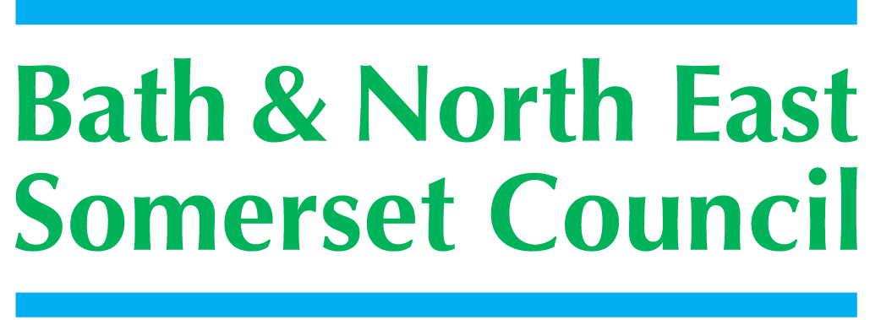 | 
5

People and Communities Department
PO Box 25, Riverside, Temple Street, Keynsham, Bristol BS31 1DN
Tel: 01225 395355 Fax: 01225 394011 E-mail: ellie_weyman@bathnes.gov.uk

SCHOOLS FORUM

7th July 2015

2014/15 Budget Outturn

Lead Officer | Richard Morgan
Contact details | Richard_morgan@bathnes.gov.uk 01225 395220
Forum asked to decide / steer / be informed | Be aware of the resources available for allocation to priorities in 2016-17
Time Needed | 20 mins

Purpose of the report

To update the forum on the financial position of the DSG for 2014-15

Recommendation

- Forum is asked to note the underspend, and

- Consider how the resources may be utilised on other priorities in 2016-17

Report

As part of the Local Authority accounts the attached statement (appendix A) shows the year end position of the DSG for 2014-15.
This statement is required annually and the shows the split between the centrally retained elements and the schools spend.
The statement also shows the comparative figures for 2013-14

The statement shows that overall the DSG was under spent by £5.924 m with the schools elements over spending by £120k and the centrally retained elements under spending by £6.044m. The 2014-15 underspend has increased from 2013-14 by £1.465m. The growth in underspend is a result of underspends in certain service areas.

The main elements of under spend in the centrally retained elements are

- Early Years – 2yr olds £571k
- Amendments to DSG in 2013-14 and 2014-15 £829k
- Small under and over spends in various budgets £65k

- Budget allocation for 2 year old (2YO) place funding for 14/15 included both the DfE allocation based on anticipated numbers and a carry forward from the DfE for the previous budget, including trajectory funding. During the summer term prior to the expansion to “40%” of children we were funding more children than the 13/14 objective but in September 2014 and subsequently, whilst we have enjoyed one of the highest take up rates in England, it has still not been at 100% and demand for trajectory funding from providers proved lower than anticipated. Consequently there was an underspend on the 14/15 total budget.

Based on both the move to participation funding taken from the January 2015 census numbers, the setting initially of a zero budget in the DSG as a consequence of this change and a continued increase in the take up of funded places it was agreed by School’s Forum that a relevant part of the 2YO budget was brought into the 2015/16 budget to support the continued success of the scheme in this Council area.

- The methodology of allocating resources to the LA for the DSG is lagged due to the necessary reconciliation of pupil numbers used in the calculation. Generally, the DFE are able to confirm the final DSG during June each year. This is obviously after the allocation of funds through the funding formula by the LA. The school funding regulations changed in 2013-14 to restrict the LA from making in year allocations to schools. With this change there has been a build-up additional resources allocated to B&NES after the formula has been allocated. In 2014-15 the additional allocations that were received totalled £829k.

As part of the budget setting for 2015-16 the ongoing elements of the increased allocations were included in the total resource increases, but the increase in 2014-15 was therefore included in the increased DSG outturn position. This issue will continue to exist as pupil number increases outweigh any estimate we make.

The large under prediction for 2014-15 was an accumulation of 2013-14 and 2014-15 as the regulations and methodology changes were not correctly accounted for in 2013-14. For 2016-17 we will be attempting to estimate the increase in DSG from October pupil number counts to try and overcome the lagged pupil problems. However we will need to be cautious as the DFE reconcile the data to eradicate duplicate pupil numbers which may bring the DSG allocation down.

- Several small under and overspends net off to an underspend of £65k

The main elements of over spend in the schools budgets relate to the overspend on school budget allocations for increased growth in primary schools with significant growth in PAN numbers at the request of the LA

Utilisation of the Carry Forward

In prior years, we have allocated some of the underspend to Forum priorities. Following a change in the school funding regulations it is no longer possible to make in year allocations to schools. The DFE guidance suggests utilising the carry forward to meet priorities or to provide additional allocations to schools in the following financial year. Forum will be aware that we have utilised prior year carry forwards to support current year pressures. It is anticipated that we could take similar steps next financial year.

The forum will need to consider how best to utilise the carry forward in the 2015-16 or 2016-17 financial year.

Appendix A

