Trees and Woodlands
Environment and Design Team
Planning Services
Lewis House
Manvers Street
BATH BA1 1JG

NOTIFICATION TO CARRY OUT WORK TO TREES WITHIN A
CONSERVATION AREA

Important: Information provided on this form and in supporting documents may be published on the authority's planning register and website.
Before completing this form, please read the guidance notes on pages 4-6

- Full postal address of the site on which the tree(s) is (are) situated:

- Name and address of the owner of the site:

Tel:

Email:

- Name and address of notifier/agent ( for correspondence ) Please indicate if you are acting for the tree owner or not:

Acting for tree owner ( Delete as appropriate): Yes No

Tel:

Email:
- Please state the types(s) of tree(s) and label number(s) as shown on your sketch plan with the proposed work for each tree. ( Please attach extra sheets as necessary )

Tree No. Species Proposed work(s) Reasons for work

- Please use the space below to draw a sketch plan of the site to show the location of the tree(s) to which the application/notification relates. Alternatively attach a site plan of sufficient size and scale for identification purposes. Please include garden boundaries and roads.

- Please list below any additional attachments which you have provided such as photographs, reports, plans.

- Please sign and date:

I/We give notification of my/our intention to carry out the work as specified above:

Signed:

Date:

Please return to:

Trees and Woodlands Team
Planning Services
Lewis House
Manvers Street
Bath
BA1 1JG
Email: trees_andwoodlands@bathnes.gov.uk

Guidance Notes

When can I use this form?

You can use this form to submit a notification for tree works within a Conservation Area
( also known as 6 weeks notice or S211 notice ).
You are not obliged to submit a tree notification on any particular form, however, this form was produced to assist residents.
You can not use this form for works to trees which are protected by a Tree Preservation Order. If you are not sure please contact the Trees and Woodlands Team on 01225 394041 ( choose option 5 when prompted) or email trees_andwoodlands@bathnes.gov.uk

Why do I need to notify the Council?

It is a criminal offence under the Town and Country Planning Act 1990 ( as amended ) to undertake works to trees within the Conservation Area, if the Local Authority has not been notified 6 weeks in advance of any works starting.
More information regarding protected trees can be found on the Councils’ website at:
http://www.bathnes.gov.uk/services/environment/trees-and-woodlands/trees-conservation-areas

How to fill in this form

Section 1-3 Complete the address panels as necessary. Correspondence will automatically be sent to the notifier/agent if panel 3 is completed. Communications will be sent via e-mail if an e-mail address is provided.

Section 4
- Please use the tree number which correlates with the tree number marked on your sketch plan
- Identify the tree if known
- Please give full details of the works which you wish to carry out. You are advised to seek advice from your Tree Surgeon regarding the description of works which should ideally reflect the recommendations within BS 3998:2010 Tree work - Recommendations. The use of percentages to describe crown reductions is no longer considered sufficiently clear. Vague descriptions can lead to a delay in a response from the Council or lead to the making of a Tree Preservation Order.
- You are not obliged to provide reasons, however, this can assist the Council, Parish and Town Council’s and interested members of the public in understanding the works proposed. Reasons can also reduce the possibility of objections being received or a Tree Preservation Order being made if discussions are not possible prior to the 6 weeks determination date.
Section 5 When drawing your plan please: 1) Try and locate your house in relation to other properties; 2) Ensure all relevant roads are named; 3) Ensure that trees are clearly marked and numbered on the plan. 4) include other trees if they could be confused with the tree/s which are the subject of your notification.

Please see the plan below as an example of a typical plan to accompany a notification.

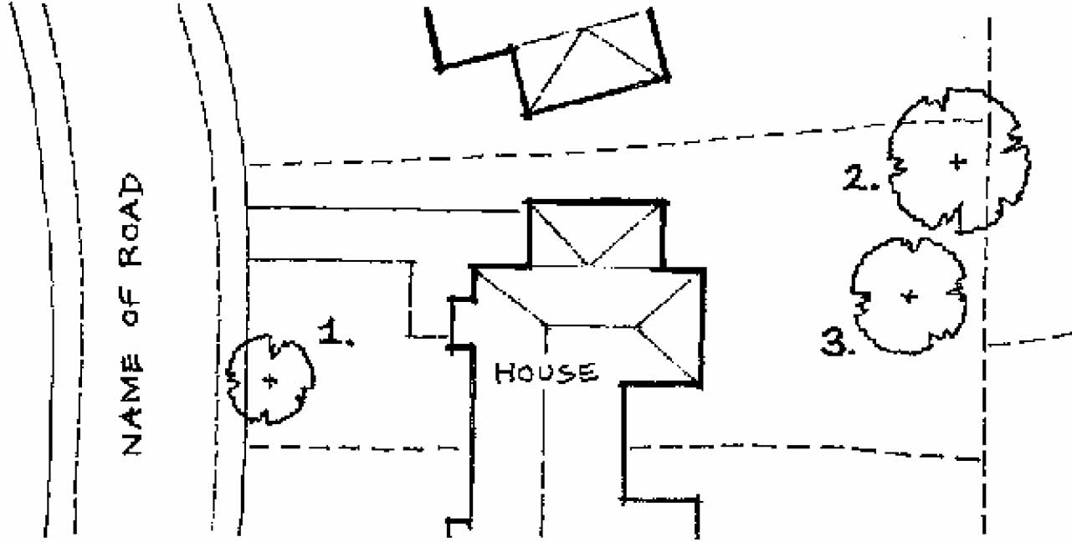

What happens after I have completed and returned the form?

- The Council will acknowledge receipt of your notification within 5 working days. This will be via e-mail if an e-mail has been provided. The acknowledgement will include a reference number and deadline by which you should expect to receive a response. Please contact the Council if you do not receive an acknowledgement.
- In most cases it will be necessary for an officer of the Council to have a look at your tree(s). This is normally done from a publicly accessible place, but in some instances a closer inspection is required. If an officer is required to enter your property they will ask your permission by calling at your house or making an appointment prior to visiting the site.
You are advised to check the identity of anybody coming to your house claiming to be a council officer. A council officer will have identification to show you.
- The Council has up to 6 weeks from the time your notification is received to consider your proposal and respond to you. The Council has two options available and those are either to respond by raising no objection or to make a Tree Preservation Order.

Is a notification always necessary?

You are not required to submit a notification for:
- a) The cutting down, topping or lopping or uprooting of a tree whose diameter does not exceed 75 millimetres; or
b) the cutting down or uprooting of a tree, whose diameter does not exceed 100 millimetres, for the sole purpose of improving the growth of other trees (eg thinning as part of forestry operations).

In either case, the diameter of the tree is to be measured over the bark of the tree at 1.5 metres above ground level. These exemptions do not apply in circumstances where a tree has more than one stem at a point 1.5 metres above the natural ground level if any stem when measured over its bark at that point exceeds the relevant minimum

- The removal of a tree which is dangerous or dead .
Unless there is an immediate risk of serious harm, anyone proposing to carry out work on a tree in a conservation area on the grounds that it is dead must give the Council 5 days notice before carrying out the proposed work. Where such a tree requires urgent work to remove an immediate risk of serious harm, written notice is required as soon as practicable after the work becomes necessary.
If you undertake work without providing 5 days notice then you are advised to retain evidence of the danger otherwise you may risk prosecution. You should to try get the opinion of a qualified tree surgeon first.
Landowners have a duty to replace a tree removed under this exemption. Replacement trees should be of an appropriate size and species and planted at the same place as soon as the owner of the land can reasonably do this

- The pruning or removal of trees where this is necessary to implement a development where full planning consent has been granted. However, you are advised to contact the Trees and Woodlands team if the work was not identified within the planning submissions for consideration or would not have been apparent. If work is proposed to trees other than those immediately affected by a proposed development then a separate notice should be submitted.

The information contained in this leaflet is for guidance only and is not a full statement of law. More information is available on: http://www.bathnes.gov.uk/services/environment/trees-and-woodlands
And:
https://www.gov.uk/guidance/tree-preservation-orders-and-trees-in-conservation-areas

Rev Oct 2017

