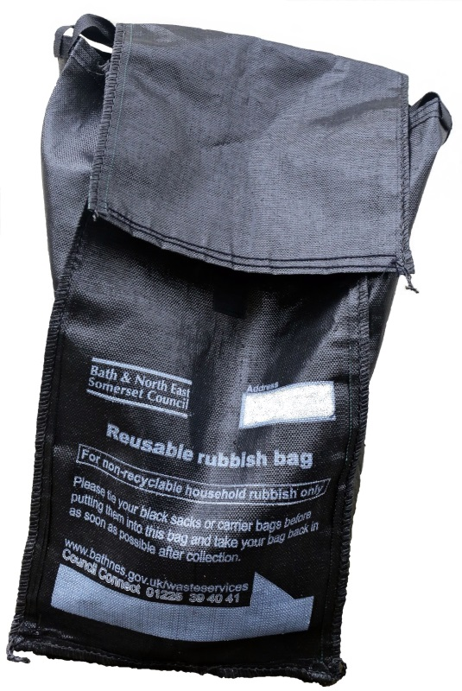
Guidelines for using your reusable rubbish bag
Please
- Use your reusable rubbish bag for household rubbish only.
- Tie up your plastic sacks or carrier bags containing your rubbish before placing them in your reusable rubbish bag so that our crews can lift the rubbish bags out of the reusable rubbish bags and throw them into the back of the collection vehicle.
- Write in your address on the space provided on the bag.
- Put your reusable rubbish bag out for collection in your usual place at the front edge of your home by 7am on your collection day, or as late as possible after 8pm the previous evening.
- You must bring your reusable rubbish bag back in as soon as you can after emptying – your bag must not be left out on the street or on railings between collections.
Please
- Do not put any loose rubbish or split sacks into your reusable rubbish bag– our crews will not take this.
- Do not put out any other rubbish bags next to your reusable rubbish bag– we will give you one bag when we visit
- Do not leave your empty bag out after collection. All bags must be brought back onto your property as soon as possible after collection.
- Do not leave your bag on railings between collections
- Do not use your reusable rubbish bag for any items that we collect for recycling. Use your green box, blue bag, food waste bin and your weekly small electricals recycling collection to recycle as much as you can. All food should be recycled in your food waste bin.
- Do not use your reusable rubbish bag to store anything else other than the general rubbish you want us to collect. Please note that the bag remains the property of the Council.

If you have any queries or would like to order an extra reusable bag or any recycling container please contact Council Connect
Telephone: 01225 39 40 41
Email: Councilconnect@bathnes.gov.uk
Visit: www.bathnes.gov.uk/wasteservices

