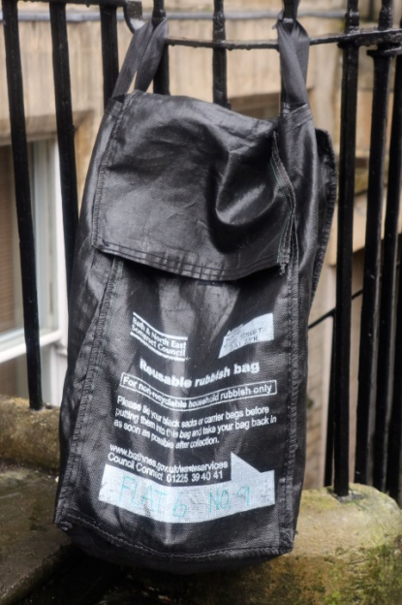
Guidelines for using your reusable rubbish bag

Please
- Use your reusable Council black bag for household rubbish only.
- Tie up your plastic sacks or carrier bags containing your rubbish before placing them in your reusable bag so that our crews can lift the rubbish bags out of the reusable bag and throw them into the back of the collection vehicle.
- Write in your address on the space provided on the bag.
- Put your reusable bag out for collection in your usual place at the front edge of your home by 7am on your collection day, or as late as possible after 8pm the previous evening. This reduces the amount of time available for birds and animals to scavenge.
- Take your reusable bag back in as soon as you can after emptying – your bag must not be left out on the street between collections.
- Tie your reusable bag to your railings (or similar) if you are worried that your bag may blow away once emptied.
Please do not
- Do not put any loose rubbish or split sacks into your reusable bag – our crews will not take this.
- Do not use your reusable bag for any items that we collect for recycling. Use your green box, blue bag, food waste bin and your weekly small electricals recycling collection to recycle as much as you can. By using your food waste recycling collection (if you have one) you will help to reduce the problems we have with birds and animals.
- Do not put out any other rubbish bags next to your reusable bag – we will give you one bag when we visit, but if you need an extra bag please contact Council Connect.
- Do not use your bag to store anything else other than the general rubbish you want us to collect. Please note that the bag remains the property of the Council.
Please encourage your neighbours to use these bags to help keep your street cleaner.

