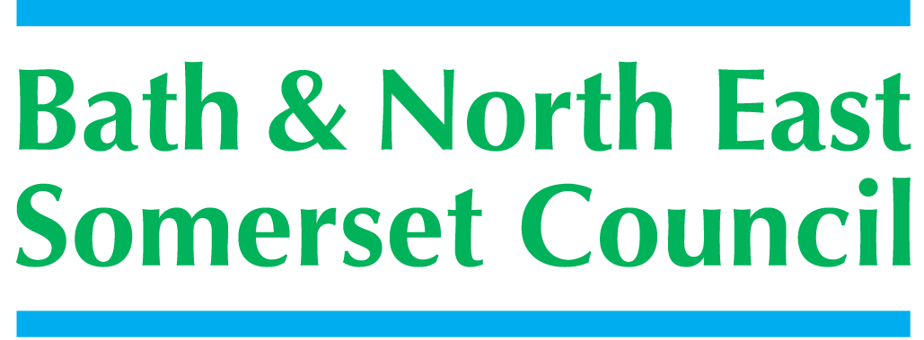

**Children’s Workforce Training**

**ON-LINE BOOKING SYSTEM**

From September 4th 2014 all course bookings must be made through [www.bathnes.learningpool.com](http://www.bathnes.learningpool.com) where you can book onto courses under the following headings:

* Early Help & Integrated Working
* Physical & Emotional Wellbeing
* Safeguarding & Child Protection

Once you have logged in you will see a page that looks like this

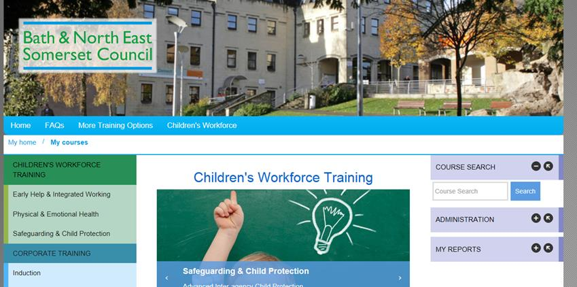

From here you can use the topic headings on the left of the page to view the list of available courses

If you know the name of the course you can use Course Search

You can then view the course pages where you can read more about the course and book a place.

In order to ‘sign up’ for a course you will be asked to provide your managers name and a cost code or invoicing details (even if the course is free).

Your manager will be asked to approve your booking before your place is confirmed.

If you are one of the few who don’t get an email with your log-in details you will need to register for an account.

* If you are a B&NES employee and are not already registered with the Learning Zone please select ‘Create New Account’
* If you work with children and young people in any other capacity select ‘Third Party Registration’

You will be asked to provide some information about your role and employer and you will need to provide an email address that is unique to you so that you can receive confirmation emails about your bookings and access your training record. This means that email addresses that begin info@, reception@ enquiries@ etc. are unlikely to be accepted as they usually refer to service or organisation email accounts. The system does accept personal email addresses and many users like this as it allows them to access their training accounts from work, home and mobile devices.

[childrensworkforce_training@bathnes.gov.uk](mailto:childrensworkforce_training@bathnes.gov.uk) or 01225394210